**University of Mumbai**



**PRACTICAL JOURNAL – ELECTIVE II**

**PSIT3P3d**

**Malware Analysis**

**SUBMITTED**

**BY**

**ROHAN GURAV**

**SEAT NO: 30352**

**SUBMITTED IN PARTIAL FULFILLMENT OF THE REQUIREMENTS FOR QUALIFYING M.Sc. (I.T.) PART-II (SEMESTER – III) EXAMINATION**

**2023-2024**

**DEPARTMENT OF INFORMATION TECHNOLOGY**

**3RD FLOOR, DR. SHANKAR DAYALSHARMA BHAVAN,**

**VIDYANAGRI, SANTACRUZ(EAST),**

**MUMBAI – 400098.**

**University of Mumbai**



**Department of Information Technology**

**Certificate**

This is to certify that **Mr. ROHAN GURAV Seat No. 30352** studying in **Master of Science** in **Information Technology Part II Semester III** has satisfactorily completed the Practical of **PSIT3P3d Malware Analysis** as prescribed by University of Mumbai, during the academic year **2023-24**.

**___________________________ _____________________________**

**Signature Signature  
Subject-In-Charge Head of the Department**

**_____________________________**

**Signature**

**External Examiner**

**College Seal: _________________ Date: _____________**

|  |  |  |  |  |
| --- | --- | --- | --- | --- |
| Index | | | | |
| **Sr. no.** | **Title** | **Pg. no.** | **Date** | **Sign** |
| **1** | **Practical 1** |  |  |  |
|  | **A. Files: Lab01-01.exe and Lab01-01.dll.** |  |  |  |
|  | **B. Analyze the file Lab01-02.exe.** |  |  |  |
|  | **C. Analyze the file Lab01-03.exe.** |  |  |  |
|  | **D. Analyze the file Lab01-04.exe.** |  |  |  |
|  | **E. Analyze the malware found in the file Lab03-01.exe using basic dynamic analysis tools.** |  |  |  |
|  | **F. Analyze the malware found in the file Lab03-02.dll using basic dynamic analysis tools.** |  |  |  |
|  | **G. Execute the malware found in the file Lab03-03.exe while monitoring it using basic dynamic analysis tools in a safe environment.** |  |  |  |
|  | **H. Analyze the malware found in the file Lab03-04.exe using basic dynamic analysis tools.** |  |  |  |
|  |  |  |  |  |
| **2** | **Practical 2** |  |  |  |
|  | **A. Analyze the malware found in the file Lab05-01.dll using only IDA Pro. The goal of this lab is to give you hands-on experience with IDA Pro. If you’ve already worked with IDA Pro, you may choose to ignore these questions and focus on reverse engineering the malware.** |  |  |  |
|  | **B. Analyze the malware found in the file Lab06-01.exe.** |  |  |  |
|  | **C. Analyze the malware found in the file Lab06-02.exe.** |  |  |  |
|  | **D. Analyze the malware found in the file Lab06-03.exe.** |  |  |  |
|  | **E. Analyze the malware found in the file Lab06-04.exe.** |  |  |  |
|  |  |  |  |  |
| **3** | **Practical 3** |  |  |  |
|  | **A. Analyze the malware found in the file Lab07-01.exe.** |  |  |  |
|  | **B. Analyze the malware found in the file Lab07-02.exe.** |  |  |  |
|  | **C. For this lab, we obtained the malicious executable, Lab07-03.exe, and DLL, Lab07- 03.dll, prior to executing. This is important to note because the malware might change once it runs. Both files were found in the same directory on the victim machine. If you run the program, you should ensure that both files are in the same directory on the analysis machine. A visible IP string beginning with 127 (a loopback address) connects to the local machine. (In the real version of this malware, this address connects to a remote machine, but we’ve set it to connect to localhost to protect you.)** |  |  |  |
|  |  |  |  |  |
| **4** | **Practical 4** |  |  |  |
|  | **A. Analyze the malware found in Lab11-01.exe** |  |  |  |
|  | **B. Analyze the malware found in Lab11-02.dll. Assume that a suspicious file named Lab11-02.ini was also found with this malware.** |  |  |  |
|  | **C. Analyze the malware found in Lab11-03.exe and Lab11-03.dll. Make sure that both files are in the same directory during analysis.** |  |  |  |
|  |  |  |  |  |
| **5** | **Practical 5** |  |  |  |
|  | **A. Analyze the malware found in the file Lab12-01.exe and Lab12-01.dll. Make sure that these files are in the same directory when performing the analysis** |  |  |  |
|  | **B. Analyze the malware found in the file Lab12-02.exe.** |  |  |  |
|  | **C.Analyze the malware extracted during the analysis of Lab 12-2, or use the file Lab12-03.exe.** |  |  |  |
|  | **D. Analyze the malware found in the file Lab12-04.exe.** |  |  |  |
|  |  |  |  |  |
| **6** | **Practical 6** |  |  |  |
|  | **A. Analyze the malware found in the file Lab13-01.exe.** |  |  |  |
|  | **B. Analyze the malware found in the file Lab13-02.exe.** |  |  |  |
|  | **C. Analyze the malware found in the file Lab13-03.exe.** |  |  |  |
|  |  |  |  |  |
| **7** | **Practical 7** |  |  |  |
|  |  |  |  |  |
|  | **A. Analyze the malware found in file Lab14-01.exe. This program is not harmful to your system.** |  |  |  |

# PracticalNo. 1

## A. ThislabusesthefilesLab01–01.exeandLab01–01.dll.

To begin with, we have Lab01–01.exe and Lab01–01.dll. At first glance, we can mightassume these associated. As .dlls can’t be run on their own, potentially Lab01–01.exe is used torun Lab01–01.dll. We can upload these to[http://www.VirusTotal.com](http://www.virustotal.com/)to gain a useful amountofinitial information (Figure1.1).

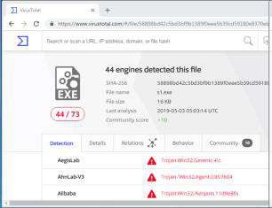

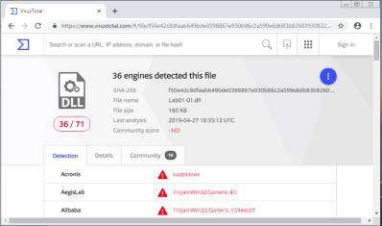Figure1.1—VirusTotal.comreportsforLab01–01.exeandLab01–01.dll.

Although the book states that these files are initially unlikely to appear within [VirusTotal](http://www.virustotal.com/), theyhave become part of the antivirus signatures so have been recognised. We currently see that44/73 antivirus tools pick up on malicious signatures from Lab01–01.exe, whereas 36/71identifyLab01–01.dllasmalicious.

We can use[VirusTotal](http://www.virustotal.com/)to identify more information, such as when the files were compiled.Weseethatthetwofileswerecompiled almostat thesame time(*around 2010–12–1916:16:19*)

— this strengthens the theory as the two files are associated. Other tools can also be utilised toidentifyTime Date Stamp, such as[PE Explorer](http://www.pe-explorer.com/)(Figure2.1).

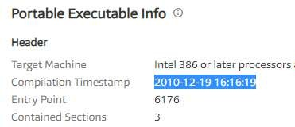

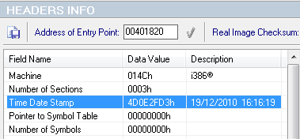

Figure2.1—DateTimeStampsfrom VirusTotal.comandPEExplorer.

When a file is packed, it is more difficult to analyse as it is typically obfuscated andcompressed.Keyindicatorsthat aprogram is packed,is alack of visiblestringsorinformation,or including certain functions such as LoadLibrary or GetProcAddress — used for additionalfunctions. A packed executable has a wrapper program which decompresses and runs the file,andwhenstatically analysinga packedprogram, onlythewrapperprogram isexamined.

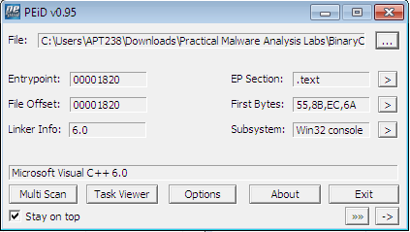

Figure3.1 —PEiDofLab01–01.exe

[PEiD](https://www.aldeid.com/wiki/PEiD)canbeusedto identifywhethera fileis packed,as itshowswhich packerorcompilerwasused to build the program. In this case *Microsoft Visual C++ 6.0* is used for both the Lab01–01.exe and Lab01–01.dll (figure 3.1), whereas a packed file would be packed with somethinglike[*UPX*.](https://upx.github.io/)

Investigating the imports is useful in identifying what the malware might do. Imports arefunctions used by a program, but are actually stored in a different program, such as commonlibraries.

Any of the previously used tools ([VirusTotal](http://www.virustotal.com/), [PEiD](https://www.aldeid.com/wiki/PEiD), and [PE Explorer](http://www.pe-explorer.com/)) can be used to identify theimports. These are stored within the ImportTable and can be expanded to see which functionshavebeen imported.

Lab01–01.exe imports functions fromKERNEL32.dlland MSVCRT.dll, withLab01–01.dllalsoimportingfunctionsfrom KERNEL32.dll, MSVCRT.dll,andWS2_32.dll(figure4.1)

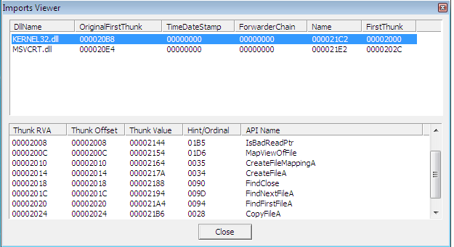

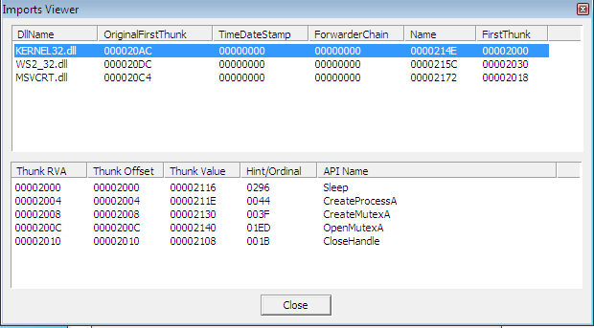

Figure4.1—ImportTablesfromLab01–01.exeandLab01–01.dll.

KERNEL32.dllisacommon DLL whichcontains corefunctionality, such asaccess andmanipulationofmemory,files,andhardware.ThemostsignificantfunctionstonoteforLab01–01.exe are are FindFirstFileA and FindNextFileA , which indicates themalware will search through the filesystem, as well as open and modify. On the otherhand,Lab01–01.dllmostnotably uses SleepandCreateProcessA.

WS2_32.dllprovides network functionality,however in this case is imported by ordinalratherthan name, it is unclear which functionsare used.

MSVCRT.dllimports arefunctions that are included inmost as partofthe compilerwrappercode.

Assessingthecombinationofimportedfunctions,sofaritcouldbeassumedthatthismalwareallowsfor anetwork-enabled back door.

Along with Lab01–01.exe and Lab01–01.dll, there are other ways to identify maliciousactivity on infected systems. Disassembling Lab01–01.exe in[PE Explorer](http://www.pe-explorer.com/)shows us a set ofstrings around kerne132.dll which is supposed to be disguised as the commonkernel32.dll—note1ratherthanl(figure5.1).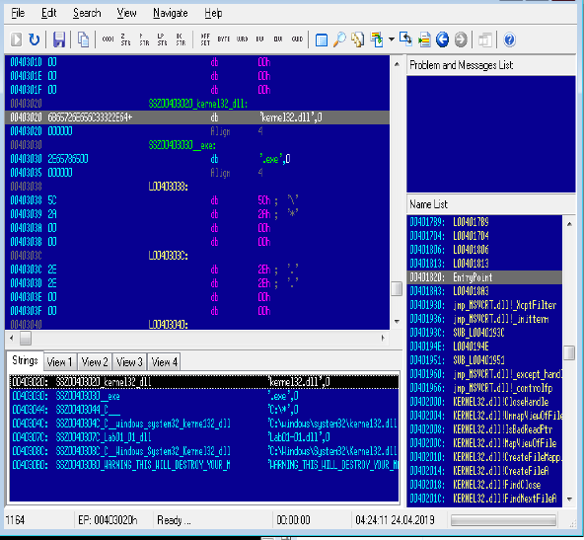

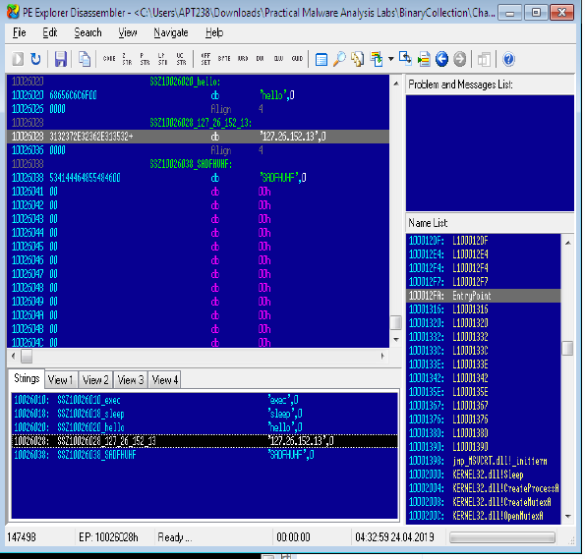

Figure5.1—DisassemblyofLab01–01.exeandLab01–01.dllusingPEExplorer

Further investigating the strings, however for Lab01–01.dll, it is apparent that there is anIP address of 127.26.152.13 , which would act as a network based indicator of maliciousactivity(figure5.1).

Bringing all the pieces together, there can be an assumption made that Lab01–01.exe, and byextension Lab01–01.dll, is malware which creates a backdoor.[VirusTotal](http://www.virustotal.com/)provided indicationthat the files were malicious, and utilising this or[PE Explorer](http://www.pe-explorer.com/)it was established that the twowere likely related, with the .dll is dependant upon the .exe. The files are not packed(asidentified by[PEiD](https://www.aldeid.com/wiki/PEiD)), small programs, with no exports, however specific imports which indicatethat Lab01–01.exe might search through directories and create/manipulate files such as thedisguised kernel32.dll, as well possibly searching for executables on the target system, assuggested by the string exec within Lab01–01.dll. In addition, there are network basedimports, an IP address, as well as the functions imported from kernel32.dll, CreateProcessandsleep, which arecommonly used in backdoors.

## B. Analyze the file Lab01–02.exe.

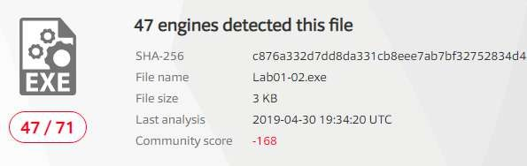As with the previous lab, uploading Lab01–02.exe in[VirusTotal.com](http://www.virustotal.com/)shows us that 47/71antivirustoolsrecognisethisfile’ssignatureasmalicious(figure1.1).

Figure1.1—VirusTotal.com reportsforLab01–02.exe.

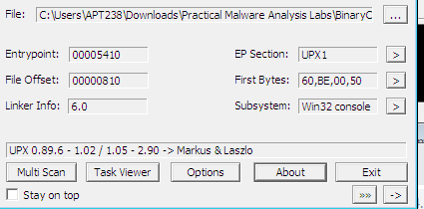We can identify whether the file is packed, either through[VirusTotal.com](http://www.virustotal.com/)or[PEiD](https://www.aldeid.com/wiki/PEiD). A filewhich is not packed will indicate the compiler (eg, *Microsoft Visual C++ 6.0*), or the method inwhich it has been packed. Initially,[PEiD](https://www.aldeid.com/wiki/PEiD)declared there was *Nothing found \**, however afterchanging from a *normal* to *deep* scan, it has been determined that the file has been packed by[*UPX*](https://upx.github.io/)(figure2.1).

Figure2.1 —PEiDDeepscan

*Normalscan isat theEntryPoint of thePE Filefor documented signatures.*

*Deepscanis the containing sectionoftheEntryPoint*

*Hardcorescan isa completescan oftheentirefile for signatures.*

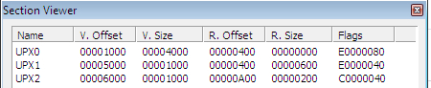Anotherway of identifyingwhetherthefilehasbeen packed or not,is viathe EntryPointSection (*EP Section*) — these are UPX0, UPX1 and UPX2, section names for UPX packed files.UPX0hasa virtualsizeof0x4000but a rawsizeof0(figure2.2),likelyreserved foruninitializeddata—the unpacked code.

Figure2.2 —PEiDPESectionViewer

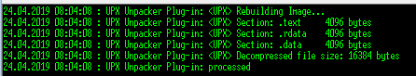We are able to unpack the file directly within [PE Explorer,](http://www.pe-explorer.com/) with the UPX Unpacker Plug-in.Whenenabled, this automatically unpacks thefilewhen loaded (Figure2.3).

Figure2.3 —UPX Unpacker Plug-inrunninginPEExplorer

Whenthefileisunpacked, wecan investigatestringsand importstoseewhat the malwaregets up to. From the Import Viewer within[PE Explorer](http://www.pe-explorer.com/), we see there are four imports (figure3.1).

KERNEL32.DLL—imported tomost programs anddoesn’ttell usmuch other than

suggestingthepotentialofcreatingthreads/processes.

ADVAPI32.dll—specificallyCreateServiceAisofnote.

MSVCRT.dll—importedto mostprograms anddoesn’ttellus much.

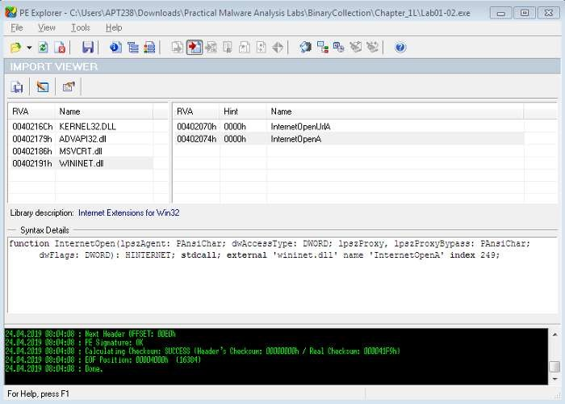WINNET.dll—specificallyInternetOpenAandInternetOpenURLAareofnote.

Figure3.1 —ImportViewerwithinPEExplorer

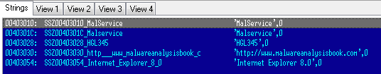So far, this is suggesting that the malware is creating a service and connecting to a URL.Checking out the strings of the file in the Disassembler, we see ‘*Malservice*’,‘[*http://www.malwareanlysisbook.com*](http://www.malwareanlysisbook.com/)’and‘*InternetExplorer8.0*’(figure3.2).Thesepotentiallyact as host or network based indicators of malicious activity, though the service to run, URL toconnectto, and the preferred browser.

Figure3.2 —DisassemblerStrings

## C.AnalyzethefileLab01-03.exe.

i- Once again, uploading to[VirusTotal.com](http://www.virustotal.com/)indicates that Lab01–03.exe is malicious due to58/69antivirus tools currently recognising signatures.

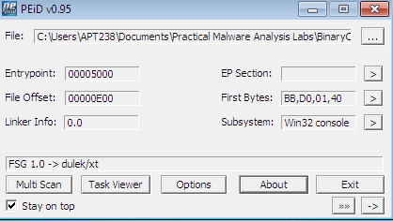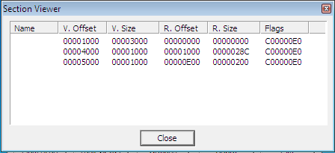ii Scanning this with[PEiD](https://www.aldeid.com/wiki/PEiD)demonstrates that Lab01–03.exe is packed withFSG 1.0(figure 2.1left). This is much more difficult to unpack than[UPX](https://upx.github.io/)and must be done manually. Currently weare unable to unpack this. Check out Lab 18–2 (Chapter 18, Packers and Unpacking) to unpackin[OllyDbg](http://www.ollydbg.de/).

Figure2.1 —PEiDshowingLab01–03.exepackedwithFSG1.0(left)andSectionVIewer(right)

Otherindicatorsthatthefileispacked,arethemissingnames intheEPSection viewer(Figure

2.1 right), as well as the first section having a virtual size of 0x3000 and a raw size of 0 — againmostlikely reserved for theunpacked code.

Although Lab01–03.exe is currently unpackable, we can still try to identify any imports togetan ideaofwhat thefilemight do.

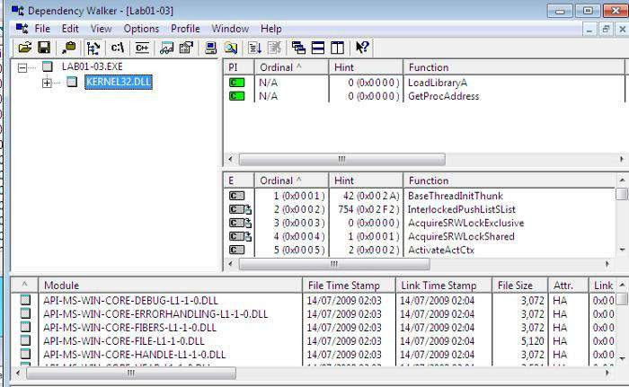

Figure3.1 —DependencyWalkerforLab01–03.exe

Loading the file into [PE Explorer](http://www.pe-explorer.com/)unfortunately shows a blank Import Table, and running it inthe Disassembler is also unhelpful. Another useful program is [Dependency Walker](http://www.dependencywalker.com/), which liststheimported and exported functions of aportableexecutable(PE) file(figure3.1).

Here, we can see that Lab01–03.exe is dependant upon (and therefore imports) KERNEL32.DLL.The particular functions here are LoadLibraryA and GetProcAddress, however this does nottellus much about thefunctionalityother than thefactthefileis packed.

We are unable to unpack the file the visible imports are uninformative, and we can’t see anystrings in[PE Explorer](http://www.pe-explorer.com/)(figure 4.1), it is difficult to suggest what the file might do, or identifyanyhost/network basedmalware-infection indicators.

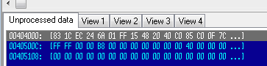Figure4.1—PEExplorershowingnostringsinformationforpacked Lab01–03.exe

## D. Analyzethe fileLab01-04.exe.

Lab01–04.exeisrecognisedasmalicious,with53/72enginesdetectingmalicioussignatures(Figure1.1).

[PEiD](https://www.aldeid.com/wiki/PEiD)shows us that the file is unpacked (and compiled with *Microsoft Visual C++ 6.0*)(figure 2.1). Likewise, the EP section shows the valid file names as well as actual raw sizes forthemall,ratherthan UPX0-3orblanks, as well asa raw sizeof 0,typicallyseen forpackedfiles(figure2.1).As this is not packed, thereis no needto unpack it.

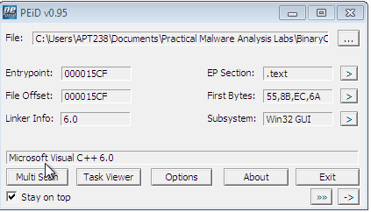

Figure2.1 —PEiDshowingLab01–04.exeisnotpackedandSectionVIewer

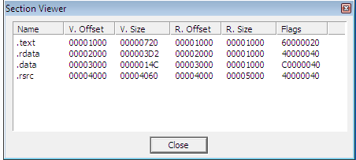Loading Lab01–04.exe into[PE Explorer](http://www.pe-explorer.com/), we initially see that the Date Time Stamp isclearlyfaked(figure3.1).At thetimeofwriting itlooks asthough thefilewas compiledmonthsinthefuture, andit's not immediately clearwhat thereal stampshould be.

Figure3.1—DateTimeStampof Lab01–04.exe

Switching to the Import Viewer within[PE Explorer](http://www.pe-explorer.com/), we see that there are three of thecommon.dllimported (figure4.1).

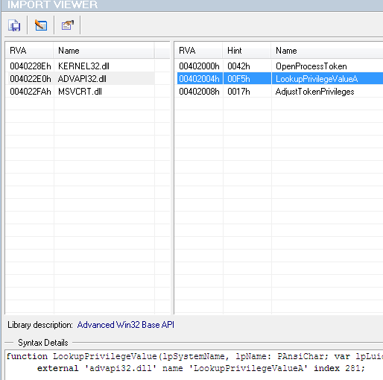

Figure4.1—ImportViewerforLab01–04.exe

KERNEL32.dll— Corefunctionality, such as access and manipulation ofmemory, files,andhardware.

ADVAPI32.dll—Access to advancedcoreWindows components such asthe ServiceManager and Registry. The functions here look like they’re doing something withprivileges.

MSVCRT.dll— imports arefunctions that areincluded in most as part of thecompilerwrappercode.

Assessingthecombinationofimports,therearea few keyoneswhichcan point usin the

directionoftheprogram’sfunctionality.

SizeOfResource,FindResource,and LoadResourceindicate thatthefileissearchingfordata in aspecificresource.

CreateFile,WriteFileand WinExecsuggests that it mightwriteafiletodisk andexecuteit.

LookupPrivilegeValueA andAdjustTokenPrivilages indicatesthatitmightaccessprotectedfiles with special permissions.

Looking at the strings is often a good way to identify any host/network based malware-infectionindicators.Again,thiscanbedonethroughtheDisassemblerin[PEExplorer](http://www.pe-explorer.com/)(Figure5.1)

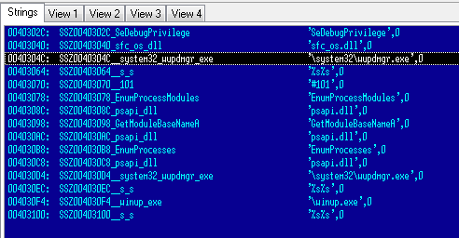

Figure5.1 —Lab01–04.exestringswithin PEExplorerDisassembler

The strings of note here look like ‘*\system32\wupdmgr.exe*’, ‘*psapi.dll*’ and ‘*\winup.exe*’ —potentially these are the files which the .dll identified, create, or execute.‘*\system32\wupdmgr.exe*’might correlatewithKERNEL32.dll GetWindowsDirectoryfunctiontowritetosystem directory andthe malwaremight modify theWindows Update Manager.

Thisgivesussomehost-basedindicators,however thereisnothingapparentregardingnetworkfunctions.

Previouslyoverlookedin[PEiD](https://www.aldeid.com/wiki/PEiD)’s Section Viewer, thereis aresourcesfile.rsrc—TheResourceTable. This isalso seen in[PEExplorer](http://www.pe-explorer.com/)’sSection Headers.

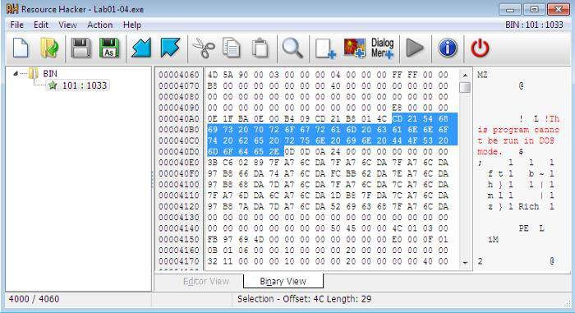Figure6.1—ResourceHackeridentifyingLab01–04.exe’sbinaryresources within [Resource Hacker,](http://angusj.com/resourcehacker/) a tool which can be used to manipulateresources within Windows binaries. Loading Lab01–04.exe into [Resource Hacker](http://angusj.com/resourcehacker/)identifies thatresourceas binaryand lets us search through it. (figure6.1)

## E. AnalyzethemalwarefoundinthefileLab03-01.exeusing basicdynamicanalysistools.

This dynamic analysis starts with initial static analysis to hopefully gain a baselineunderstanding of what might be going on. Straight in with[PEiD](https://www.aldeid.com/wiki/PEiD)and[PE Explorer](http://www.pe-explorer.com/)we see thatLab03–01.exe isevidently PEncrypt3.1 packed,andonly visible import ofkernel32.dllandfunctionExitProcess(figure1.1).Also,thereare arenoapparent strings visible.

Figure

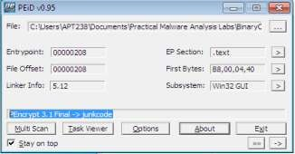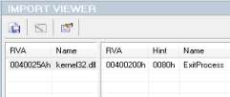

1.1—File Lab03–01.exeispacked,andhasminimalimports

It’sdifficulttounderstandthismalware’sfunctionalitywiththisminimalinformation.

Potentiallythefilewillunpack andexposemoreinformation whenit is run. Onething wecandois execute [strings](https://docs.microsoft.com/en-us/sysinternals/downloads/strings)to scan the file for UNICODE or ASCII characters not easily located. Doingthiswecan identify someuseful information.

Thereisa bitofnoise herewhich havebeenremoved, andthe mainones are highlightedin red(table1.1).

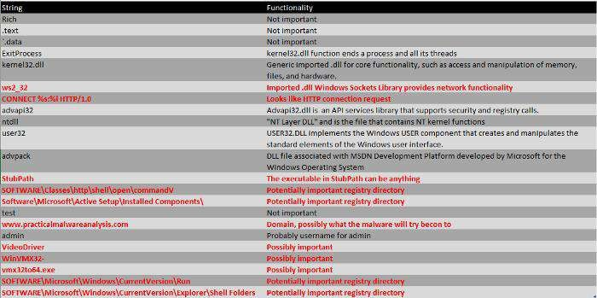

Table1.1—Processedoutputof strings*functionon*Lab03–01.exe

Looking at these, we can make some rough assumptions that Lab03–01.exe is likely to do somenetwork activity and download and hide some sort of file in some of the registry directories,under oneof thosestring names.

To identify host-based indicators, we can make assumptions from the previous stringsoutput, such as potentially attaching itself toSOFTWARE\Microsoft\Windows\CurrentVersion\Run\VideoDriver—however,itismoreuseful to perform dynamic analysis and see what it’s doing. Take a snapshot of the VM soyou’reableto revert to apre-execution state!

Set VM networking to Host-only, and manually assign the preferred DNS server as [iNetsim](http://www.inetsim.org/), orconfigure the DNS reply IP within [ApateDNS](https://www.fireeye.com/services/freeware/apatedns.html)to loopback, and set up listeners using [Netcat](http://netcat.sourceforge.net/)(ports80 and 443 arerecommendedas astarting point as theseare common).

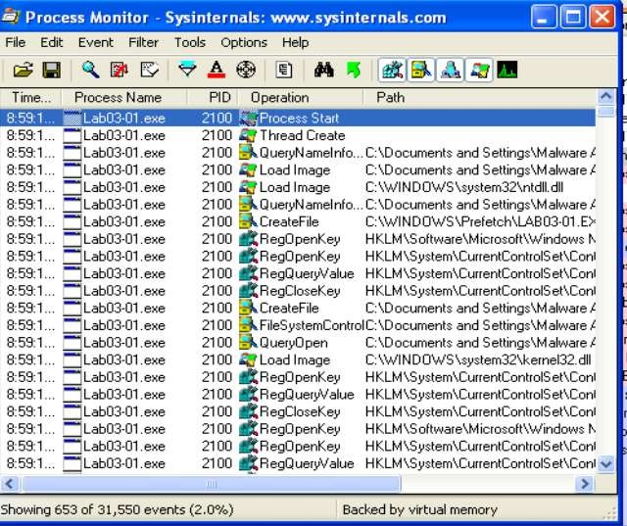Clearallprocesseswithin [Procmon](https://docs.microsoft.com/en-us/sysinternals/downloads/procmon),andapplysuitablefilterstoclearoutanynoiseandfindoutwhat the malware is doing. Initially filter to include Process Lab3–1.exe so we can see itsactivity. Likewise, start [Process Explorer](https://docs.microsoft.com/en-us/sysinternals/downloads/process-explorer)for collecting information about processes running onthe system.

Figure2.1—[Procmon](https://docs.microsoft.com/en-us/sysinternals/downloads/procmon)ofLab03–01.exe

Thefirstthingwenotice whenexecutingLab03–01.exeistheseriesofRegistry Keyoperations

(Figure2.1).Thisdoesn’ttellustoomuch aboutwhatthemalwareisdoingspecifically however,

it’salwaysusefultosee anoverviewoftheactivities.Wecanfilterthis furthertoonlyshow

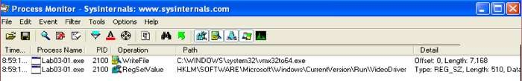WriteFileandRegSetValuetoseethe keyoperations(figure2.2)

Figure2.2—[Procmon](https://docs.microsoft.com/en-us/sysinternals/downloads/procmon)ofLab03–01.exe,filtered forWriteFileand RegSetValue

We can investigate these operations further, and we see that they are related. First, a file iswrittentoC:\WINDOWS\system32\vmx32to64.exe (*note,thisfilenameisastringwe’veidentified as part of the initial static analysis*) however, this appears to be set to the registry ofHKLM\SOFTWARE\Microsoft\Windows\CurrentVersion\Run\VideoDriver(*anotheridentifiedstring!*).This isastronghost-based indicatorthatthemalwareisup tosomething (Figure2.3).

Mostlikelythemalwareisintended toberunatstartup.

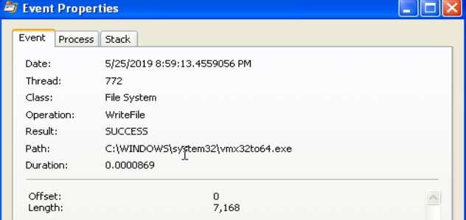

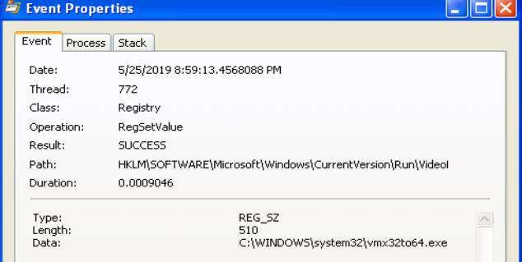Figure2.3—Lab03–01.exehidingundervmx32to64.exe*andsettoVideoDriverregistry.*

Upon further investigation, it appears as though files vmx32to64.exe and Lab03–01.exe sharethe same hash (figure 2.4), indicating the malware has established persistence through creatingandhidinga copyof itself, as well as to executeat startup via theVideoDriverregistry.

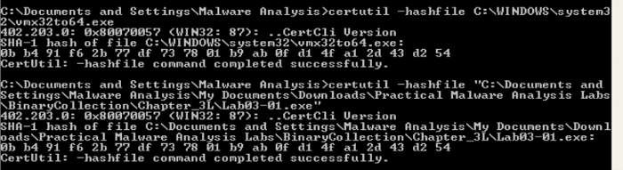Figure2.4—Lab03–01.exesharingthesameSHA1Hashas vmx32to64.exe*.*

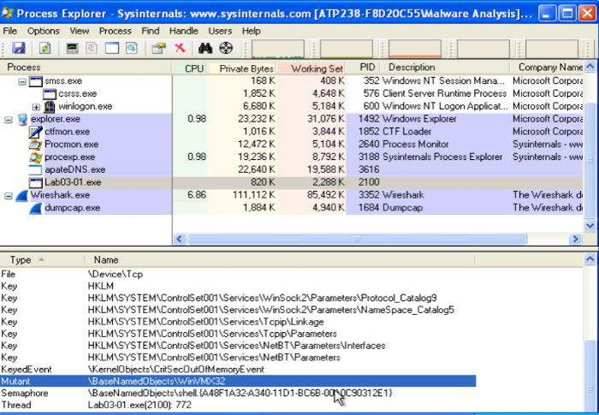Further host-based indicators can be identified through analysis of [Process Explorer](https://docs.microsoft.com/en-us/sysinternals/downloads/process-explorer), to showwhichhandles andDLLsthe malwarehasopenedor loaded.

Figure2.4—[ProcessExplorer](https://docs.microsoft.com/en-us/sysinternals/downloads/process-explorer)showingMutexWinVMX32

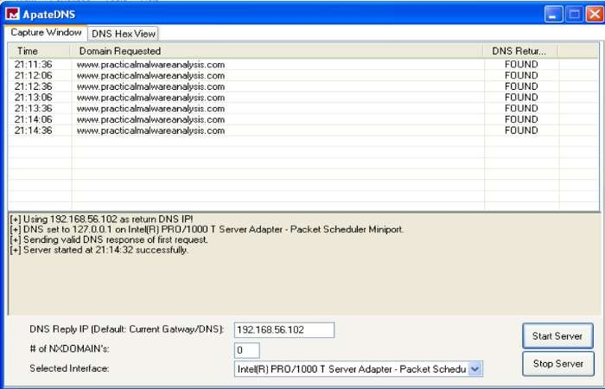[ProcessExplorer](https://docs.microsoft.com/en-us/sysinternals/downloads/process-explorer)shows usthat Lab03–01.exehas createdat mutex of WinVMX32(*again, anotheridentified string*) (Figure 2.4). A mutex (mutual exclusion objects) is used to ensure that onlyonce instance of the malware can run at a time — often assigned a fixed name. We also seeLab03–01.exe utilises ws2_32.dlland wshtcpip.dllfornetworkcapabilities.We’re able to analyse network activity either locally on the victim, or utilising[iNetSim](https://www.inetsim.org/). Ihavedemonstratedboth, havingconfiguredDNS toeitherthe[iNetSim](https://www.inetsim.org/)machine orloopback(forthe[netcat](https://en.wikipedia.org/wiki/Netcat#%3A~%3Atext%3Dnetcat%20(often%20abbreviated%20to%20nc%2Cby%20other%20programs%20and%20scripts) listeners). Turning our attention to[ApateDNS](https://www.fireeye.com/services/freeware/apatedns.html)and our[iNetSim](https://www.inetsim.org/)logs, we see somepretty significant network-based indicators of this malware activity.[ApateDNS](https://www.fireeye.com/services/freeware/apatedns.html)show regularDNSrequeststo[www.practicalmalwareanalysis.com](http://www.practicalmalwareanalysis.com/)every 30 seconds(figure3.1).

Figure3.1 —[ApateDNS](https://www.fireeye.com/services/freeware/apatedns.html)showingDNSbeaconing

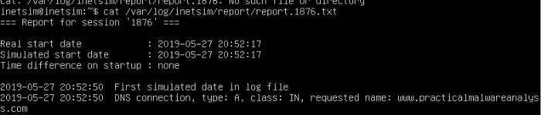The [ApateDNS](https://www.fireeye.com/services/freeware/apatedns.html)capture suggests the malware is beaconing — possibly to either to fetchupdates/instructionsor to send back stolen information.

Figure3.2 —[iNetSim](https://www.inetsim.org/)logs

Also,theassociated[iNetSim](https://www.inetsim.org/)logs showarecognisedDNSrequest forthe maliciouswebsite,providingfurtherindication ofbeaconing intent.

Finally,the[Netcat](http://netcat.sourceforge.net/)listener(withDNSconfigured forloopback) haspickedupatransmissiononport 443. This shows a series of illegible characters emitted from the malware (Figure 3.3). Onsubsequentexecutions or periodicticks, thetransmission is unique.



Figure3.3 —IllegiblecharacterstransmittedbyLab03–01.exe.

Thecombinationofhostandnetwork-basedindicatorsprovidesignificantgroundingtomake

assumptionsregardingthemalware’sactivity.

From Static Analysis, not a lot was uncovered other than the output of what might use ashard-codedparameters.

DynamicAnalysistouncoverfurtherhost-basedindicatorsshowthatthe malwarehasreplicated and masked under another file name has associated with the registry forexecutionon startup andhas networkfunctionality.

Network-basedactivityisidentifiedthroughcapturingperiodicDNSrequests,aswellasinterceptingrandomcharactertransmissions of HTTP &SSL

## F. Analyze the malware found in the file Lab03-02.dll using basic dynamic analysistools.

At first glance, we have Lab03–02.dll. As this is not a .exe file, we are unable to directlyexecuteit.rundll32.exeis a windows utility which loads and runs 32-bitdynamic-link libraries(.dll).

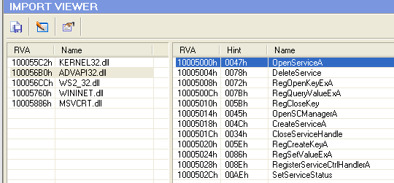First, however, we likely require any exported functions to pass in as an argument. This can beidentified through PE analysis, which shows us a set of exported and imported functions. Theimported functions (Figure 1.1) give us an idea of the .dll’s capabilities. Speculation into thesemightsuggesttherewill likelybesomenetworkinggoingon, aswellas somefile,directory andregistry manipulation. Functions included as part of ADVAPI32.dll suggests the malware mayneedto berunasaservice,which isbacked upbyLab03–02.dll’sexports (Figure1.1)

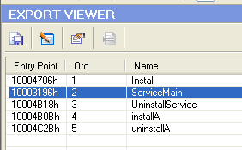

Figure1.1—Lab03–02.dll’sImportsandExportsshowinglikelyservicecapabilities

Running[streams](https://docs.microsoft.com/en-us/sysinternals/downloads/strings)also gives us a lotof useful insight into potential actions. Mostof which arefound as imported functions, however, there are others worth noting that my be usefulhost/network-based indicators. These include some very distinctive strings, potential registrylocations and file or network names, as well as some base64 encoded strings hinting at somefunctionality(Figure1.2).

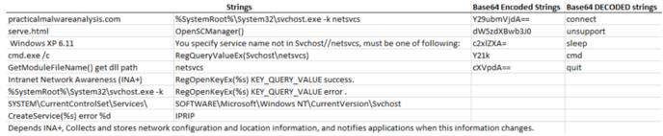

Figure1.2 —Lab03–02.dll’sstringsshowingpotentialfunctionality.

Nowwehaveastarting point to look out for, wecan prepareourenvironment fortrying to runthemalware—clearing[procmon](https://docs.microsoft.com/en-us/sysinternals/downloads/procmon),taking a[registrysnapshot](https://sourceforge.net/projects/regshot/), andsetting up thenetwork.

Toinstallthemalware,passone ofInstallorinstallA(found fromtheexports) into

rundll32.

Executing C:\rundll32.exe Lab03-02.dll,install doesn’t give any immediate feedback onthecommandline,within[processexplorer,](https://docs.microsoft.com/en-us/sysinternals/downloads/process-explorer)or [Wireshark](https://www.wireshark.org/)/[iNetSim](https://www.inetsim.org/),however takinga2nd[registrysnapshot](https://sourceforge.net/projects/regshot/)and comparing the two, it’s clear that keys and values have been added — many ofthesematching up with what wefoundfrom[strings](https://docs.microsoft.com/en-us/sysinternals/downloads/strings)(Figure2.1)

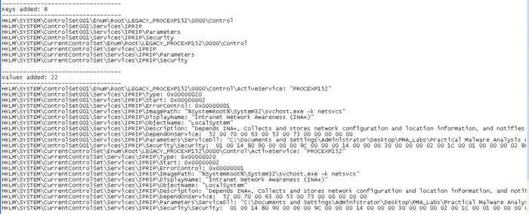

Figure 2.1 — Registry keys and values added as a result of installing Lab03–02.dll

We can see within the [regshot](https://sourceforge.net/projects/regshot/) comparison that something called IPRIP has been added as aservice, with some of the more identifiable strings as \DisplayName or \Description. Theimagepathhasalsobeensetto%SystemRoot%\System32\svchost.exe-knetsvcswhichshows the malware is likely to be launched within svchost.exe with network services as anargument.

Sincewehaveinstalledlab03–02.dll as aservice, wecan nowrun this andweseethe same

\DisplayName+updatefoundfrom theadded regvalues (Figure3.1).

Figure3.1—StartingtheIPRIPservice

Checkingout [ProcessExplorer](https://docs.microsoft.com/en-us/sysinternals/downloads/process-explorer)toseewhat’shappened,wecansearchfortheLab03–02.dll

whichwillpoint usto thesvchost.exeinstancethatwas created.

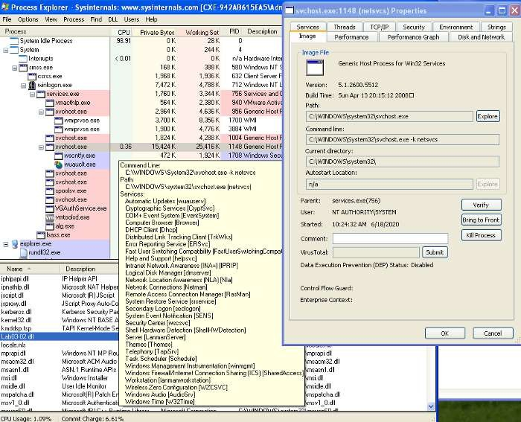

Figure3.2—ProcessExplorershowingsvchost.exelaunchedwithLab03–02.dll

WecanidentifyvariousindicatorswhichattributeLab03–02.dlltothisinstanceofsvchost.exe

thoroughtheinclusionofthe.dll,theservicedisplayname*“IntranetNetworkAwareness*

*(INA+)”*,andthecommandlineargumentmatchingwhathasbeenfoundinstrings.Thishelpsus to confirm that Lab03–02.dll has been loaded — note the *process ID, 1148*. We’ll need this toseewhat’s going on in [ProcMon](https://docs.microsoft.com/en-us/sysinternals/downloads/procmon)!

Checkingout[ProcMon](https://docs.microsoft.com/en-us/sysinternals/downloads/procmon),filteredon*PID1148*,wesee awholeloadofregistry RegOpenKey

andReadFiles,however,seemsmostlysvchost.exerelatedandnothingjumpsoutasmalicious.

Turing our attention to look for network-based indicators, we have traffic captured within[Wireshark,](https://www.wireshark.org/) as well as logged within[iNetSim](https://www.inetsim.org/). To give us an idea of what to look for, we cancheckout the[iNetSim](https://www.inetsim.org/)logsfirst (Figure5.1),which show usthat wehaveseen2 notabletypesofactivity; DNS and HTTP connections. The DNS appears to be periodic requests topracticalmalwareanalysis.com (which we previously saw similar with Lab03–01.exe), aswellasaHTTPGET requestto<http://practicalmalwareanalysis.com/serve.html>whichattempts to download a file. Fortunately, as we had[iNetSim](https://www.inetsim.org/)set up to respond, it provides adummy file to complete the request — /var/lib/inetsim/http/fakefiles/sample.html. Ifwedidn’t havethis,we might havedownloadedsomething real nasty.

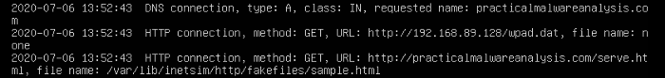

Figure5.1 —iNetSim logsof Lab03–02.dll’sDNSandHTTP request

We’reabletolookatthesewithin [Wireshark](https://www.wireshark.org/)andinspectthepacketsinmoredetail. Filteringon

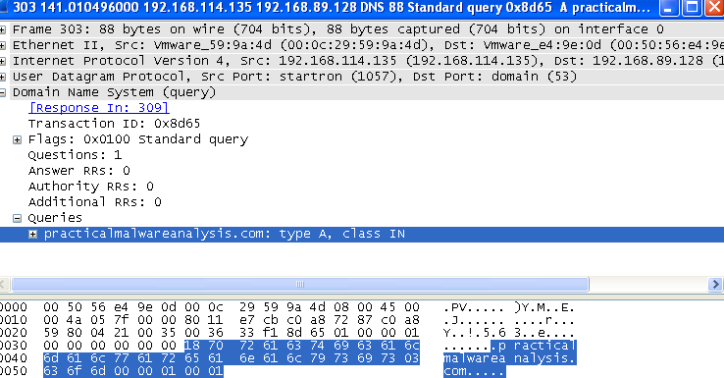DNS, we’re able to see the DNS request to practicalmalwareanalysis.com (Figure 5.2).Finding the conversation between the host and [iNetSim](https://www.inetsim.org/)and following the TCP stream, we’reable to see the content within the HTTP GET request to<http://practicalmalwareanalysis.com/serve.html>(Figure5.2).Thisalsoshows iNetSim’s dummy content replacing serve.hmtl .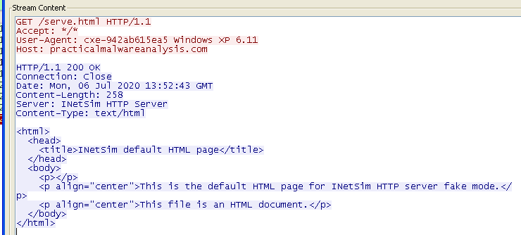

Figure5.2 —[Wireshark](https://www.wireshark.org/)trafficforLab03–02.dllDNS(left)andHTTP(right)

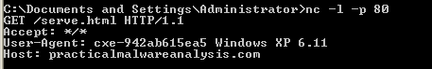

Figure5.3—[Netcat](http://netcat.sourceforge.net/)receiving HTTPGETheader

Revertingtosnapshotandreinstalling&launchingthe malicious.dll/service,wecanalsocapture traffic by using [ApateDNS](https://www.fireeye.com/services/freeware/apatedns.html)to redirect to loopback were we have a [Netcat](http://netcat.sourceforge.net/)listener on port80(Figure5.3).Here, weseethe sameHTTP GETheaderas wedid within[Wireshark.](https://www.wireshark.org/)

Referring back to the strings output, *“practicalmalwareanalysis.com”*, *“serve.html”*, and*“WindowsXP6.11”*arealsoevidentwithinthenetworkanalysisandcanbeusedassignaturesforthe malware.

Torecapon themain host/network-basedindicators wesee:

IPRIPinstalledas aservice, including strings suchas*“Intranet NetworkAwareness(INA+)”*

Networkactivityto*“practicalmalwareanalysis.com/serve.html”* aswellas theUser-Agent*%ComputerName%Windows XP 6.11.*

## G. Execute the malware found in the file Lab03-03.exe while monitoring it using basicdynamicanalysis tools in a safeenvironment

After prepping for dynamic analysis, launch Lab03–03.exe and you may notice it appearbrieflywithin[ProcessExplorer](https://docs.microsoft.com/en-us/sysinternals/downloads/process-explorer)withachildprocessofsvchost.exe.Afteramomenthowever,itdisappearsleaving svchost.exeorphaned(Figure1.1).

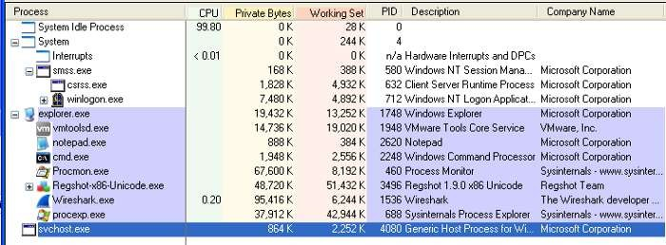

Figure1.1—Orphanedsvchost.exe

Anorphanedprocessisone with no parent listed in the process tree.svchost.exetypically hasaparentprocessofservices.exe,butthis onebeingorphanedis unusualandsuspicious.

Investigating this instance of svchost.exe, we see it has a Parent: Lab03-03.exe(904),confirmingit’scomefromexecutingLab03–03.exe.Exploringthepropertiesfurther,wedon’tseemuch anomalous until weget to the strings.

Utilizingstringswithin[ProcessExplorer](https://docs.microsoft.com/en-us/sysinternals/downloads/process-explorer)isactuallyausefultrickto analysemalwarewhichispackedor encrypted, becausethemalwareisrunning andunpacks/decodesitself whenitstarts.

We’realso abletoviewstrings in boththeimageon diskand in memory.

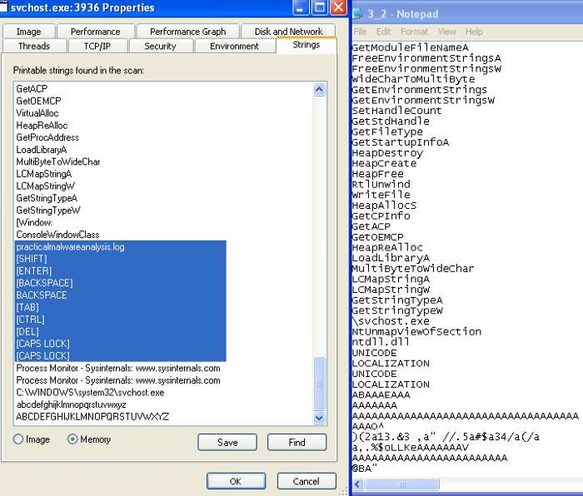

Figure 2.1 — Comparing strings in memory from process explorer and from running strings on Lab03–03.exe

Takingadvantageof this,wecaninspectthestringsin Imageandin Memory,as wellascompareagainstwhat wefoundfromstringsduring quick staticanalysis.

The strings on image appear pretty consistent with other instances of svchost.exe however,within Memory, these much greater resemble what we discovered earlier, but with a few distinctdifferences—practicalmalware.loganda setof keyboardcommands(Figure2.1).Thisis anindicatorthat thekeylogger guess might beaccurate.

To test the keylogger hypothesis, we can open something and type stuff. To target explicitlyonthemalware,filter onthe suspectsvchost.exe(PID, 3936) withinProcess Monitor, and weseeawholeloadoffilemanipulationforpracticalmalwareanalysis.log(Figure3.1).

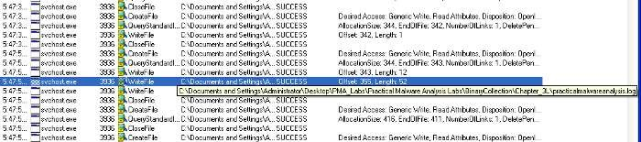

Figure3.1—ProcessMonitorfilemanipulationfrommalicioussvchost.exe

Opening practicalmalwareanalysis.log, we find that the file captures inputted stringsand distinctive keyboard commands as seen within the memory strings from[Process Explorer](https://docs.microsoft.com/en-us/sysinternals/downloads/process-explorer)(Figure 4.1). This confirms that Lab03–03.exe a keylogger using process replacement onsvchost.exe.

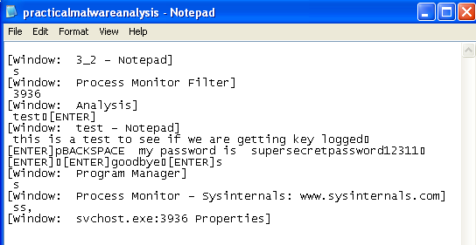

Figure4.1 —EvidenceofLab03–03.exekeylogging

## H. Analyze the malware found in the file Lab03-04.exe using basic dynamic analysis tools.

i. Whathappens when you run this file?

Whenwerunthefile. Processiscreatedwhich opensuptheCMDand thendeletedtheoriginalexecutableafter making it executeandhideitself somewhere else.

Whatiscausingtheroadblockindynamicanalysis?

Theexecutableis evasiveandtrying to evadeitself bychecking whetherthesystem isVM ornot. AV-Detection etc. Obviously this will make it difficult to observer the file via dynamicanalysis.

Arethereother waysto runthis program?

Theotherways canbeto openthis executableusing Ollydbgor IDAprowherewecananalyzeitina moreefficient way.

# PracticalNo. 2

## A. AnalyzethemalwarefoundinthefileLab05-01.dllusingonly IDAPro.Thegoalof this lab is to give you hands-on experience with IDA Pro. If you’ve alreadyworked with IDA Pro, you may choose to ignore these questions and focus onreverseengineering the malware.

[IDA Pro,](https://www.hex-rays.com/products/ida/) an Interactive Disassembler, is a disassembler for computer programs that generatesassembly language source code from an executable or a program. IDA Pro enables thedisassemblyofanentireprogramandperformstaskssuchasfunctiondiscovery,stackanalysis,localvariableidentification, in orderto understand (orchange)its functionality.

ThislabutilisesIDAtoexploreamalicious.dllanddemonstrates varioustechniquesfornavigationand analysis.Any usefulshortcuts will be identified.

### i. Whatistheaddressof DllMain?

TheaddressoffDllMainis 0x1000D02E. Thiscan befoundwithin thegraph mode,orwithin theFunctionswindow (figure2).

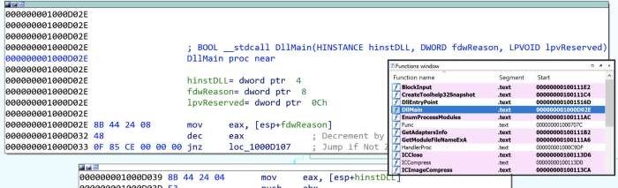Figure2:AddressofDllMain

### ii. Whereistheimportgethostbynamelocated?

gethostbynameislocated at0x100163CCwithin .idata(figure3).This isfound through theImportswindowanddouble-clickingthe function.Here wecanalsoseegethostbynamealsotakesasingleparameter— something likeastring.

Figure3:Locationofgethostbyname

### iii. Howmanyfunctionscallgethostbyname?

Searchingthe xrefs (ctrl+x)ongethostbynameshowsit is referenced 18times, 9 of which aretype (p) for the near calll, and the other 9 are read (r) (figure 4). Of these, there are 5 uniquecallingfunctions.

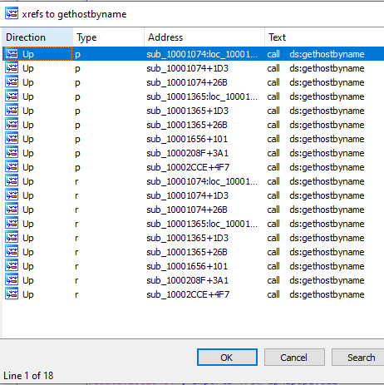

Figure4:gethostbynamexrefs

### iv. Forgethostbynameat0x10001757, whichDNSrequest ismade?

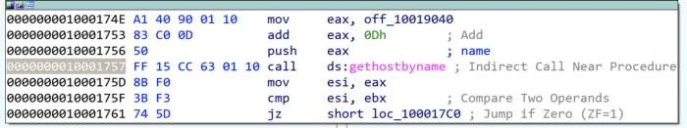Pressing G and navigating to 0x10001757, we see a call to thegethostbyname function, whichweknowtakesone parameter; in thiscase, whatever is ineax—the contents of off_10019040(figure5)

Figure5:gethostbynameat0x10001757

Thecontentsof off_10019040points to avariable aThisIsRdoPicsPwhich containsthestring

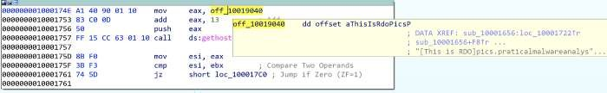[ThisisRDO]pics.practicalmalwareanalysis.com.Thisismovedintoeax(figure6).

Figure6:Contentsofoff_1001904(aThisIsRdoPicsP)

Importantly,0Dhis added toeax, which moves the pointer alongthecurrent contents.0Dhcan beconverted in IDA by pressing H, to 13. This means the eax now points to 13 characters inside ofits current contents, skipping past the prefix [This is RDO] and resulting in the DNS requestbeingmadeforpics.practicalmalwareanalysis.com.

### v&vi.How manyparametersandlocal variablesarerecognizedforthesubroutineat0x10001656?

Therearea totalof 24 variables and parameters forsub_10001656(figure7).

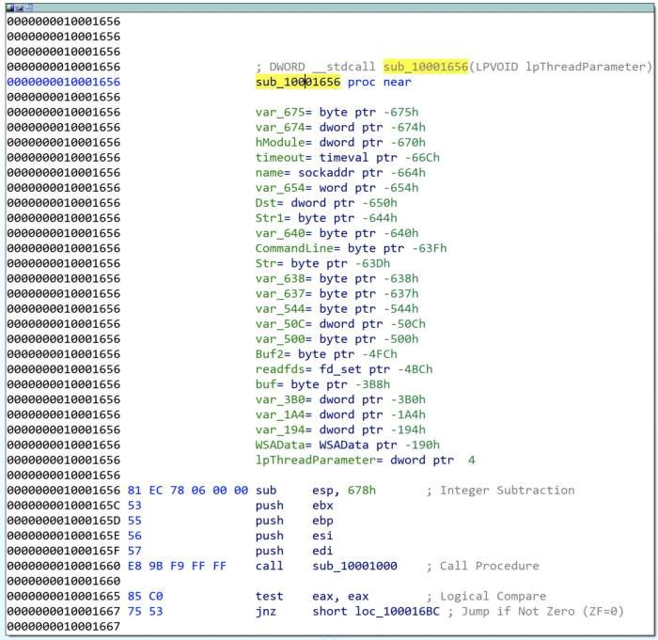

Figure7:sub_10001656parametersandvarliables

Localvariablescorrespondtonegativeoffsets,wherethereare 23. Manyaregeneratedby IDAand prepended with var_ however there are some which have been resolved, such as name orcommandline.As weworkthrough, wegenerallyrenameany of the important ones.

Parameters have positive offsets. Here there is one, currently lpThreadParameter. This mayalsobeseenas arg_0ifnot automagically resolved.

### vii. Whereisthestring\cmd.exe/c locatedin the disassembly?

PressAlt+Ttoperformastring searchfor \cmd.exe /c, which is stored asaCmdExeC, foundwithinsub_1000FF58atoffset0x100101D0(figure8).

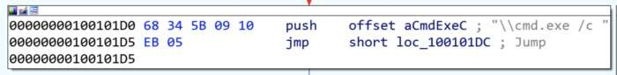

Figure8:Locationof‘\cmd.exe/c’

### viii. Whathappensaroundthereferencingof\cmd.exe/c?

Thecommandcmd.exe/copens a new instanceof cmd.exe and the/cparameter instructs it toexecute the command then terminate. This suggests that there is likely a construct of somethingtoexecute somewherenearby.

Taking a cursory look around sub_1000FF58, we see several indications of what might behappening. Look forpush offset Xforquick wins.

Towardsthetop ofthefunction,wesee an addressthat isquitetellingofwhatis happening.Theoffset aHiMasterDDDDDD called at 0x1001009Dcontains a long message which includes severalstrings relating to system time information (actually initialised just before), but more notablyreferenceto a RemoteShell(figure9).

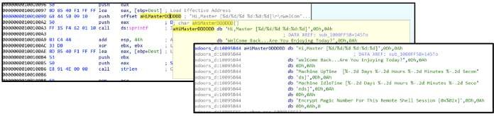

Figure9:ContentsofoffsetaHiMasterDDDDDD

Further on throughout the function, there are more interesting offset addresses with strings thatmayprovide an indication of activity.

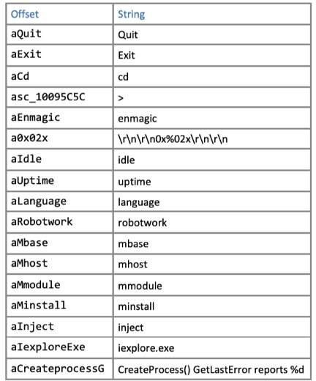

Figure10:Offsetstringswithinsub_1000FF58

Someofwhicharelikelypartofanycommandlineactivity,whereasothers maybeadditionalmodules.Some ofthe notable ones might be

aInject,aIexploreExe,andaCreateProcessG,whichcouldbeindicativeofprocessinjectionintoiexplore.exe.

### ix. At0x100101C8,dword_1008E5C4indicateswhichpathtotake.Howdoesthemalwaresetdword_1008E5C4?

Thecomparisonof dword_1008E5C4andebxwilldeterminewhether \cmd.exe/cor

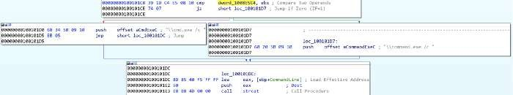\command.exe/cis pushed; likey based upontheOperating System version to utilise thecorrectcommand prompt(figure11).

Figure11:cmd.exeorcommand.exeoptions

Followingthexrefsof dword_1008E5C4,wesee it written(typew) in sub_10001656,with thevalue of eax. There is a preceding call to sub_10003695, where the function takes a look at thesystem’sVersionInformation(usingAPIcallGetVersionExA) (figure12).

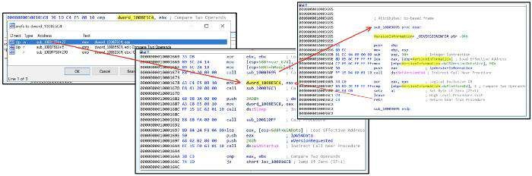

Figure12:

There is a comparison between the VersionInformation.dwPlatformId and 2, so looking atthe [Windows Platform IDs](https://docs.microsoft.com/en-us/dotnet/api/system.platformid?view=net-6.0)we see that it is looking to see if ‘The operating system is WindowsNT orlater.’Ifitis, then\cmd.exe /cis pushed. Ifnot, thenit is\command.exe /c.

### x. Whathappensifthestringcomparison torobotworkissuccessful?

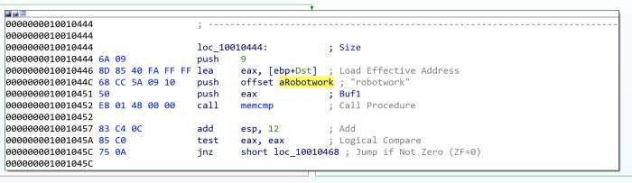Therobotworkstring comparison is completedusing thefunctionmemcmp, whichreturns 0 if thetwo strings are identical. The JNZ branch jumps if the result Is Not Zero. This means, if therobotwork comparison is successful, returning 0, then the jump does not execute (the red path).If the memcmp was unsuccessful, then some other non-zero value would be returned and the jump(greenpath) would befollowed (figure 13).

Figure13:memcmpofrobotwork

Not jumping, (and following the red path), leads to a new function sub_100052A2 whichincludesregistrykeysSOFTWARE\Microsoft\Windows\CurrentVersion WorkTime andWorkTimes. The function is looking for values within the WorkTime and WorkTimes (RegQueryValueExA)andifso,aredisplayedas part of the relevantaRobotWorktimeoffsetaddresses (via%d) (figure14).

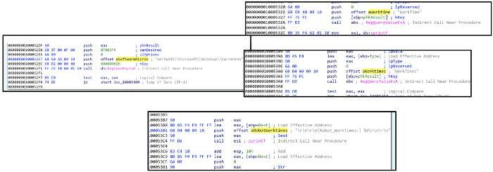

Figure14:QueryingSOFTWARE\Microsoft\Windows\CurrentVersionWorkTimeandWorkTimesregistrykeys

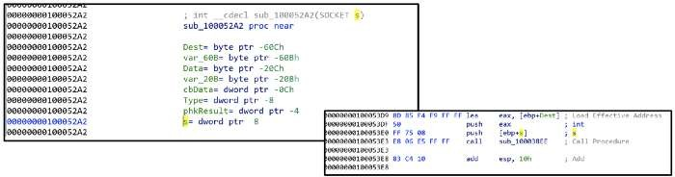Thestartofthe function takes in a parameter forSOCKETas s, which is then passed through to anewfunction (sub_100038EE)along with theregistry values(ebp) (figure15).

Figure15:PassingregistryvaluesthroughSOCKETs

Therefore, if the string comparison for robotwork is successful, the registry keysSOFTWARE\Microsoft\Windows\CurrentVersionWorkTimeandWorkTimesarequeriedandthevalues passed through (likely) theremoteshellconnection.

### xi. Whatdoestheexport PSLISTdo?

Figure16:Exportsview

Opentheexports listand findtheexported functionPSLIST. (figure16).

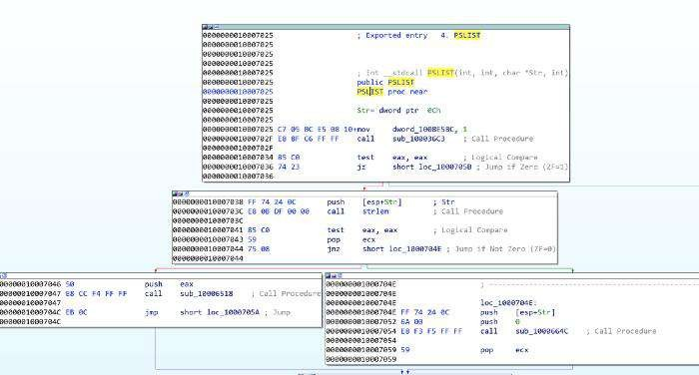Navigate here and see there are three subroutines. One of which queries OS version information(similar as seen in Q9, but this time also sees if dwMajorVersion is 5 for more specific OSfootprinting ([dwMajorVersions](https://docs.microsoft.com/en-us/windows/win32/api/winnt/ns-winnt-osversioninfoexa#remarks))), and depending on the outcome, will call either sub_10006518orsub_1000664C(figure17).

Figure17:PSLISTexportedfunctionpaths

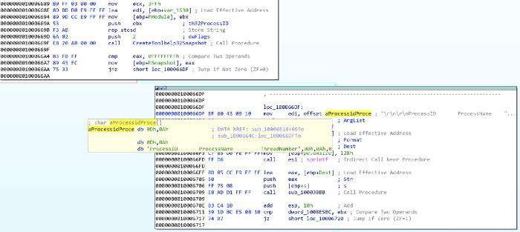Bothsub_10006518 andsub_1000664C utiliseCreateToolhelp32Snapshot totakeasnapshotofthespecifiedprocessesand associatedinformation,andthen executeappropriatecommandstoquerytherunningprocessesIDs, names,and thenumberof threads.sub_1000664Calso includesthe SOCKET(s) to send theoutput out to (figure18).

Figure18:UsingCreateToolhelp32Snapshot,queringrunningprocesses,andsendingtosocket

### xii. WhichAPIfunctionscould becalledbyenteringsub_10004E79?

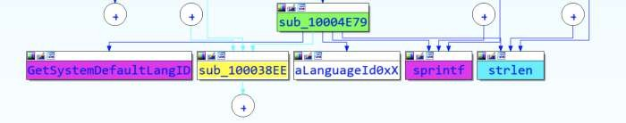Ausefulway toquicklyseewhatAPIfunctionsarecalled byacertainsubroutineis throughtheProximity Brower view, this transforms the standard Graph or Text views into a much morecondensedgraph highlightingwhich APIfunctionsorsubroutines arecalled (figure19)

Figure19:ProximityViewofsub_10004E79

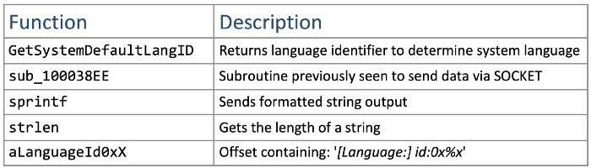

Figure20:Functionscalledbysub_10004E79

Thefunctionscalledfromsub_10004E79(figure 20) indicate that thefunctionality is to identifythe language used on the system, and then pass that information through the SOCKET (as we’veseen sub_100038EE before). It might make sense to rename sub_10004E79 to something likegetSystemLanguage. While we’re at it, we might aswell rename sub_100038EE to somethinglikesendSocket.

### xiii. HowmanyWindowsAPIfunctionsdoesDllMaincalldirectly,andhowmanyatadepth of2?

Another way to view the API functions called from somewhere, is through View -> Graphs ->UserXRefChart.Set start and end addresses toDllMainand the Recursion depth to1 to seefourAPIfunctions called (figure21).At adepth of2, thereare around32, withsomeduplicates.

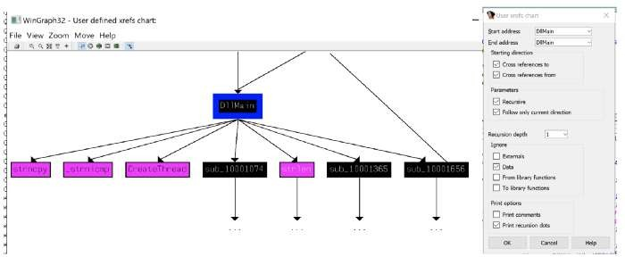

Figure21:APIfunctionscalledbyDllMain.

Some of the more notable API calls which may provide indication of functionality are: sleepwinexec gethostbyname inet_nota CreateThread WSAStartup inet_addr recv sendsocketconnectLoadLibraryA

### xiv. HowlongwilltheSleepAPIfunctionat0x10001358executefor?

Atfirstglance,one might think that thevalue passed to thesleepis 3E8h(1000), equating to 1second,however it is aimulcall which means thevalue ateaxis getting multiplied by 1000.

Lookingup,wesee thataThisIsCti30at theoffset addressis moved intoeaxand then thepointeris moved 13 along (similar to what's seenin Q2) (figure22).

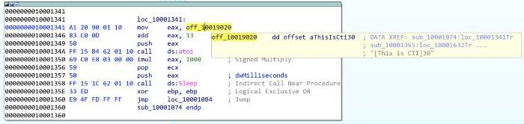

Figure22:Sleepfor30seconds

Thismeansthatthe valueof eaxwhen it is pushedis 30.atoiconverts thestring to an integer,andit ismultiplied by 1000.Therefore, the SleepAPIfunction sleepsfor30 seconds.

### xv&xvi. Whatarethethreeparametersfor thecall tosocket at0x10001701?

The three values pushed to the stack, labeled as protocol, type, and af, and are 6, 1, 2respectively,arethethreeparameters used forthecallto socket (figure23).

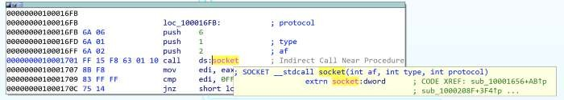

Figure23:Calltosocketat0x10001701

These depict what type of socket is created. Using [Socket Documentation](https://docs.microsoft.com/en-us/windows/win32/api/winsock2/nf-winsock2-socket)we can determine thatinthiscase, itisTCP IPV4.Atthis point,wemight aswellrenamethose operands(figure24).

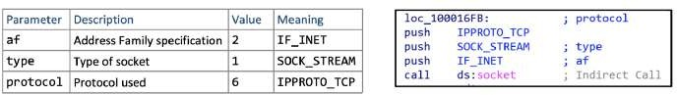

Figure24:Definitionsandrenamingofsocketparameters

### xvii. Is thereVMdetection?

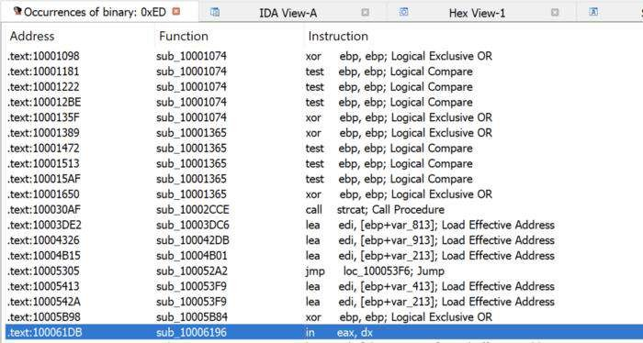

Figure25:Searchingforthe ininstructionusing0xEDin binary.

The in instruction (opcode 0xED) is used with the string *VMXh* to determine whether themalwareisrunning inside VMware.0xEDcanbesearched (alt+B)and lookfortheininstruction(figure25).

Fromhere,wecannavigateintothefunctionandsee whatisgoingonwithin sub_10006196.

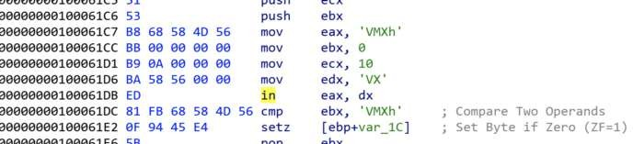

Figure26:ininstructionwithinsub_10006196

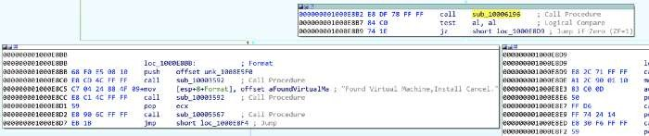Directlyaround the ininstruction, weseeevidenceofthestring VMXh(converted from originalhex value) (figure 26), which is potentially indicative of VM detection. If we look at the otherxrefs of sub_10006196 we see three occurrences, each of which contains aFoundVirtualMa,indicatingthe install is canceling ifaVirtual Machine is found (figure27).

Figure27:FoundVirtualMachinestringfoundafter*VMXhstring*

### xviii,xix, &xx. What isat 0x1001D988?

Thedatastartingat0x1001D988appearsillegible, however,wecan convertthis toASCII(bypressingA), albeit still unreadable(Figure28).

Figure28:Randomdataat0x1001D988

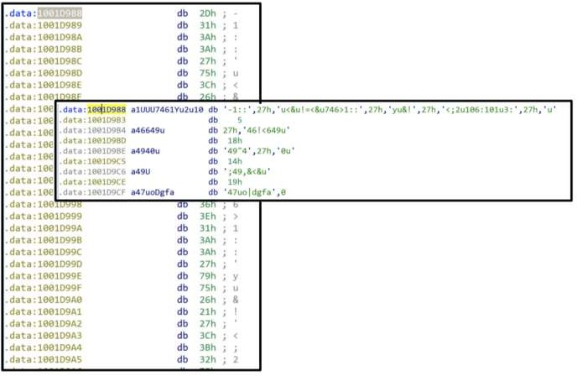We have been provided a python script with the lab lab05–01.py which is to be used as an IDApluginfora simple script. For 0x50bytes fromthecurrentcursorposition, the script performs anXORof 0x55, and prints out theresulting bytes, likely to decodethe text (figure29).

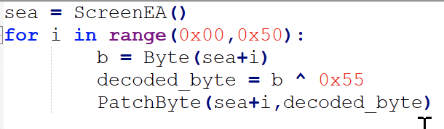

Figure29:XOR0x55script

We are unable to do this within the free version of IDA, however we can loosely do it manuallyourselvesby taking thebytes from 0x1001D988and doingXOR 0x55.

Evidently, the conversion to ASCII and manual decoding has messed up something with thecapitalisation,butwecanseesomeplaintextanddeterminethecompletedmessage(figure30)

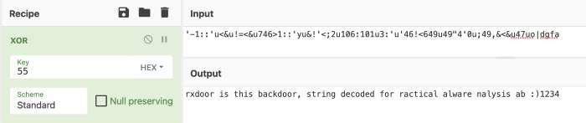

Figure30:ManualXOR0x55

## B. AnalyzethemalwarefoundinthefileLab06-01.exe.

### i. Whatisthemajorcodeconstructfoundin theonlysubroutinecalledbymain?

Before we start, it is worth noting that sometimes IDA does not recognise the main subroutine.We can find this quite quickly by traversing from the start function and finding sub_401040.Thisismainasitcontains therequiredparameters(argcand **argv).I renamed the subroutinetomain(figure1).

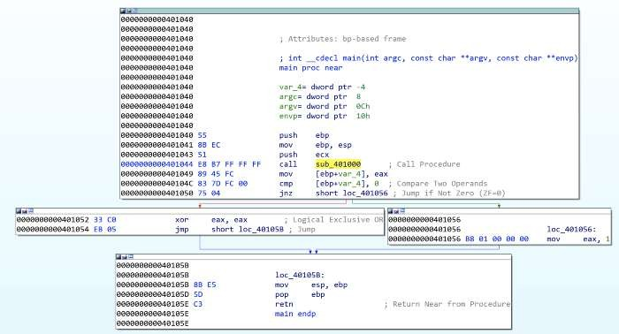

Figure1: Lab06–01|mainsubroutine

Navigatingintothefirstsubroutinecalledinmain(sub_401000)(figure2), weseeitexecutes anexternal API call InternetGetConnectedState, which returns a TRUE if the system has aninternet connection, and FALSE otherwise. This is followed by a comparison against 0 (FALSE)and then a JZ (Jump If Zero). This means the jump will be successful ifInternetGetConnectedStatereturnsFALSE(0)(Thereisno internet connection).

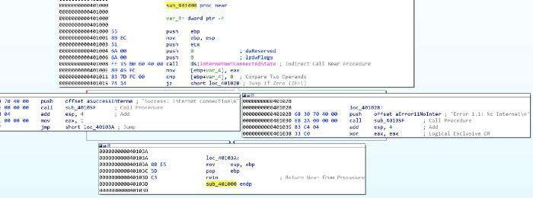

Figure2:Lab06–01|sub_401000internetconnectiontest

Therefore, the jump path (short loc_40102B) is taken and the string returned will be ‘*Error1.1:No Internet\n*’.

InternetGetConnectedStatereturnsTRUE, thenthejump is not successful,and the returned

stringis‘*Success:InternetConnection\n*’.

Baseduponthis, itcanbedeterminedthatthe majorcodeconstruct isabasicIfStatement.

### ii. Whatisthesubroutinelocatedat0x40105F?

Giventheproximitytothestringsat theoffsetaddressesineachpath,it canbeassumedthatsub_40105Fisprintf,afunction usedto print textwith formatting (supportedby the*\n*fornewline inthe strings).

IDA didn’t automatically pick this up for me, but with some cross-referencing and looking intowhatwewould expect asparameters, wecan besafein theassumption.

### iii. Whatisthepurposeofthisprogram?

Lab06–01.exe is a simple program to test for internet connection. It utilises API callInternetGetConnectedStateto determine whether there is internet,andprintsan advisorystringaccordingly.

## C. Analyzethemalwarefoundinthefile*Lab06–02.exe*.

### i&ii.Whatoperationdoesthefirstsubroutine calledbymainperform?Whatisthesubroutinelocated at 0x40117F?

This is very similar to Lab06–01.exe. We can easily find the main subroutine again (this timesub_401130), and again we see the first subroutine called is sub_401000. This is very similar asitcallsInternetGetConnectedStateandprints theappropriatemessage(figure3).Wealso canverifythat 0x40117Fis still theprintf function, which I’verenamed.

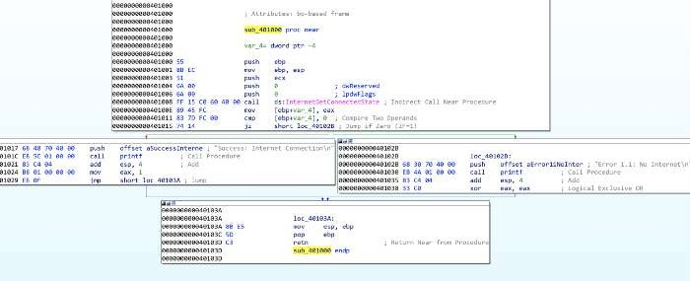

Figure3:Lab06–02 |sub_401000internetconnectiontest&sub_40117F(printf)

### iii. Whatdoesthesecondsubroutinecalledbymaindo?

Thisissomething new now; the mainfunction in lab06–02.exeis a littlemorecomplex with anadded subroutine and another conditional statement (figure 4). We can see that sub_401040 isreachedbytheprecedingcmpto 0being successful (jnzjump if not0), which therefore meanswe’re hopingfor thereturnedvaluefromsub_401000to be not 0— indication thereISinternetconnection.

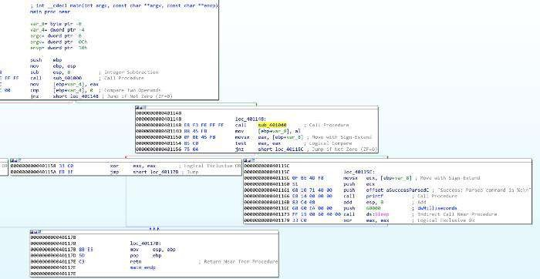

Figure4: Lab06–02|mainsubroutine

Navigating to sub_401040, we immediately see some key information, which supports thedeterminationthat this occurs ifthereis an internetconnection.

Themoststand-outinformationisthetwoAPIcalls,InternetOpenAandInternetOpenUrlA,which are used to initiate an internet connection and open a URL. We also see some strings atoffsetaddresses just beforethese, indicating these arepassed to theAPIcalls (figure5).

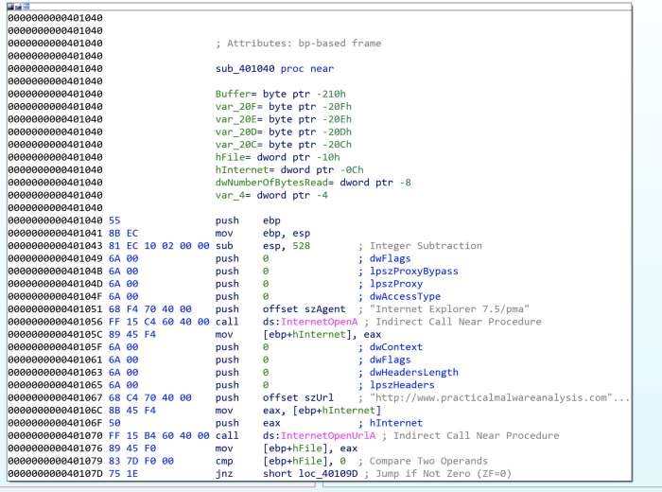

Figure5:Lab06–02|InternetconnectionAPIcallsandstrings

First,szAgentcontainingstring “*Internet Explorer7.5/pma*”, which isaUser-Agent String,ispassedto InternetOpenA.

szUrlcontainsthestring “[*http://www.practicalmalwareanalysis.com/cc.htm*](http://www.practicalmalwareanalysis.com/cc.htm)”whichis theURL

forInternetOpenUrlA.

Thishasanotherjnzwherethe jumpis not takenifhFilereturnedfrom InternetOpenUrlAis 0(meaning no file was downloaded), where a message is printed “*Error 2.2: Fail to ReadFile\n*”andthe internet connection is closed.

### iv. Whattypeofcodeconstructisusedin sub_40140?

If szURl is found, the program attempts to read 200h (512) bytes of the file (*cc.htm*) using theAPI callInternetReadFile(thejnzunsuccessfulpath leadsto “*Error2.2: Failto ReadFile\n*”printedand connections closed)(figure6).

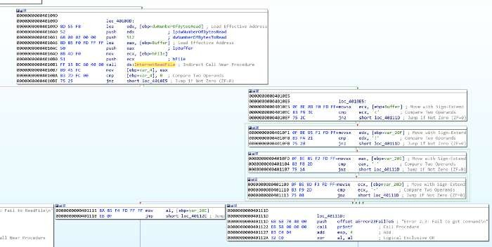

Figure6: Lab06–02|Readingfirst 4 bytes ofcc.htm

Therearethenfourcmp/jnzblocks whicheach comparing a single bytefrom theBufferandseveral variables. These may also be seen as Buffer+1, Buffer+2, etc. This is a notable codeconstructinwhichacharacterarrayisfilledwithdatafromInternetReadFileandisreadonebyone.

These values have been converted (by pressing R) to ASCII. Combined these read <!--,indicative of the start of a comment in HTML. If the value comparisons are successful, thenvar_20C (likely the whole 512 byes in Buffer, but just mislabeled by IDA) is read. If at anypoint a byte read is incorrect, then an alternative path is taken and the string “*Error 2.3: Fail togetcommand\n*”is printed.

Lookingbackatmain,ifthisallpasseswithnoissues,thestring“*Success: Parsedcommandis*

*%c\n*” isprintedand the systemdoesSleepfor60000 milliseconds (60seconds) (figure7).Thecommand printed (displayed through formatting of %c is variable var_8) is the returned valuefromsub_401040, the contents of *cc.htm.*

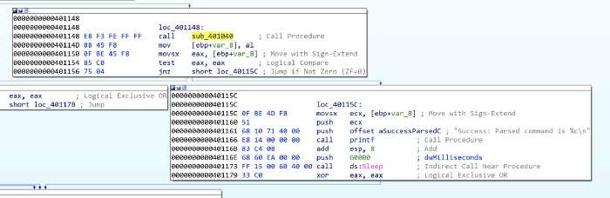

Figure7:Lab06–02|Reporting successfulreadof commandand sleepingfor60seconds

### v. Arethereany network-basedindicatorsforthisprogram?

The key NBIs (network-based indicators) from the program are the user-agent string and URLfound relatedtotheInternetOpenAand InternetOpenUrlAcalls;*Internet Explorer 7.5/pma*and[*http://www.practicalmalwareanalysis.com/cc.htm*](http://www.practicalmalwareanalysis.com/cc.htm)

### vi. Whatisthepurposeof thismalware?

Very similar to Lab06–01.exe, Lab06–02.exe tests for internet connection and prints anappropriatemessage.Uponsuccessfulconnection,however,theprogramthenattemptstodownloadandread thefilefrom[*http://www.practicalmalwareanalysis.com/cc.htm.*](http://www.practicalmalwareanalysis.com/cc.htm)

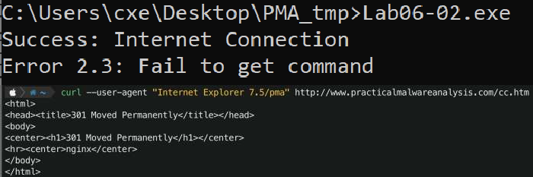

Figure8:Lab06–02.exe |Testedexecution

Upontesting,this fileisnotavailableon theserver. Theprogram didnotsuccessfully readtherequiredfirst 4 bytes thereforean errormessagewas printed (figure8).

## D. Analyzethemalwarefoundinthefile*Lab06–03.exe*.

### i. Comparethecalls inmain to Lab06–02.exe’smainmethod. Whatisthenewfunction

calledfrom main?

For both executables, I have renamed all of the functions that we have already analysed. Thedifferentiatorbetweenthetwoisanadditionalfunctiononceinternetconnectionhasbeentested,the file has been downloaded, and the successful parsing of the command message has beenprinted— sub_401130(figure9).

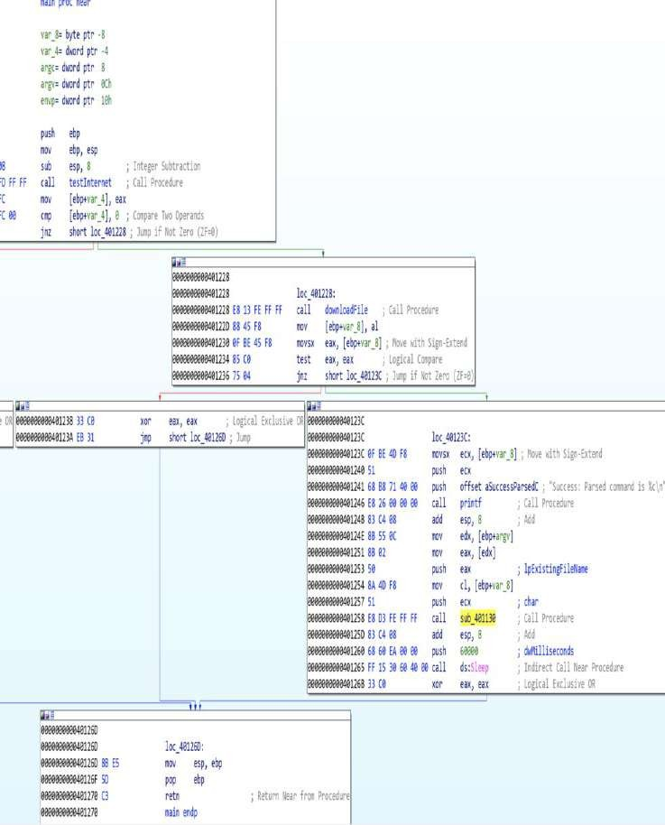

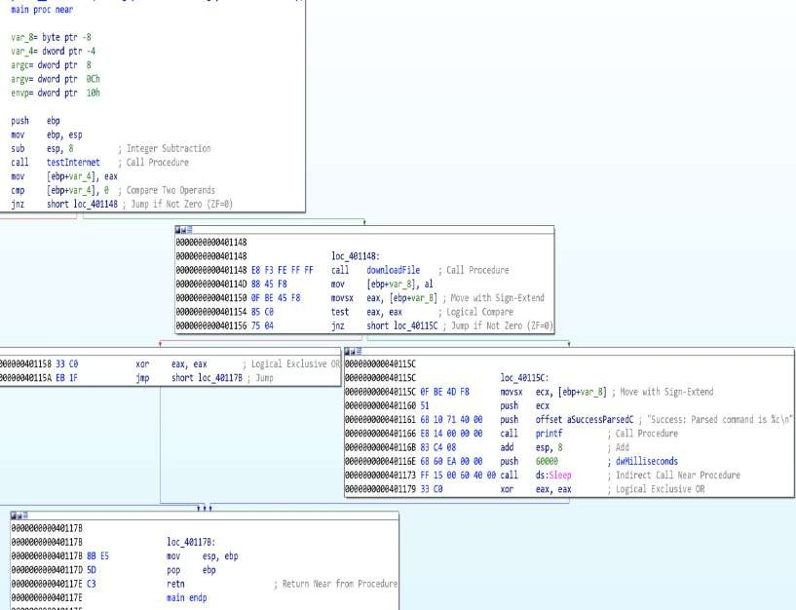

Figure 9: Lab06–03.exe | Comparisons of Lab06–03.exe (left) and Lab06–02.exe (right) mainfunctions

### ii. Whatparametersdoesthisnewfunctiontake?

sub_401130 takes 2 parameters. The first is char, the command character read from[*http://www.practicalmalwareanalysis.com/cc.htm*](http://www.practicalmalwareanalysis.com/cc.htm)and lpExistingFileName (a long pointer to acharacter string, ‘Existing File Name’, which is the program’s name ( Lab06–03.exe) (figure 10).These wereboth pushedonto thestack as part of themainfunction.

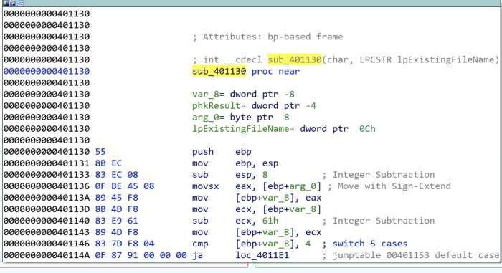

Figure10:Lab06–03.exe |sub_401130parameters.

### iii. Whatmajorcodeconstructdoesthisfunctioncontain?

IDA has helpfully indicated that the major code construct is a five-case switch statement byaddingcommentsfor'switch5cases'andthe'jumptable00401153defaultcase'.Wehave previously seen similar cmp which are if statements, however, in this case, there is apossibility of five paths. We can confirm this in the flowchart graph view, where there are fiveswitchcases and onedefault case(figure11).

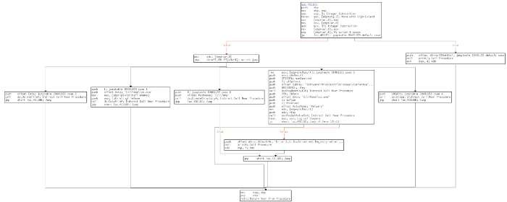

Figure11:Lab06–03.exe|sub_401130flowchart

### iv. Whatcanthisfunctiondo?

Thefiveswitchcasesareas follows(figure12):

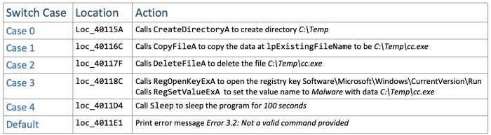

Figure12:Lab06–03.exe |sub_401130switchcases

Dependingon thecommand provided(0–4) theprogram will executetheappropriateAPIcallstoperform directory operations or registry modification. lpExistingFileName is the current file,Lab06–03.exe*.* Setting the registry keySoftware\Microsoft\Windows\CurrentVersion\Run\Malware withfileC:\Temp\cc.exe isamethodofpersistenceto execute themalwareon system startup.

### v. Arethereanyhost-basedindicatorsforthismalware?

The key HBIs (host-based indicators) are the file written to disk (C:\Temp\cc.exe), and theregistry key used for persistence ( Software\Microsoft\Windows\CurrentVersion\Run /vMalware| C:\Temp\cc.exe)

### vi. Whatisthepurposeof thismalware?

Following on from the functionality of the simpler Lab06–01.exe and Lab06–02.exe, Lab06–03.exe also tests for internet connection and prints an appropriate message. The programattempts to download and read the file from [*http://www.practicalmalwareanalysis.com/cc.htm*](http://www.practicalmalwareanalysis.com/cc.htm)*.*The program then has a set of possible functionalities based upon the contents of *cc.htm* and theswitchcode construct to perform one of:

CreatedirectoryC:\Temp

Copythecurrentfile(Lab06–03.exe)toC:\Temp\cc.exe

Setthe Runregistry keyasMalware | C:\temp\cc.exeforpersistence

DeleteC:\Temp\cc.exe

Sleeptheprogramfor100seconds

## E. AnalyzethemalwarefoundinthefileLab06-04.exe.

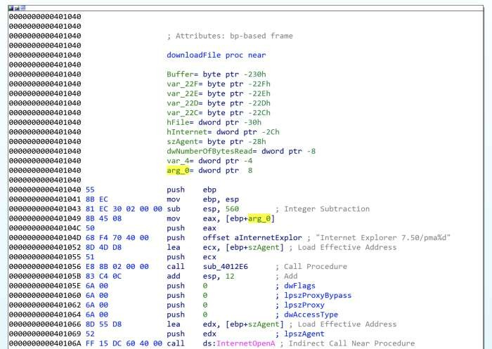

### i. What is the difference between the calls made from the main method in Lab06–03.exeandLab06-04.exe?

Figure13:Lab06–04.exe|Modified downloadFilefunctionwitharg_0

Of the subroutines called from main we have analysed (renamed to testInternet, printf,downloadFile, and commandSwitch) only downloadFile has seen a notable change. TheaInternetExploraddress contains thevalue *Internet Explorer7.50/pma%d*forthe user-agent(szAgent) which includes an *%d* not seen previously, as well as a new local variable arg_0(figure13).

Thisinstructsthe printffunctionto takethe passed variablearg_0as anargument andprint asan int. The variable is a parameter taken in the calling of downloadFile , donated by IDA asvar_C(figure14).

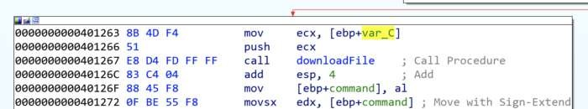

Figure14:Lab06–04.exe |VariablepassedtodownloadFile

SomeofthecalledsubroutineshavedifferentmemoryaddressestowhatwesawinthepreviousLab06–0X.exes, dueto the mainfunction being somewhat morecomplexand expanded.

### ii. Whatnewcodeconstructhasbeenaddedtomain?

mainhasbeendevelopeduponto include a forloopcodeconstruct,as observedin theflowchartgraph view(figure15).

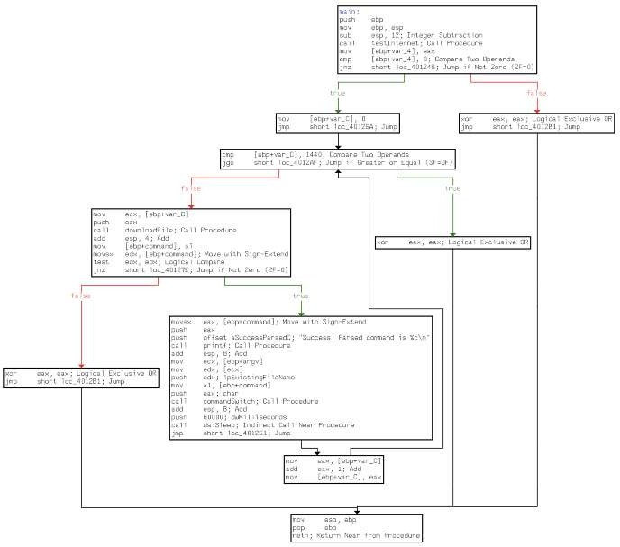

Figure15:Lab06–04.exe |Forloopwithinmain

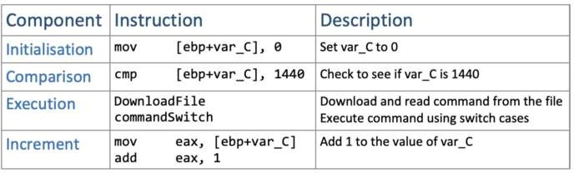A forloopcode construct contains fourmain components— initialisation, comparison,execution, and increment. All of which areobserved withinmain(figure16):

Figure16:Lab06–04.exe |Forloopcomponents

### iii. Whatisthedifferencebetweenthislab’sparseHTMLfunctionand thoseofthepreviouslabs?

As previously identified, the parse HTML function (downloadFile) now includes a passedvariable.Havinganalysedthisand main,wecandeterminethatitistheforloop’scurrentconditional variable (var_C) value which is passed through to downloadFile’s user-agent*InternetExplorer 7.50/pma%d*,as arg_0asthis will incrementby 1 eachtime, it maypotentiallybeused to indicate howmany times it has been run.

### iv. Howlongwillthisprogramrun?

(AssumethatitisconnectedtotheInternet.)Thereareseveral aspectsofmain’sforloopwhichcan help usroughly work howlong theprogramwillrun. Firstly,weknow that thereis aSleepfor60 seconds,after thecommandSwitchfunction. We also knowthat theconditionalvariable (var_C)is incrementedby1each loop. (Figure17).

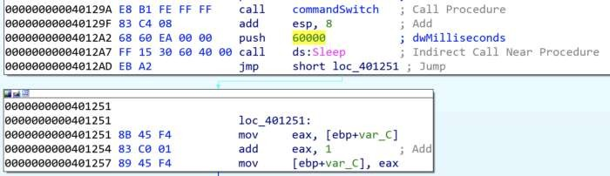

Figure16:Lab06–04.exe|Sleepfunctionandforloopincrement

Theforloopstarts var_Cat 0, and willbreak theloop onceit reaches 1440. This meansthatthere are 1440 60second loops, equalling 86400 seconds (24hours). The program may run forlongerifthe command instructsthe switchwithin commandSwitchtosleep for100secondsatanyofthe 1440 iterations.

### v. Arethereanynewnetwork-basedindicatorsforthismalware?

Theonlynew NBIfor Lab06–04.exeis theaInternetExplor“*Internet Explorer 7.50/pma%d”*,

with“[*http://www.practicalmalwareanalysis.com/cc.htm*](http://www.practicalmalwareanalysis.com/cc.htm)”astheother,alreadyknown,indicator.

### vi. Whatisthepurposeof thismalware?

Lab06–04.exe is the most complex of the four samples, where a basic program to check forinternet connection has been developed into an application that connects to a C2 domain toretrieve commands andperform specificactions onthehost.Themalwareruns foraminimumof24hrs or at least makes 1440 connections to the C2 domain with 60-second sleep intervals. Thefunctionality of the malware allows it to copy itself to a new directory, set it as autorun forpersistenceby modifyingaregistry, deletethe new file, or sleepfor100 seconds.

# PracticalNo. 3

## A. AnalyzethemalwarefoundinthefileLab07-01.exe.

### i. Howdoesthisprogramensurethatitcontinuesrunning(achievespersistence) whenthecomputeris restarted?

Creates a service named “Malservice”. Establishes connection to the service control manager(OpenSCManagerA)—requiresadministratorpermissions,thengetshandleofcurrentprocess(GetCurrentProcess), gets File name (GetModuleFileNameA). Creates the service named“Malservice”wich autostarts eachtime. (CreateServiceA)

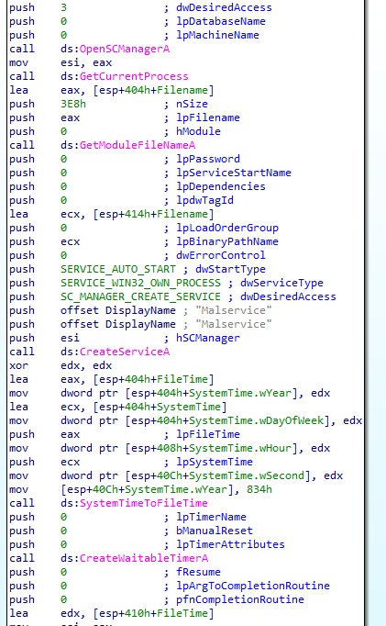

### ii. Whydoesthisprogram useamutex?

Program uses mutex to not reinfect the same machine again. Opens mutex (OpenMutexA) withthe name “HGL345” with MUTEX_ALL_ACCESS. If instance is already created, terminatesprogram,otherwisecreates one.

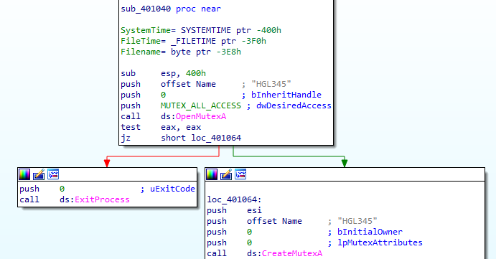

### iii. Whatis agoodhost-basedsignaturetouse fordetecting thisprogram?

Host-basedsignatureare mutex“HGL345”andservice“Malservice”,whichstartstheprogram.

### iv. Whatis agood network-basedsignaturefordetecting this malware?

UserAgentis“InternetExplorer8.0”goodnetwork-basedsignatureandconnectsto server

“[http://www.malwareanalysisbook.com](http://www.malwareanalysisbook.com/)"forinfinity time.

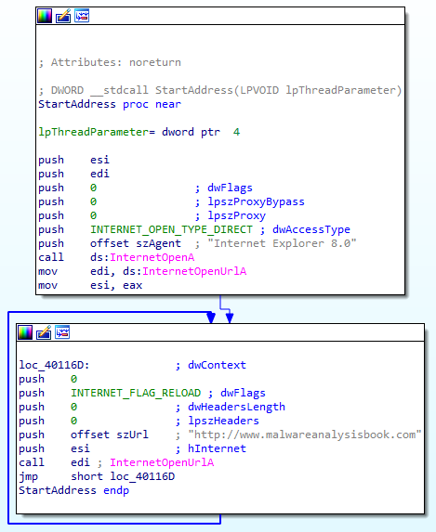

### v. Whatisthepurposeof thisprogram?

Program is designed to create the service for persistence, waits for long time till 2100 years,creates thread, which connects to “[http://www.malwareanalysisbook.com](http://www.malwareanalysisbook.com/)" forever, this loopneverends.Therest codeisnot accessed:20times calls thread,whichconnectsto webpageandsleeps for 7.1 week long before program exits. Infinitive loop is created to DDOS attack thepage. Attacker is only able to compromised the web page if has more resources than hostingprovidercan handle.

### vi. Whenwillthisprogram finishexecuting?

Programwillwait2100Yearstofinish.ThistimerepresentsmidnightonJanuary1,2100.

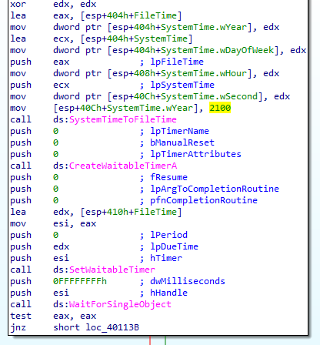

Creates new thread (CreateThread), important argument is lpStartAddress, which indicates thestartofthethreadandconnectstointernet(described atparagraph4)for20times.Thensleepsforenormous time ~7.1week andexits the program.

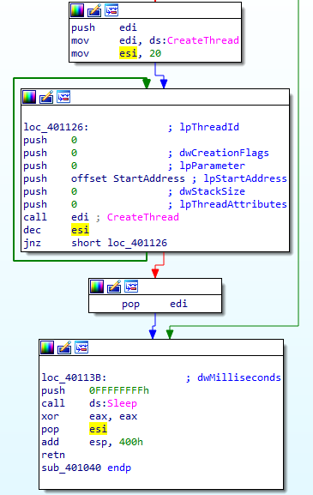

## B. AnalyzethemalwarefoundinthefileLab07-02.exe.

### i. Howdoesthisprogram achievepersistence?

Programdoesn’tachievepersistance. InitializesCOMobject(OleInitialize)createssingleobjectwithspecified clsid (CoCreateInstance).

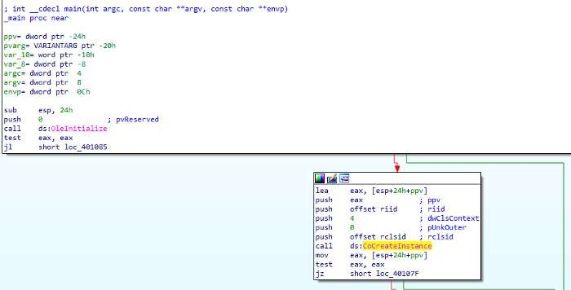

IDAPROrepresentsrclsidandriidlikethis:

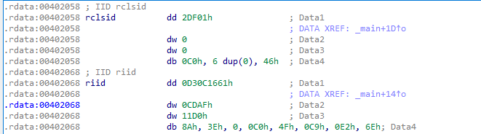

There are two ways to get GUID value of rclsid andriid.Conversion through size representation:dd (dword — 4 bytes)0002DF01

dw0-0000

dw0-0000

dbC0(takesonly1byte)

00000046GUIDformatis{8–4–4–12}IfwewriteasGUIDweget:

{0002DF01–0000–0000-C000–000000000046}Hereisanotherway:The

interval of value rclsid is from [402058–402068). If weeliminate image base (40 0000), we get the interval [2058–2068)or [2058–2067] (we don’t want to take byte which belongs toothervalue).

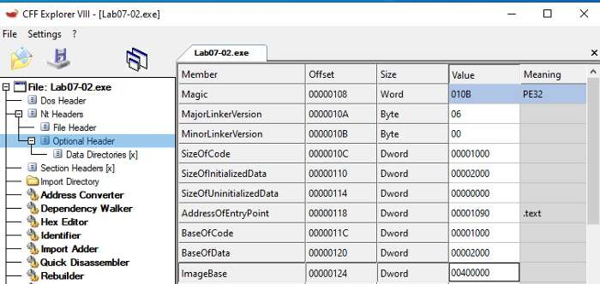

CFFExplorershowingtheImageBase

IuseHxDtoselecthexbytesEdit->Selectblock…

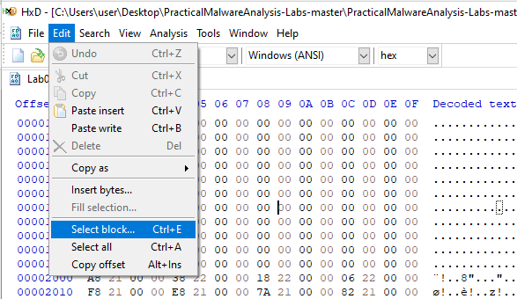

Settheranges:

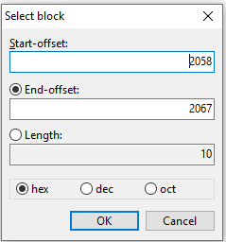

“Datainspector”viewshowsrclsid—GUIDvalue(ByteordershouldbesettoLittleEndian):

{0002DF01–0000–0000-C000–000000000046}

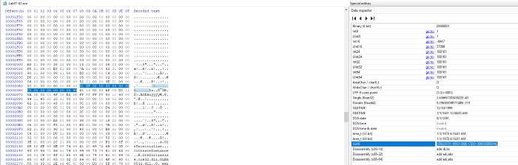

If we do the same for riid we get {D30C1661-CDAF-11D0–8A3E-00C04FC9E26E}

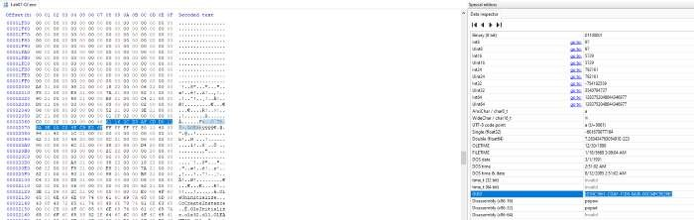

These registry keys will show clsid and riidmeanings:HKEY_CLASSES_ROOT\CLSID\ andHKEY_CLASSES_ROOT\Interface\P.S.HKEY_CLASSES_ROOT(HKCR)isa

[shortcut](https://docs.microsoft.com/en-us/windows/win32/sysinfo/hkey-classes-root-key)ofHKLMandHKCU,butinourcaseitdoesn’t

matter.HKEY_CLASSES_ROOT\CLSID\{0002DF01-0000-0000-C000-

000000000046}showsthatCLSIDbelongstoInternetExplorer(Ver1.0).

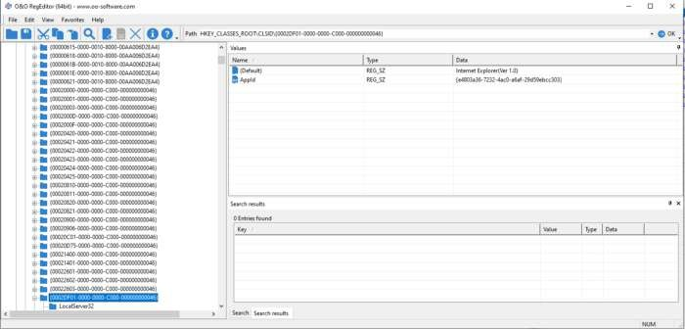

HKEY_CLASSES_ROOT\Interface\{D30C1661-CDAF-11D0-8A3E-

00C04FC9E26E}andtheinterfaceisIWebBrowser2.

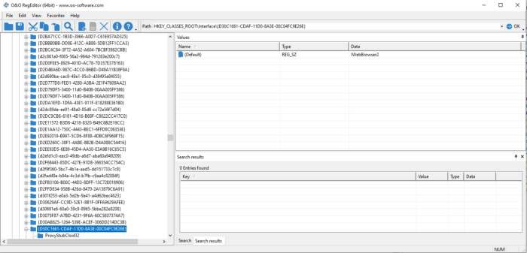

More info about could be found [here](https://repo.zenk-security.com/Reversing%20.%20cracking/Reversing%20Encrypted%20Callbacks%20and%20COM%20Interfaces.pdf).After execution ofCoCreateInstanceoneofarguments*\*ppv*containstherequestedinterfacepointer.

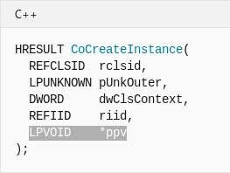

Pointer *ppv is moved to eax. which is later de-referenced(pointertoobject).

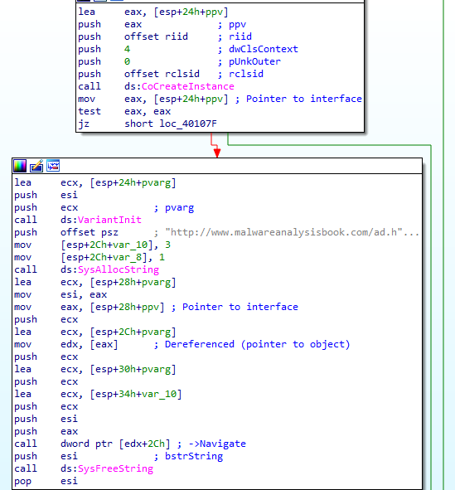

Fromde-referencedobject2Chisadded(44indec).

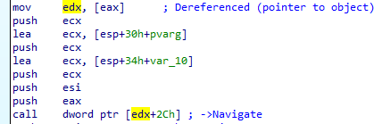

StructureofIWebBrowser2,canbefound[here](https://wasm.in/threads/kak-programmno-vvesti-nik-i-parol-cherez-interfejs-iwebbrowser2.32326/).

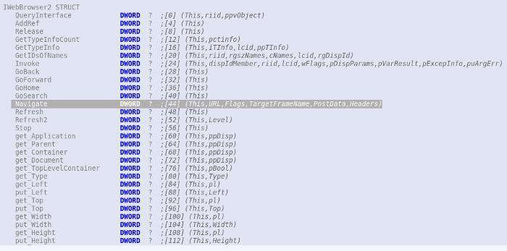44meansNavigatemethodiscalled.

### ii. Whatisthepurposeof thisprogram?

ProgramjustopensInternetexplorerwithanadvertisement.

“[http://www.malwareanalysisbook.com/ad.html.”](http://www.malwareanalysisbook.com/ad.html)

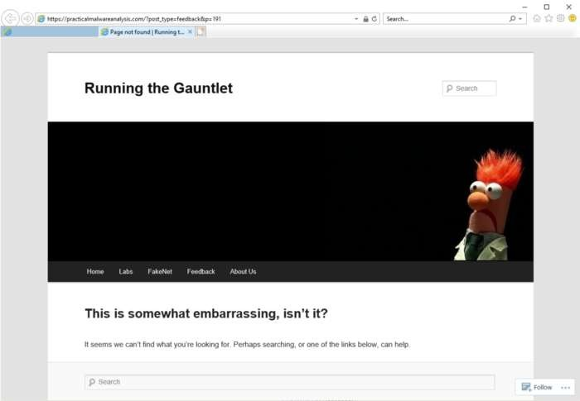

### iii.Whenwillthisprogram finishexecuting?

Aftersomecleanupfunctions:SysFreeStringandOleUninitialize

programterminates.

## C. For this lab, we obtained the malicious executable, Lab07-03.exe, and DLL,Lab07- 03.dll, prior to executing. This is important to note because the mal-ware might change once it runs. Both files were found in the same directoryon the victim machine. If you run the program, you should ensure that bothfiles are in the same directory on the analysis machine. A visible IP stringbeginning with 127 (a loopback address) connects to the local machine. (In thereal version of this malware, this address connects to a remote machine, butwe’veset it to connect to localhost to protect you.)

### i.Howdoesthisprogram achievepersistencetoensurethatitcontinuesrunningwhenthecomputeris restarted?

Persistenceisachievedbywritingfileto

“C:\Windows\System32\Kerne132.dll”

andmodifyingevery".exe"filetoimportthatlibrary.

### ii. What are two good host-based signatures for this malware?

Good host-based signatures are:“C:\\Windows\\System32\\Kerne132.dll”

Mutexname“SADFHUHF”

### iii. Whatisthepurposeofthisprogram?

Dynamic analysisExecute program with correctargument:"WARNING_THIS_WILL_DESTROY_YOUR_MACHINE"

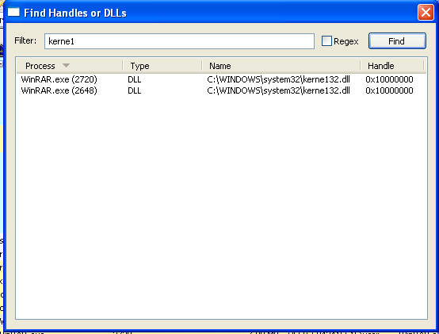modifies"WinRAR.exe"inmycase.

Library"kerne132.dll"isreplacedinsteadof"kernel32.dll"toexecutable.

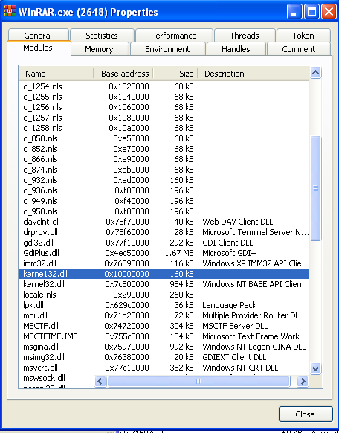

Using API Monitor from [Rohitab](http://www.rohitab.com/apimonitor)we identify what is it doing:Searchingforexecutables".exe"inCdrive.

If found opens it, Creates file mapping object, opens it inmemory, searches if import is "kernel32.dll". Replaces with"kerne1.dll"Unmapsfrommemory.Closeshandles.

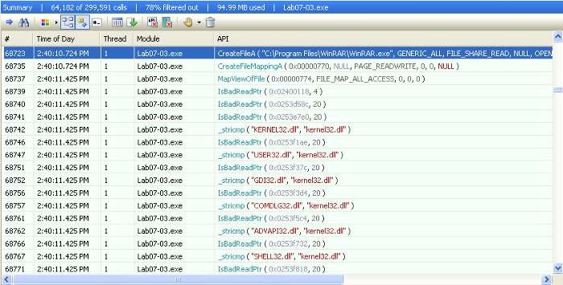

Ifanyofexecutable(notinmemory)isopenedin“PEStudio”,we

seethereonly“kerne132.dll”libraryisimported.

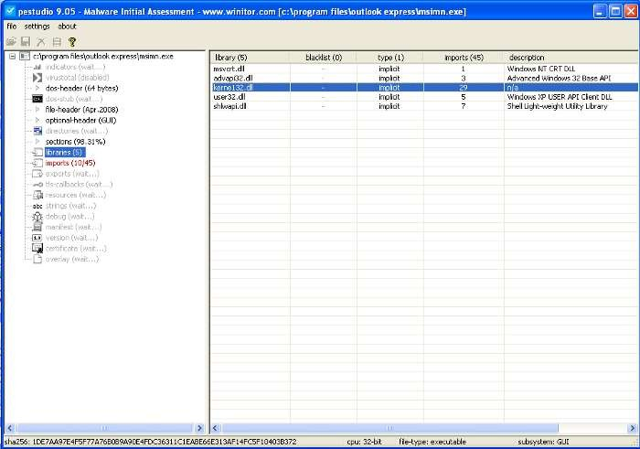

StaticanalysisExecutableislaunchedwiththisparameter

“WARNING_THIS_WILL_DESTROY_YOUR_MACHINE”

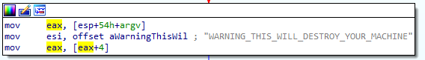

Opens file “C:\\Windows\\System32\\Kernel32.dll” (CreateFileA) withreadpermissions(File_Share_ReadandGenericread).Createsmappingobject (CreateFileMappingA with Page_Readonly permissions) for thisfile.Thismappingobjectisusedtomap(copy)intothememory.

Opens another file (CreateFileA in FILE_SHARE_READ mode) “Lab07–03.dll”.Exitsiffailedtoopenthelibrary(Lab07–03.dll).

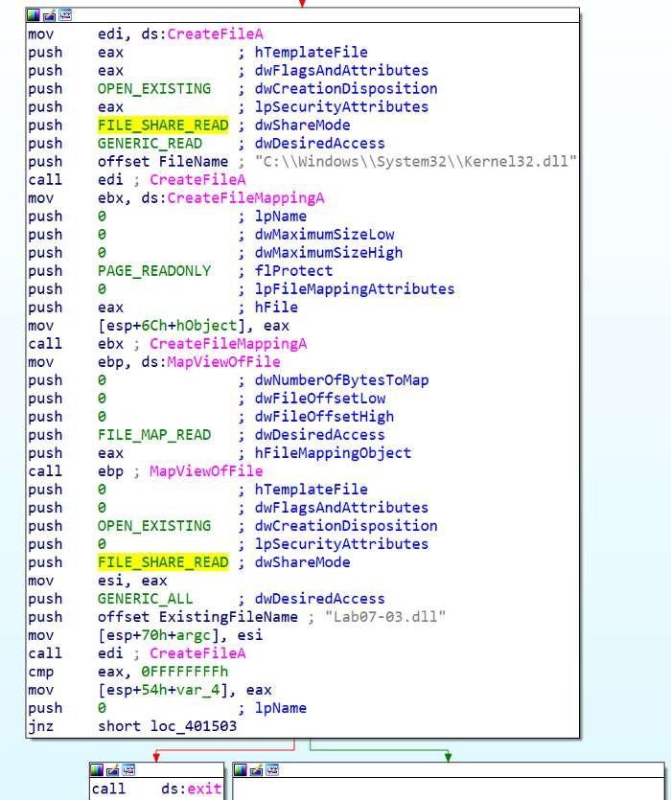

Creates file mapping object of the library "Lab07-03.dll"(CreateFileMappingAwithPAGE_READWRITEprotection).Mapsthisobjectin to the memory (MapViewOfFile with FILE_MAP_ALL_ACCESS). Exits iffailedtomap.

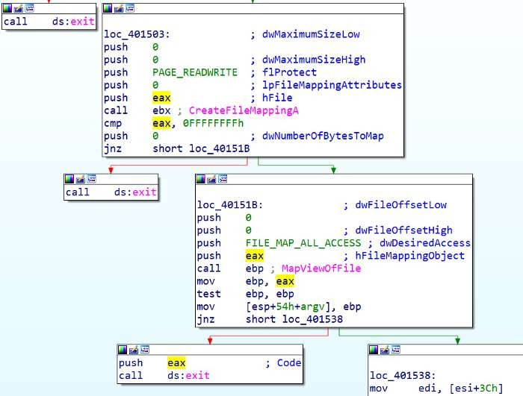

Closes both handles of libraries. Copies file “Lab07–03.dll” to “C:\\windows\\system32\\kerne132.dll”(looks like original, except ”l” letter is misspelled as number “1”). Zero and string “C:\\*” is passed asargsto anotherfunction. *means allfiles locatedin Cdirectory.

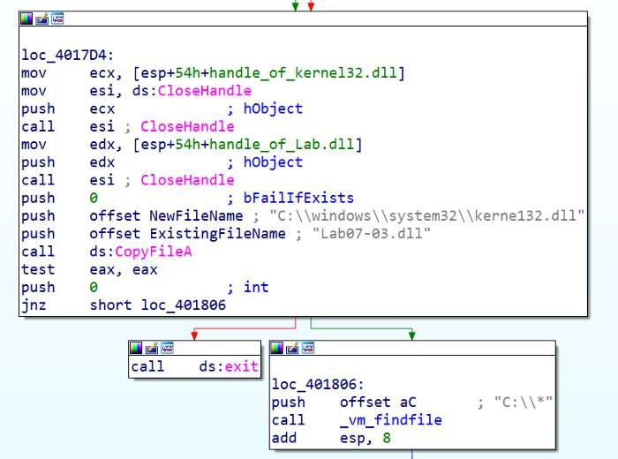

Searches forthefirstfile orfolder(FindFirstFileA).Checksiffileattribute isdirectory(FILE_ATTRIBUTE_DIRECTORY).

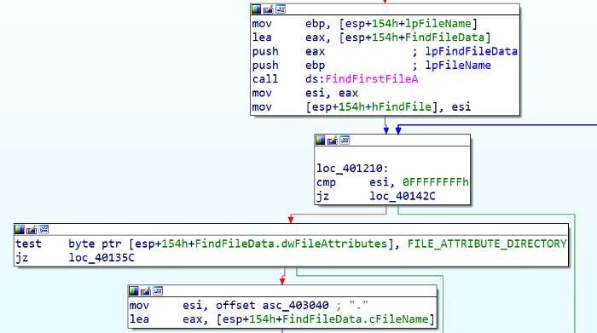

Callsfunction_mv_mapfile.

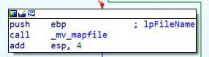

Ifnotthedirectorychecksiffilenameisequalto“.”(current

directory).

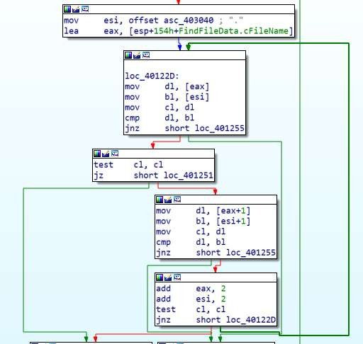

Alsocomparesifitisrootdirectory(“..”)

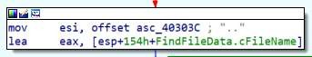

Explanation:

Ifyouenter“dir”commandin“cmd.exe”seeonedot(current

directory)andtwodots(rootdirectory).

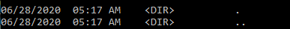

For example if current directory is “C:\WINDOWS\system32”, thenroot dir is “C:\WINDOWS”.Also compares if it is root directory(“..”)

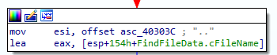

lea edi, [esp+154h+FindFileData.cFileName] ; edi points to filename

orecx,0FFFFFFFFh;cleverwaytosetecxto-1

xoreax,eax;seteaxregistertozero

repne [scasb](https://www.aldeid.com/wiki/X86-assembly/Instructions/scasb); repeat if eax and edi are not equal to null. Eachcycleecxisdecremented,untillitfindsnullsymbolattheendofstring.

not ecx ; inverts negative number to positive. Have stringlength+1(nullbyte)

dececx;stringlength

All these [assembly](http://www.int80h.org/strlen/) instruction do the same as [strlen](http://www.cplusplus.com/reference/cstring/strlen/) inc++.Allocatesspaceforfilenameinmemory(malloc).

Checksiffileextensionis“.exe”.

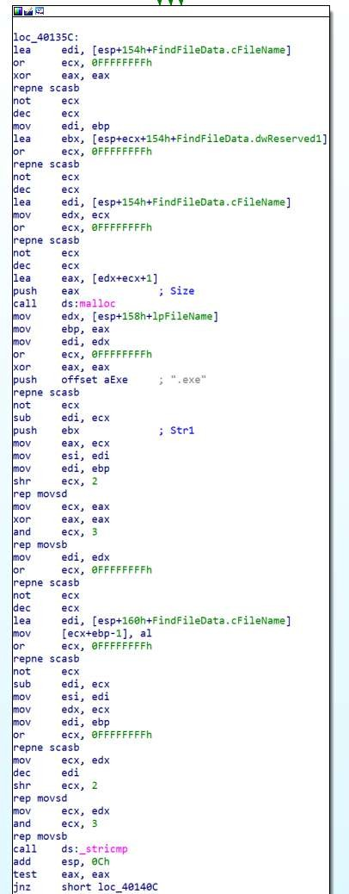

When enumerates all files in the directory it pushes anotherstring “\\*” and calls the same function again (recursivefunction).Entersthesubfolderandrepeatenumerationprocess.FindallexecutablefilesintheCdrive(FindNextFileA).

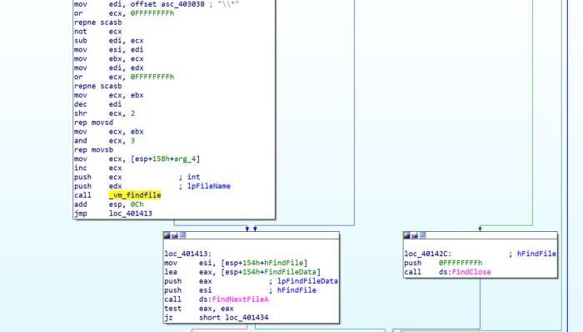

Checksiffilehas“PE”header.

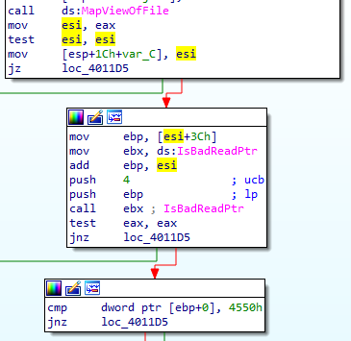

Example:Image_File_Header->e_lfanew(OffsettoPEHeader)

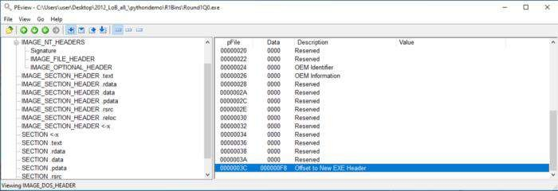

Dllcreatesoropensthemutex“SADFHUHF”.Mutexareusefulltocheck if instance of the program has been executed before ornot.

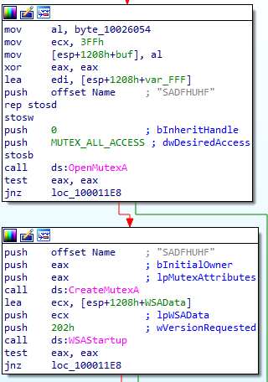

InitiatesWinsockdllfunction(WSAStartup)usesTCPprotocolto

connecttoserver“127.26.152.13:80”.

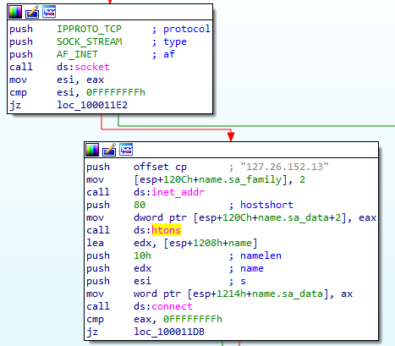

Ifconnectstoserver,sendshellomessage:“hello”.

Disablessendonasocket(shutdown).

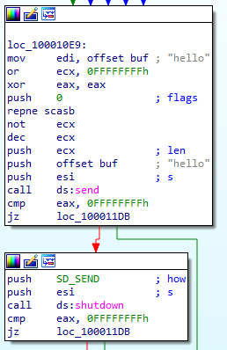

Ready to receive command from the server.Received message is up to4096 bytes length. Compares if command is "sleep" (sleeps for 1 minandrepeatsthesamefromsendinghellomessage).

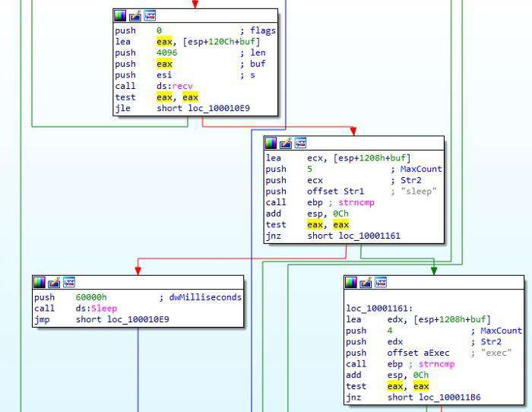

If command is “exec”, Creates process ([CreateProcessA](https://docs.microsoft.com/en-us/windows/win32/api/processthreadsapi/nf-processthreadsapi-createprocessa)) with argument“CREATE_NO_WINDOW”. One of the most important parameteris lpCommandLine.Looking backwads edx register is pushed on to the stack. edx has the addressofCommandLine(calculatedusing leainstruction).

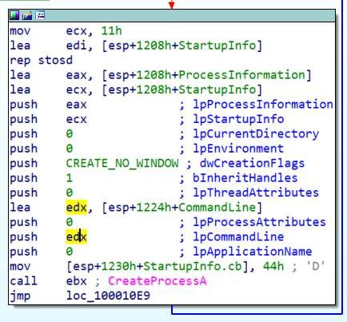

Thisaddressdoesn’tappearanywhereexceptthebeginningof

function:

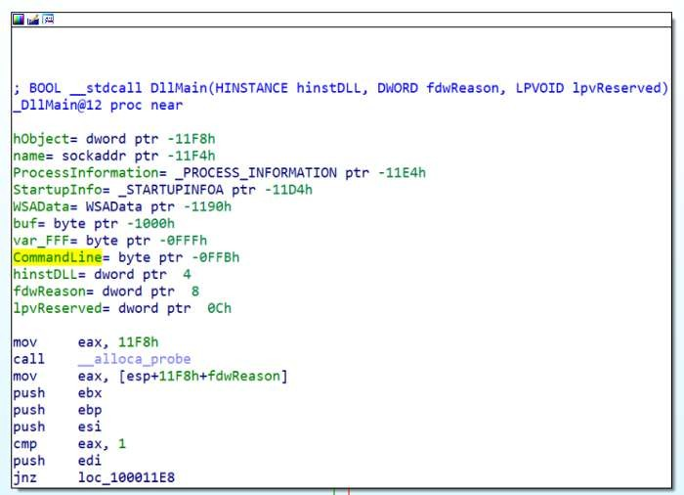

It means that it has not defined CommandLine already. The valueappears on a runtime, when command is received fromserver.Variables has negative, while arguments - positive value.CommandLine is the variable. buf contains the received commandand CommandLinecontains whatto execute.Thedifferencebetween buf and CommandLineare 5 bytes. 1000h-FFBh=5(h meansinhexdecimal).

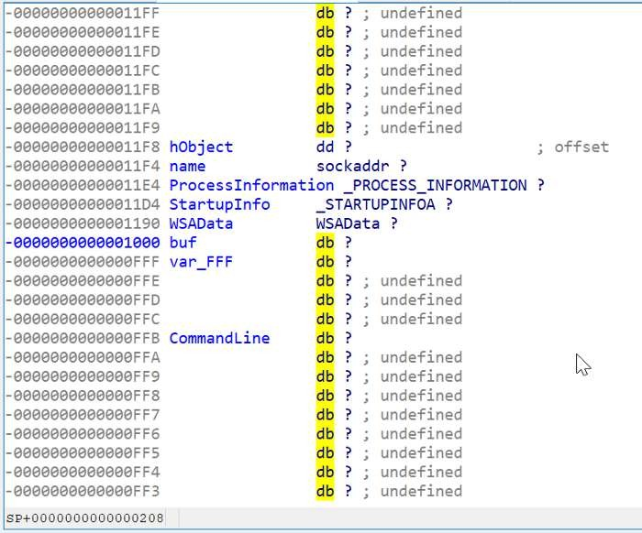

If we look at the received buff command, we got “exec”, which is 4bytes long. Mostlythe space (fifthbyte) is theseparator betweenexec and CommandLine.Strings are the arrays (index will be visualizedas the arrow whereit points). Indexpoints before orafter thesymbol,notontheletteritself.Everyarraystartsfromzeroindex—

[0](before“e”letter).Indexof[1]-pointsafter“e”andbefore“x”.

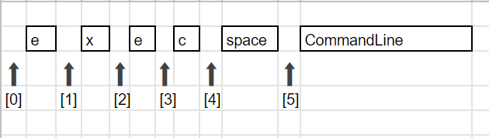

If command is “q” exits loop.If none of them — Sleep for 1 minute andloop.

When executable is found, calls mv_mapfile function (renamed bymyself). Opens executable (CreateFileA). Creates mapping object(CreateFileMappingA).Mapsfileintothememory(MapViewOfFile).

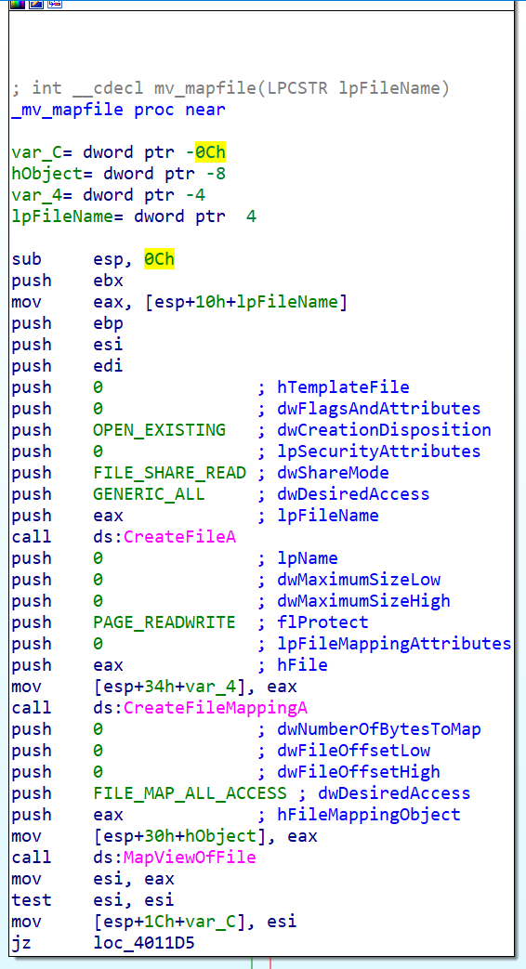

Esiregisterpointstostartofthefile.movebp,[esi+3Ch];dosheader->e_lfanew

cmpdwordptr[ebp+0],4550h;Checkifvalid‘PE’header.

Tounderstandthisyoushouldknow[PEstructure](http://opensecuritytraining.info/LifeOfBinaries.html).

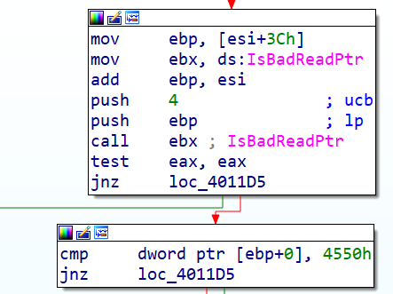

Explanation:

FileisopenedinPEViewer.3Ch(RVA-Relativevirtualaddress)points to offset to New EXE Header. In order to get the value(Data), it should be de referenced [] brackets grabs whats atthataddress:E8h(inourexample).

DosHeader->e_lfanew(equivalentinc++)

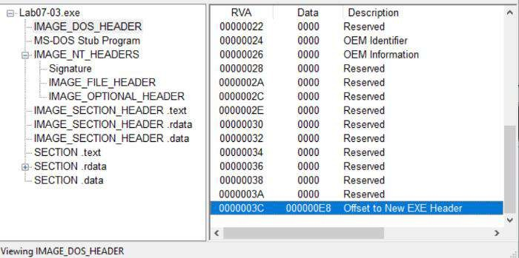

However grabbed offset to New EXE Header is another address.Shouldbedereferencedagain.

Image_NT_SignatureisattheaddressE8h(RVA).

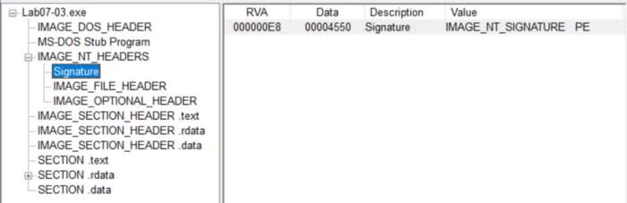

ChecksifvalidPEfile:

ImageNtHeaders->Signature != 'PE' (equivalent in c++)CallIsBadReadPtrtocheckifthecallingprocesshasreadaccesstothatmemoryregion.

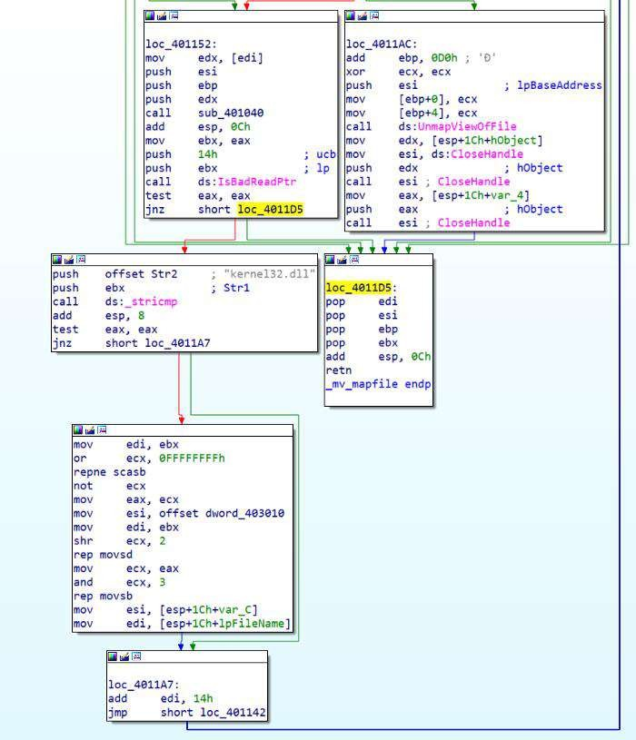

StringStr1iscomparedto“kernel32.dll”.

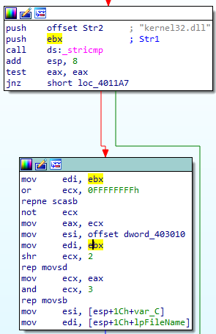

Twoinstructionsrepresentsstrlen(repnescasb)andmemcpy(repmovsd).Using repne scasb we get length of the string.rep movsdinstructionmovesbytefromesitoediregisterecxtimes(ecx=stringlength).movesi,offsetdword_403010

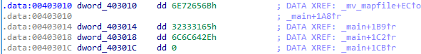

If we open dword_403010 we see that is actually ascii letters(lookinginasciitableweseethatnumbersandlettersstartsfrom30hto7Ah)

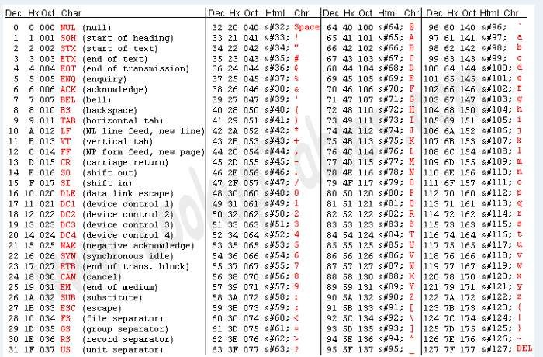

lookuptables.com

Bypressing“a”(convertdatatostringinIDA)twotimesweget“kerne132.dll”:

StringStr1isoursource,whichis“kernel32.dll”andreplacedby the string kernel132.dll (destination).Access import table:movecx,[ebp+80h];ImporttableRVA:E8h+80h=168h

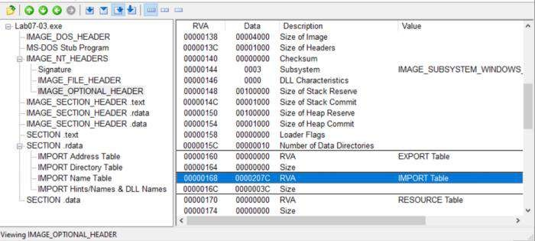

### iv. Howcould youremovethismalwareonceit isinstalled?

Malware could be removed replacing imports to original"kernel32.dll"foreveryexecutable.Usingautomatedprogramorscript to do this.Or original "kernel32.dll" replaced of"kerne132.dll"Orreinstallwindowsoperatingsystem.

# PracticalNo. 4

## A. Analyze themalwarefoundinLab11-01.exe

### i. Whatdoesthemalwaredroptodisk?

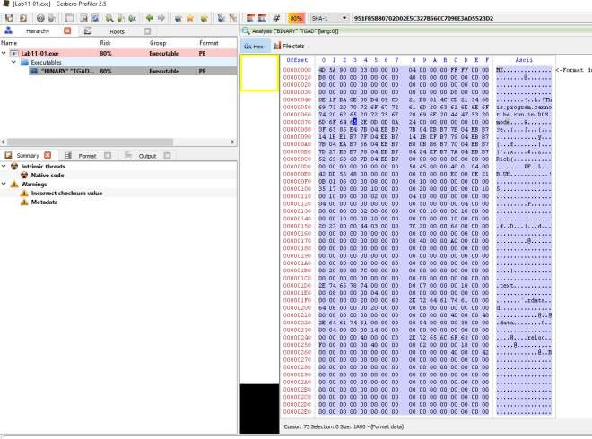

Figure1.BinaryresourceinLab11-01.exe’sTGAD

Thereis abinary inthe resourcesection ofLab11-01.exe.

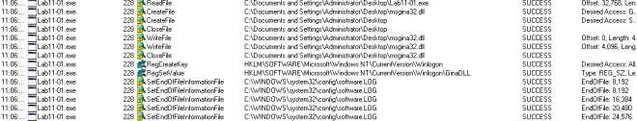

Figure2.msgina32.dlldropped

FromProcMonwecanobservethatmsgina32.dll andsoftware.LOGaredropped onthemachine.

### ii. Howdoesthemalwareachievepersistence?

In figure 2, the malware adds “HKLM\SOFTWARE\Microsoft\WindowsNT\CurrentVersion\Winlogon\GinaDLL”into the registry.

According to [MSDN,](https://msdn.microsoft.com/en-us/library/windows/desktop/aa380543(v%3Dvs.85).aspx)[*Winlogon*](https://msdn.microsoft.com/en-us/library/windows/desktop/ms721635(v%3Dvs.85).aspx#_security_winlogon_gly), the [*GINA*](https://msdn.microsoft.com/en-us/library/windows/desktop/ms721584(v%3Dvs.85).aspx#_security_gina_gly), and network providers are the parts of the interactivelogon model. The interactive logon procedure is normally controlled by Winlogon, MSGina.dll,and network providers. To change the interactive logon procedure, MSGina.dll can be replacedwith a customized GINA DLL. Winlogon will trigger the use of the malicious dll and that is howthemalware achievepersistency.

### iii. Howdoesthemalwarestealuser credentials?

Lookingat thedropped dll’sexport, itseems likeit isacustomdll to hookto thewinlogon

process.

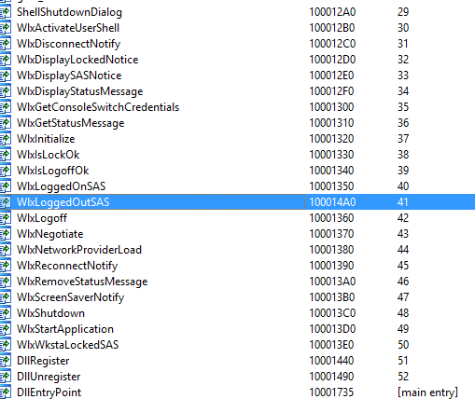Figure3.

WlxLoggedOutSAS

After checking through the exports function, only 1 function (WlxLoggedOutSAS) behavessuspiciously.Therest simply passthe inputs to theoriginal function address.

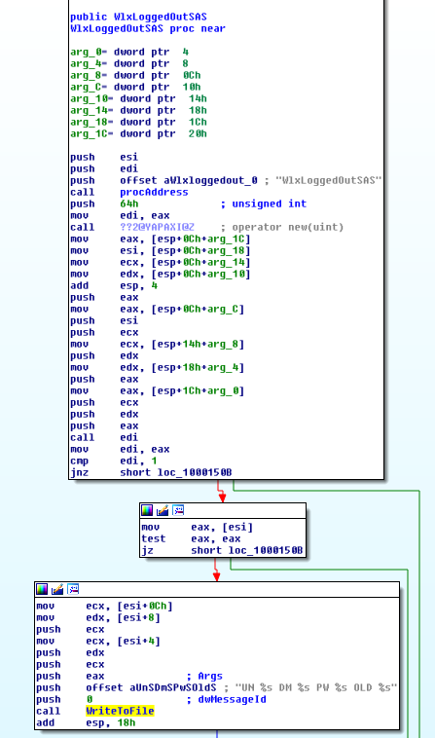

Figure4.InterceptingWlxLoggedOutSAS

The above figure is pretty straight forward, the inputs are passed to the originalWlxLoggedOutSASfunction andacopyofthe inputsarepassedtoafunction to writeto afile.

### iv. Whatdoesthemalwaredo withstolencredentials?

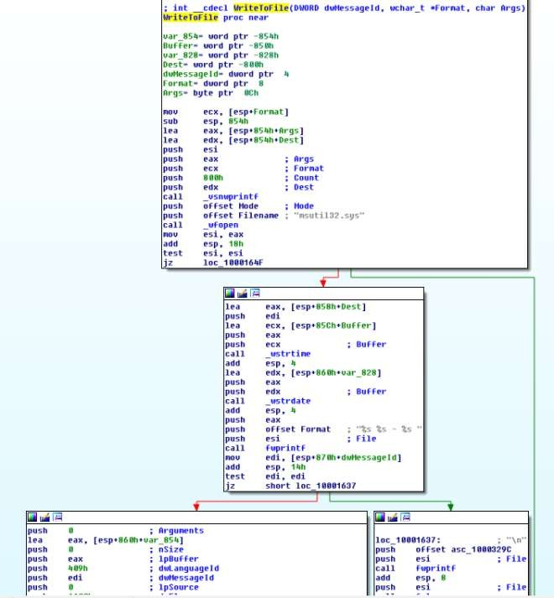

Figure5.Writetofile

Theabove figureshowsthemaliciousdllwritingthestolenvaluesintoc:\windows\system32\msutil32.sysfile.

### v. Howcan youusethismalwaretoget usercredentials from yourtest environment?

Byrebooting themachineor bylogging offandre-login

again. c:\windows\system32\msutil32.sys will contains the password used to login to thewindows.

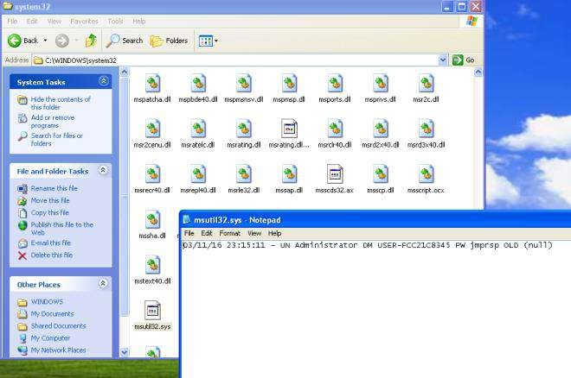

Figure6.CapturedPassword

## B. Analyze the malware found in *Lab11-02.dll*. Assume that a suspicious filenamed*Lab11-02.ini*was alsofoundwiththis malware.

### i. Whatarethe exportsforthis DLLmalware?



Figure1.Exports

### ii. Whathappensafteryouattempttoinstallthismalwareusingrundll32.exe?

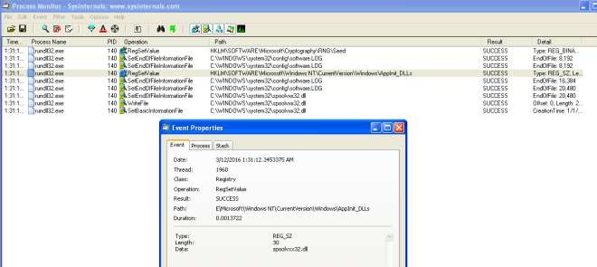

Figure2.SetRegistry&WriteFile

The malware add a registry value in HKLM\\SOFTWARE\\Microsoft\\WindowsNT\\CurrentVersion\\Windows\\AppInit_DLLS.

It then copy itself; the dll as C:\Windows\System32\spoolvxx32.dll.ThemalwarethentriestoopenC:\Windows\System32\Lab11-02.ini.

### iii. WheremustLab11-02.iniresidein orderforthemalwareto installproperly?

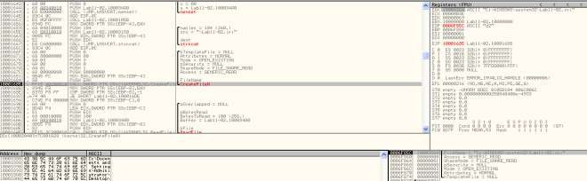

Figure3.Loadsconfigfile

The malware will attempt to load the config from C:\Windows\System32\Lab11-02.ini. Wewouldneed to placethe ini file in system32 folder.

### iv. Howis thismalwareinstalledforpersistence?

According to [MSDN,](https://msdn.microsoft.com/en-us/library/windows/desktop/dd744762(v%3Dvs.85).aspx) AppInit_DLLs is a mechanism that allows an arbitrary list of DLLs to beloadedinto each user modeprocess on thesystem.By addingAppInit_DLLs

in HKLM\\SOFTWARE\\Microsoft\\Windows NT\\CurrentVersion\\Windows\\ we areloadingthe maliciousDLL intoeach usermodeprocess thatgets executed on thesystem.

### v. Whatuser-spacerootkit techniquedoesthismalwareemploy?

Ifwelookatthesubroutine@0x100012A3,youwillseethatitisattemptingtogettheaddressofsend from wscock32.dll.It then passtheaddress tosubroutine@0x10001203.

Thesubroutine@0x10001203is employing theinlinehooktechnique. It firstgettheoffset fromthe hook position to the function where it wants to jump to. It then uses VirtualProtect to make 5bytesofspacefrom thestart of thesubroutine address

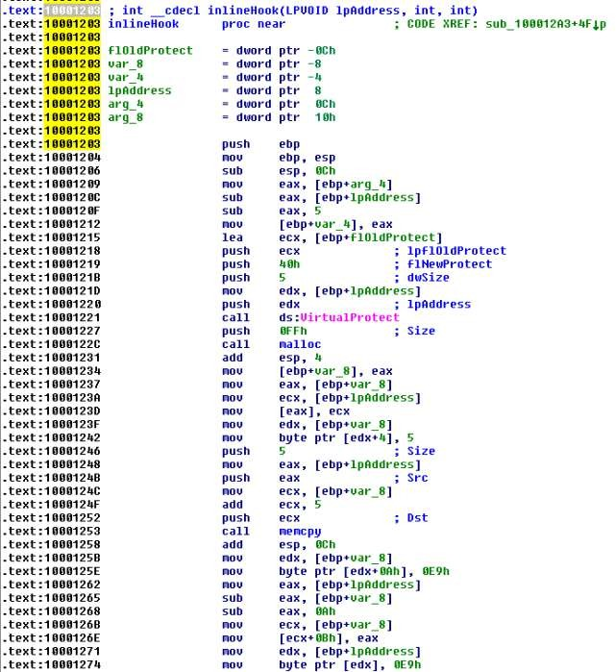to PAGE_EXECUTE_READWRITE. Once it is done it then rewrite the code to jmp to thehookfunction.Finallyitresetthe5bytesofmemoryspacebacktotheoldprotection attributes.

Figure4.inline hook

However, the malware only hook 3 programs; THEBAT.EXE, OUTLOOK.EXE,MSIMM.EXE.

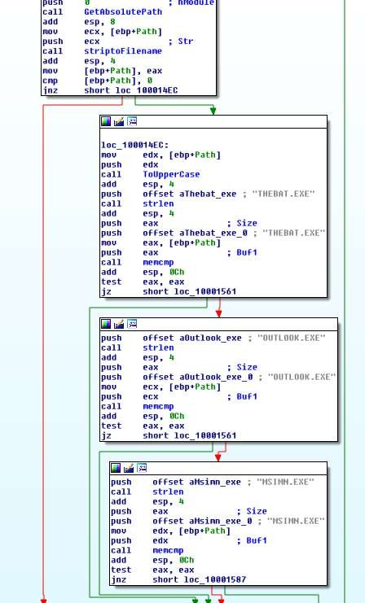

Figure5.Hookselectedprograms

Toconclude,themalwareisattemptingto doaninline hookonwsock32.dll’s sendfunctionfor

selectedprograms.

### vi. Whatdoesthehookingcodedo?

Wefirstlook atwhat the malwareisretrieving fromtheconfigfile.

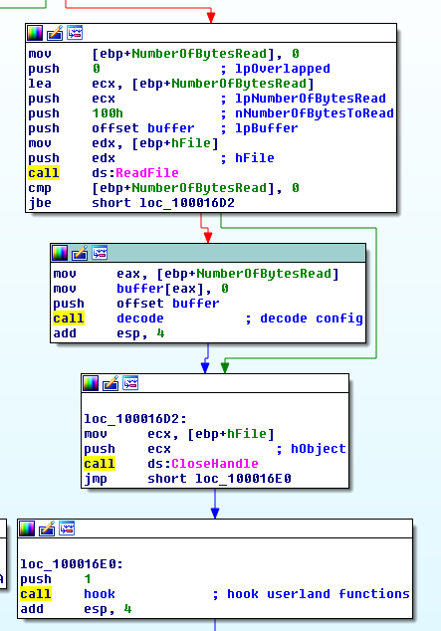

Figure6.Decodingconfig

Afterreading thedatafrom theconfigfile, the malwarethen decodeitby calling thesubroutine@0x100016CA. If we dive into this subroutine, you will realize that it is a xor decodingfunction.Let’s placeahook there in ollydbgto seewhat comes out.

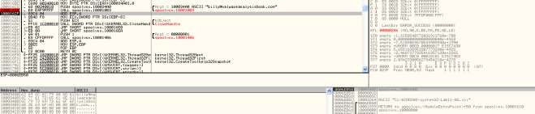

Figure7.[billy@malwareanalysisbook.com](mailto:billy@malwareanalysisbook.com)

Thisdecoded stringwill beusein thefollowing function.

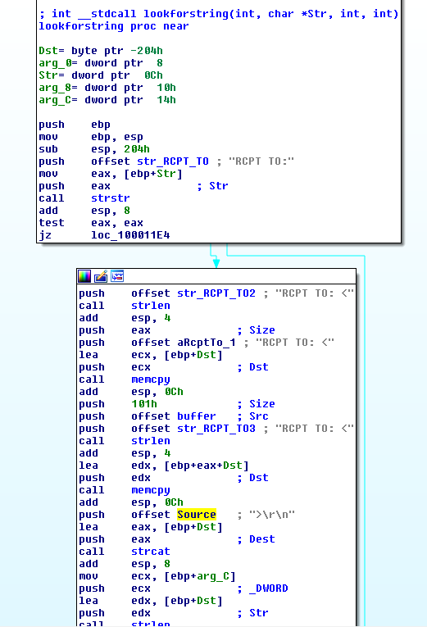

Figure8.replacingsenddata

The inline hook jumps to the above function. Its starts off with checking if the send buffercontains the string “RCPT TO”. If it does, it will create a new buffer “RCPTT[O:<b](mailto:billy@malwareanalysisbook.com)il[ly@](mailto:billy@malwareanalysisbook.com)m[alwareanalysisbook.com](mailto:billy@malwareanalysisbook.com)>\r\n” and send it off via the original send function.Thefunction willthen end ofby simplyforwarding the originaldatatothesend function.

### vii. Whichprocess(es)doesthismalwareattackandwhy?

Asansweredinquestionv… themalwareonlyhook 3programs;THEBAT.EXE,OUTLOOK.EXE,MSIMM.EXE. They areallemail clients.

### viii.Whatisthesignificanceofthe.inifile?

Asansweredinquestionv…theconfig.inicontainstheencodedattackeremailaddress. Itisuse

toreplace recipientaddresscausingemailto besendtotheattacker instead.

## C. Analyze the malware found in Lab11-03.exe and Lab11-03.dll. Make surethatboth files are inthesame directoryduring analysis.

### i. What interesting analysis leads can you discover using basic static analysis?Lab11-03.exe

Figure1. Installation

The main method in Dll11-03.exe is pretty straight forward. It first copy the Lab11-03.dll toC:\\Windows\\System32\\inet_epar32.dll.It thenattemptsto modifyC:\\Windows\\System32\\cisvc.exeand executestheinfectedexecutableby startingaserviceviathe command “net start cisvc”

Lab11-03.dll

Thedllcontainssomeinterestingstuff…In export,wecanseeasuspiciouslookingfunction;

zzz69806582.

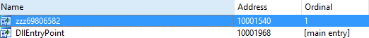

Figure2.

Exportfunctionsurface afunnyfunction

The imports contains GetAsyncKeyState and GetForegroundWindow which highly suggeststhatthis is a keylogger.

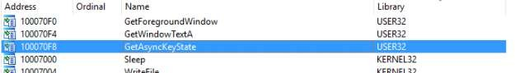

Figure3.imports

Thefunction@zzz69806582isprettysimple.Itjustcreates athread.

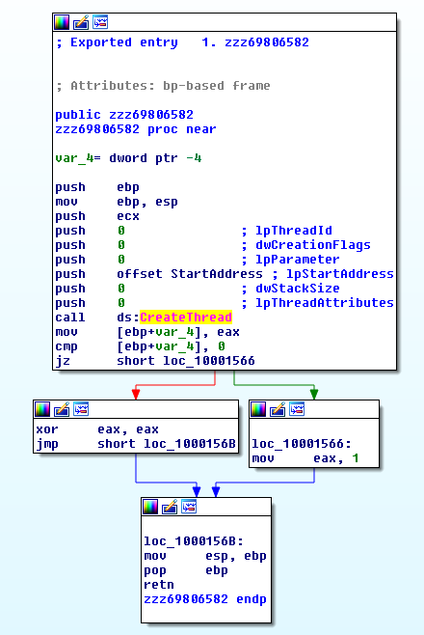

Figure3.function zzz69806582

The thread that the above function creates first check for mutex; MZ.Itthencreateafile@ C:\\Windows\\System32\\kernel64x.dll.

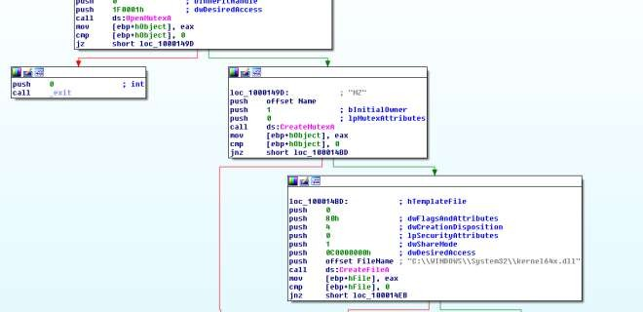

Figure4.MutexMZ

Next,thethreadcallsasubroutinetorecordkeystrokes.

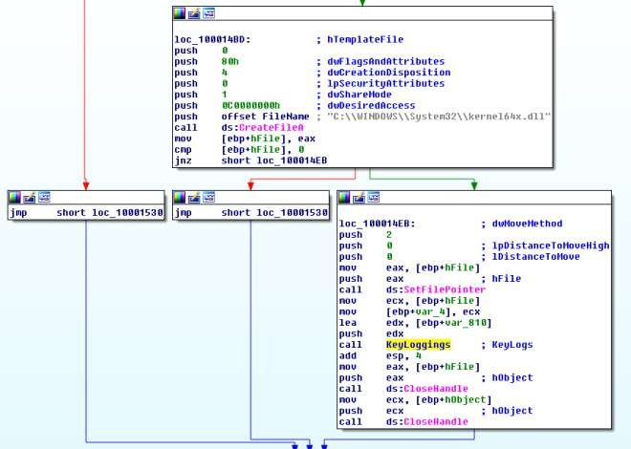

Figure5.Keylogs

### ii. Whathappenswhenyou runthismalware?

Asanswered in question 1,It firstcopy the Lab11-03.dll toC:\\Windows\\System32\\inet_epar32.dll.It thenattemptsto modifyC:\\Windows\\System32\\cisvc.exeand executestheinfectedexecutableby startingaserviceviathecommand “net start cisvc”

The infected service then begin to log keystroke and save itinC:\\Windows\\System32\\kernel64x.dll.

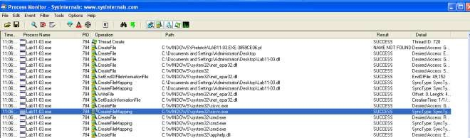

Figure6.Procmonshowingfilecreationininfectedsystem

### iii. HowdoesLab11-03.exepersistentlyinstallLab11-03.dll?

It infects C:\\Windows\\System32\\cisvc.exe; an indexing service by inserting shellcodes intothe program. The infected cisvc.exe will load C:\\Windows\\System32\\inet_epar.dll as showninthefigurebelow.

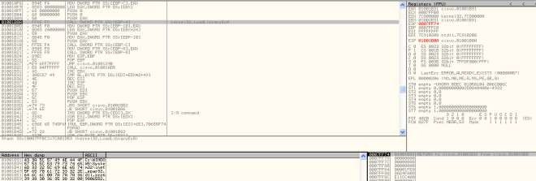

Figure7.LoadLibrary

Comparingtheinfected executablewiththeoriginal one,we could seesomeadditional functionsaddedto it. On top of thatwecan observethat theentrypoint has beenchanged.

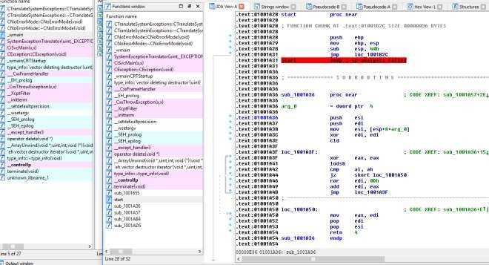

Figure8.AdditionalFunctions

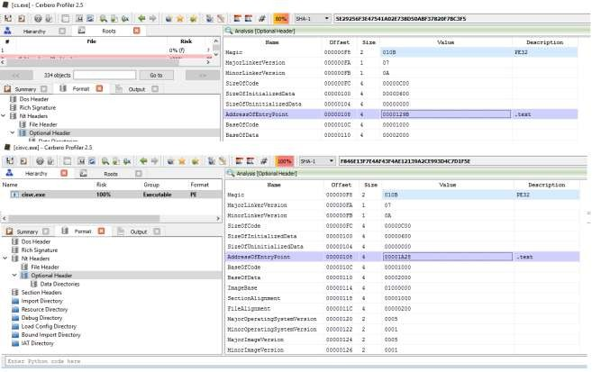

Figure9. Changes inEntry Point

### iv. WhichWindowssystem filedoesthemalwareinfect?

ItinfectsC:\\Windows\\System32\\cisvc.exe.

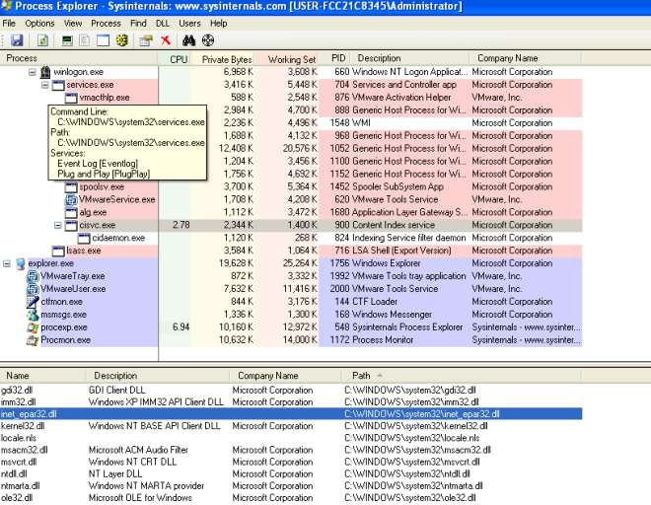

Figure10.inet_epar32.dllloadedin cisvc.exe

### v. Whatdoes Lab11-03.dll do?

UsingGetAsyncKeyStateandGetForegroundWindow,thedlllogskeystrokes

intoC:\\Windows\\System32\\kernel64x.dll.Thedllalsousesamutex“MZ”toprevent

multipleinstances ofthekeyloggeris runningat once.

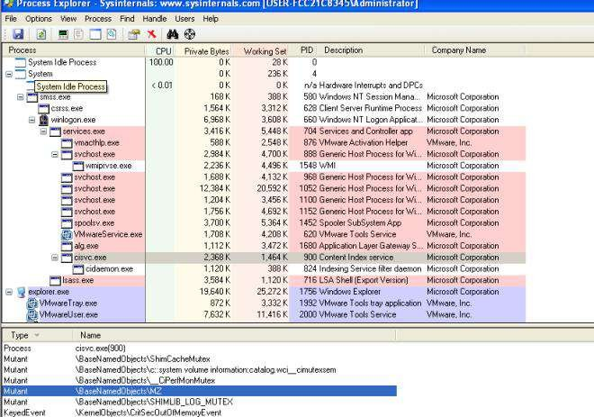

Figure11.MutexMZ

### vi. Wheredoes themalwarestorethe dataitcollects?

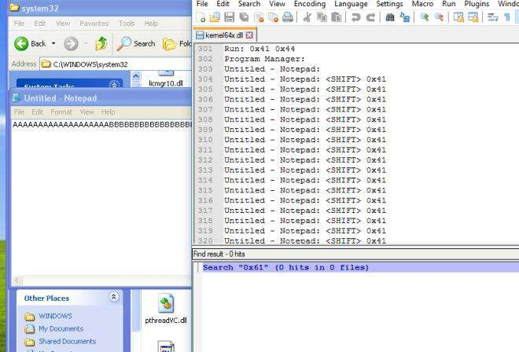

Figure 12. Key Logs CapturedInC:\\Windows\\System32\\kernel64x.dll

# PracticalNo. 5

## A. Analyze the malware found in the file *Lab12-01.exe* and *Lab12-01.dll*. Makesurethatthesefilesareinthesamedirectorywhenperforming theanalysis.

### i. Whathappenswhenyourunthemalwareexecutable?

AMessagebox witha incrementalnumberin itstitlepops up everynowand then…

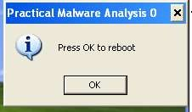

### ii. Whatprocessisbeinginjected?

Intheimportstable,CreateRemoteThreadisused bytheexewhichhighlysuggeststhatthemalwaremight be injecting DLL into processes.

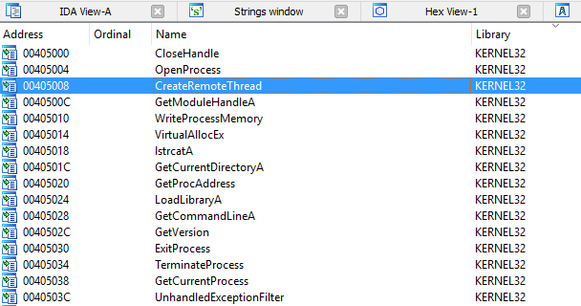

Figure2.CreateRemoteThread inimports

“explorer.exe” is found in the list of string. X-ref the string and we will come to the followingsubroutine.Seemslike explorer.exeis beingtargetedtobe injectedwith themalicious dll.

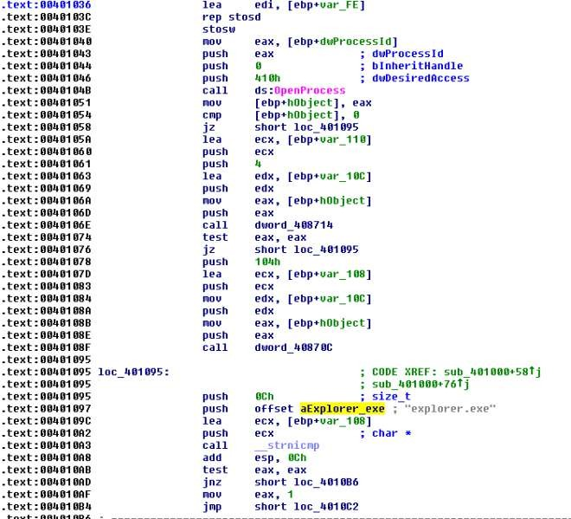

Figure3.explorer.exe

Wecan confirmour suspicion using processexplorer asshown below.

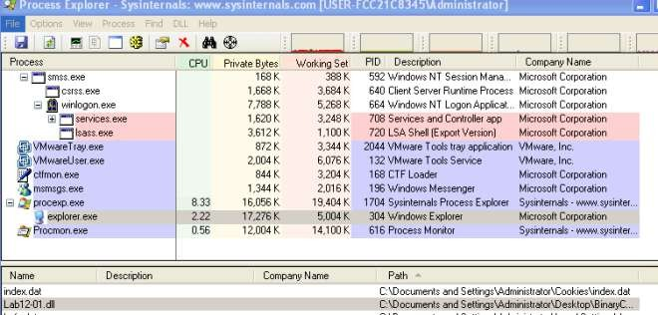

Figure4.Explorer.exeinjectedwithdll

### iii. Howcan youmakethe malwarestop thepop-ups?

Killexplorer.exeandre-runit again

### iv. Howdoesthismalwareoperate?

Lab12-01.exe

The malware begins by using psapi.dll’s [EnumProcesses](https://msdn.microsoft.com/en-us/library/windows/desktop/ms682629(v%3Dvs.85).aspx) to loop through all running processes.Also note that it attempts to form the absolute path for the malicious dll. This will be used latertoinject thedll in remoteprocesses.

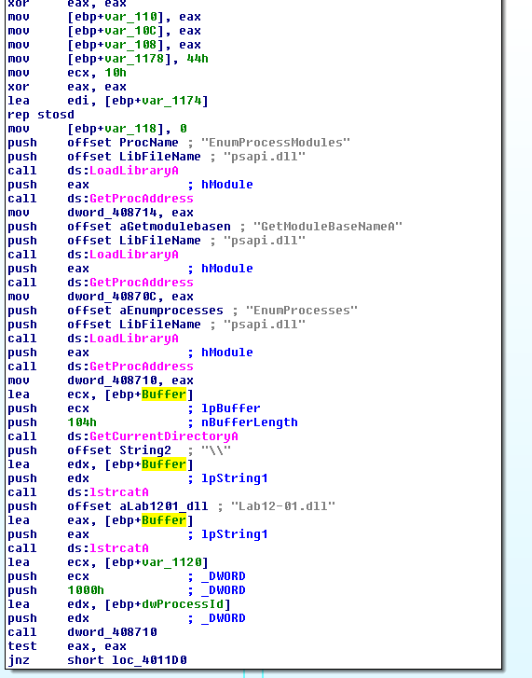

Figure5.EnumPorcesses

Whileloopingthroughtheprocessesonly“explorer.exe”willbeinjected. Thefollowingfigure

showsthefilteringtakingplace.

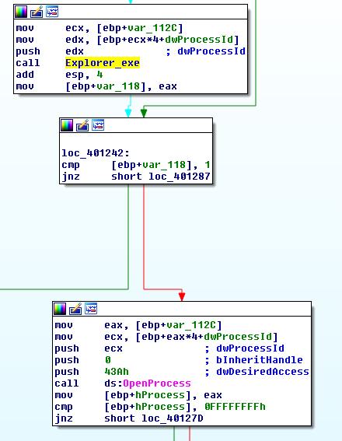

Figure6.Checkforexplorer.exe

Once the malware located the “explorer.exe” process, it will ask the remote process(explorer.exe) to allocate a heap space. The space will contains the malicious dll’s absolute pathas mentioned earlier. It will then get the LoadLibraryA address of explorer.exe and triggers thefunctionviaCreateRemoteThread.Explorer.exewilltheninvokeLoadLibraryAwiththeinputasthe malicious dll’s absolute path which is already in its heap memory and that is howexplorer.exegot injected.=)

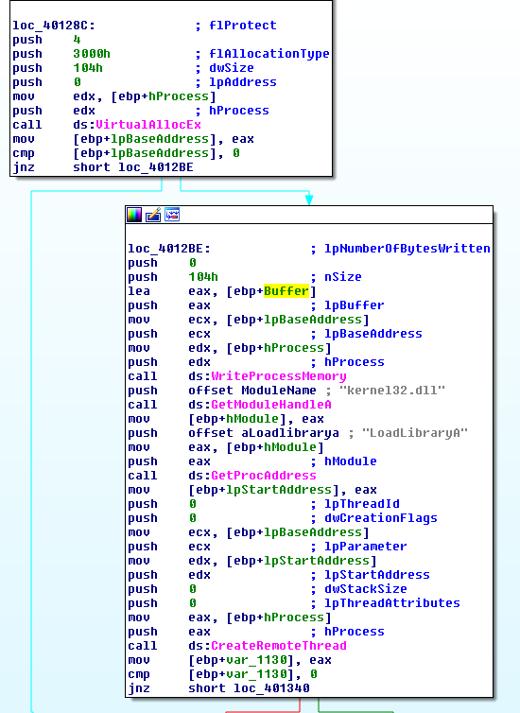

Figure7.Injecting

Lab12-01.dllTheDllMain first createsathread @ subroutine0x1001030.

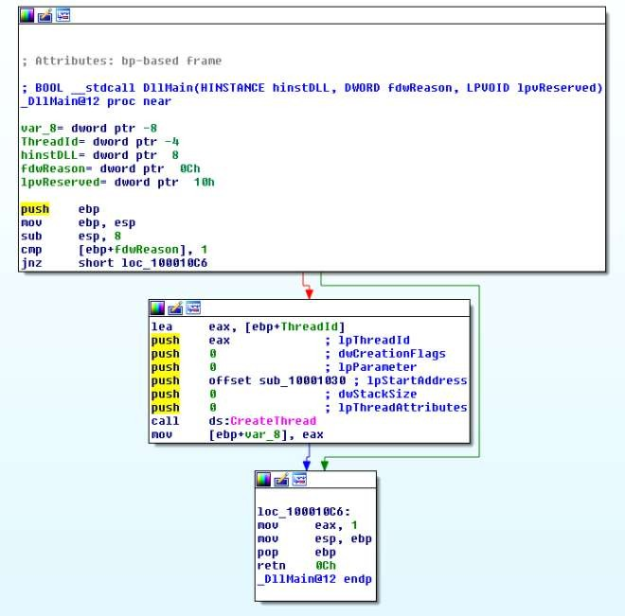

Figure8.CreateThread

Inside this subroutine, we will find a infinite loop popping a message box every 1 minute. Thetitle of the message box is “Practical Malware Analysis %d” where %d is the value of the loopcounter.

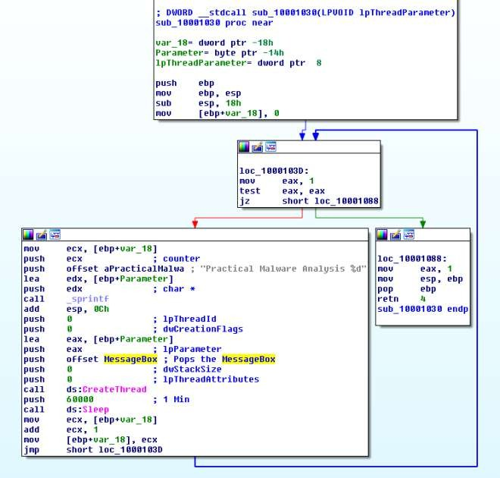

Figure9.PoppingMsgBoxeveryminute

## B. Analyzethemalwarefoundinthefile*Lab12-02.exe*.

### i. Whatisthepurposeof thisprogram?

Basedondynamicanalysisresultsusingprocmonandprocessexplorer,we canconcludethatthisis akeyloggerthat performs process hollowing onsvchost.exe.

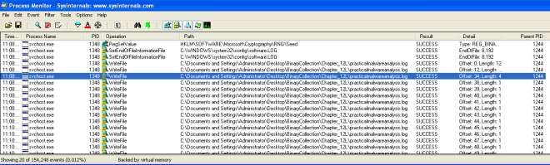

Figure1.Writefiletopracticalmalwareanalysis.log

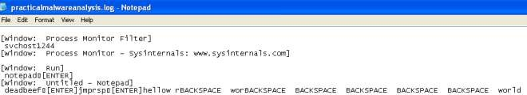

Figure2. Keystrokes in log file

### ii. Howdoesthelauncherprogram hideexecution?

The subroutine @0x004010EA is highly suspicious. It is trying to create a process in suspendedstate, calls UnmapViewOfSection to unmap the original code and tries to write process memoryinit.Finallyit resumestheprocess.This isa recipeforprocesshollowingtechnique inwhichtherunning process will look like svchost.exe (in this case) but it is actually running something elseinstead.

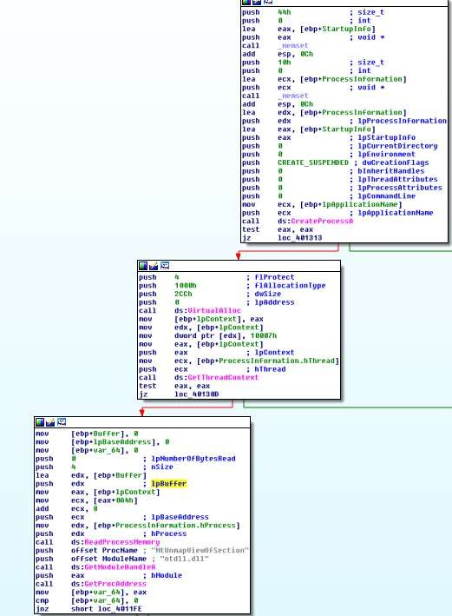

Figure3.CreateSuspended process,unmapmemory

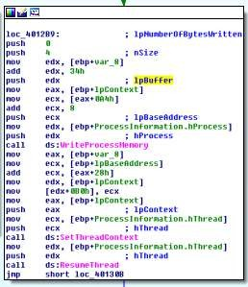

Figure4. WriteProcessMemory,ResumeThread

### iii. Whereisthemaliciouspayload stored?

Intheresource,wecanseeasuspiciouslookingpayload.IDAPro furtherconfirmedthatthisisthepayload that will be extracted out.

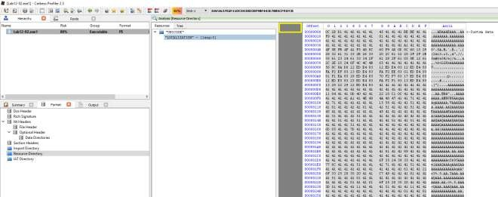

Figure5. Resourcewith lots of As in it

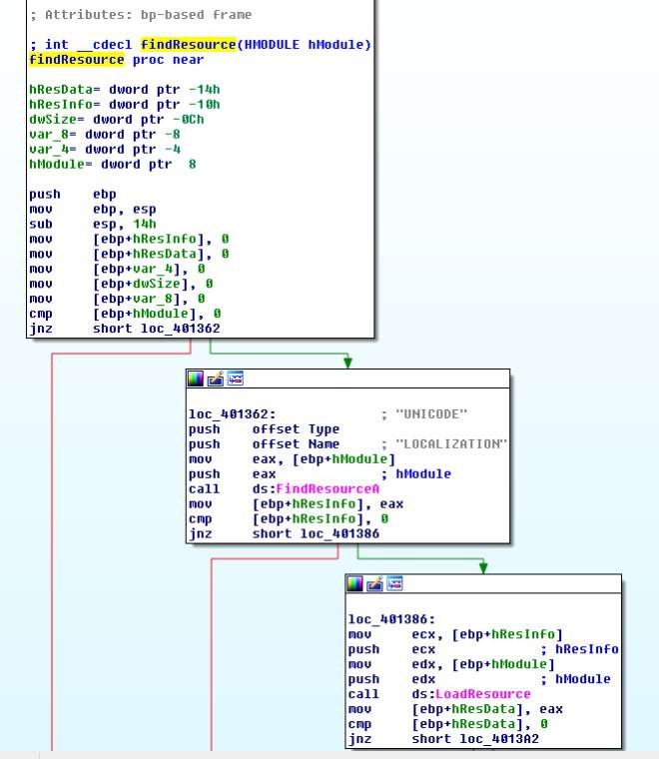

### iv. Howisthemaliciouspayload protected?

Byanalyzingthefindresourcefunction@0x0040132C wewillcomeacrossthefollowingcodes

thatsuggeststousthatthepayloadisXORby“A”.

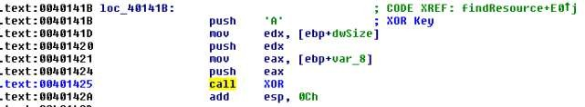

Figure7. XOR by A

### v. Howarestringsprotected?

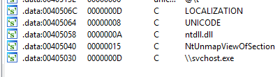Thestringsareinplain… correctmeifiamwrong

Figure8. Stringsin plain

## C. Analyzethemalwareextracted duringtheanalysis ofLab12-2,orusethefile*Lab12-03.exe*

### i. Whatisthepurposeof thismaliciouspayload?

Theuseof SetWindowsHookExAwithWH_KEYBOARD_LLasthe idwhichsuggests thatthisisa keylogger.

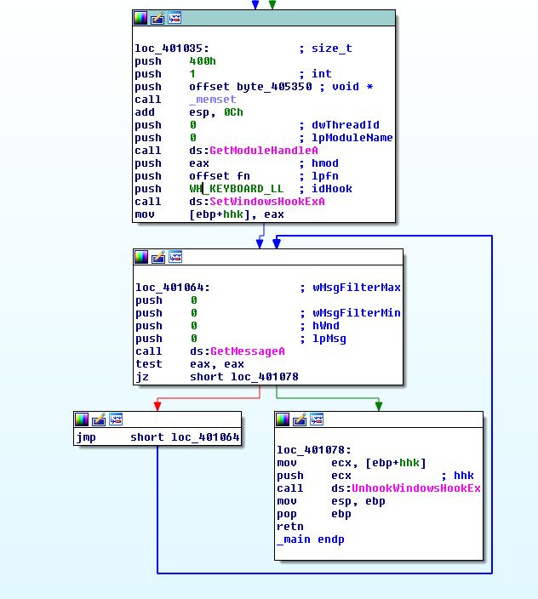

Figure1.SetWindowsHookExA

### ii. Howdoesthemaliciouspayloadinjectitself?

It uses Hook injection. Keystrokes can be captured by registering high- or low-level hooks usingthe WH_KEYBOARD or WH_KEYBOARD_LL hook procedure types, respectively. ForWH_KEYBOARD_LL procedures, the events are sent directly to the process that installed thehook, so the hook will be running in the context of the process that created it. The malware caninterceptkeystrokes andlog them toafile as seeninthefigurebelow.

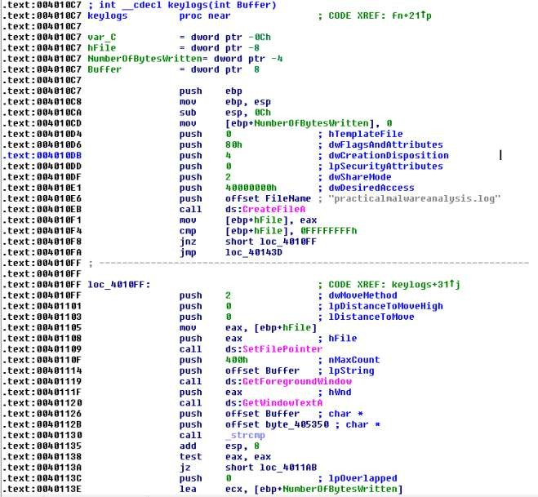

Figure2.Logtopracticalmalwareanalsysis.log

### iii. Whatfilesystemresiduedoesthisprogramcreate?

Themalwarewillleavebehindalogfilecontainingthekeylogs;practicalmalwareanalsysis.log.

## D. Analyzethemalwarefoundinthefile *Lab12-04.exe*.

### i. Whatdoes thecodeat 0x401000 accomplish?

Thesubroutinecheck iftheprocesswiththegivenprocessid isWinlogon.exe.If itis,itreturns1 else it returns0.

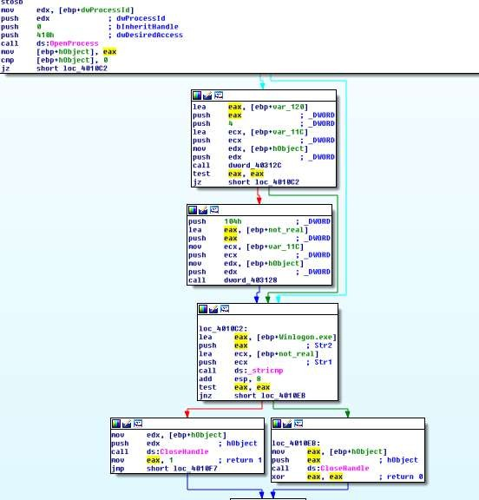

### ii. Whichprocesshascodeinjected?

Winlogon.exe is being targeted for injection. Subroutine @0x00401174 is responsible forprocess injection via CreateRemoteThread. If we trace back, we can see that only winlogon’s pidisbeing passed to the subroutine.

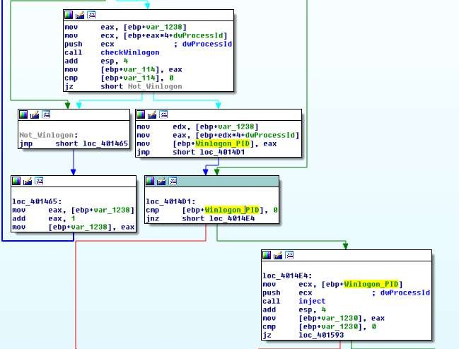

Figure2.WinlogonPidbeingpushedasargumenttoinjectsubroutine

### iii. WhatDLLisloadedusingLoadLibraryA?sfc_os.dll

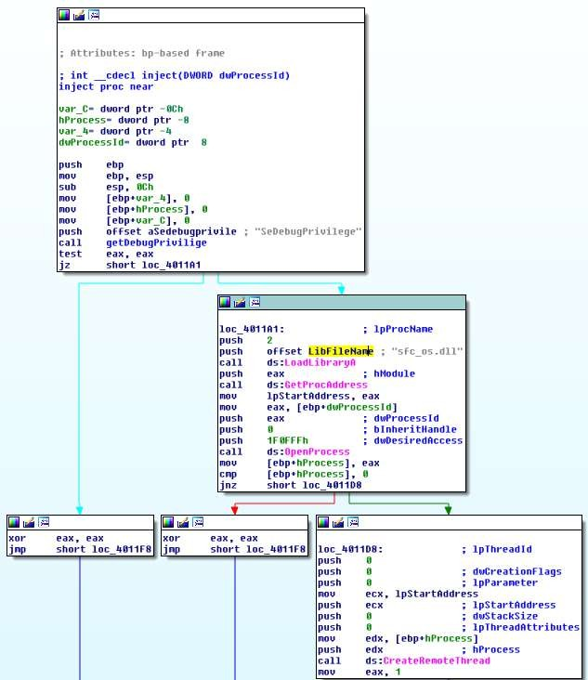

Figure3.sfc_os.dll

### iv. WhatisthefourthargumentpassedtotheCreateRemoteThreadcall?

Basedonfigure3, the fourthargument islpStartAddressin whichifweweretotraceupwewilluncoverthat lpStartAddress is the address returnbyGetProcAddress(LoadLibraryA(“sfc_os.dll”),2).

Loadingsfc_os.dllin idapro wecanseetheexports thatpointsto ordinal2whichresovlestoSfcTerminateWatcherThread()as shown in figure5..

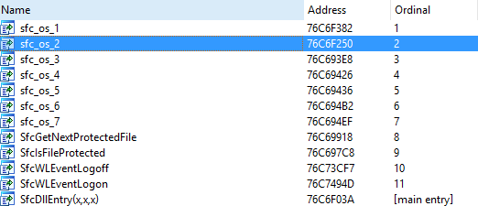

Figure4.sfc_os.dll’sordinal2

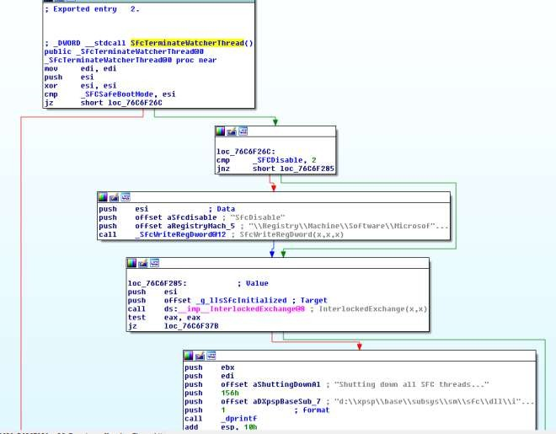

Figure5.SfcTerminateWatcherThread()

### v. Whatmalwareis droppedbythemainexecutable?

Analyzing the main method, we can see file movement from“C:\WINDOWS\system32\wupdmgr.exe” to a temp folder“C:\DOCUME~1\ADMINI~1\LOCALS~1\Temp\\winup.exe”

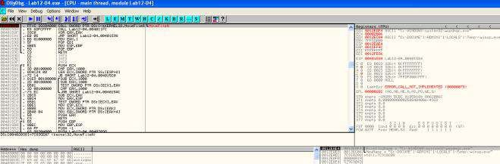

Figure

6.Backingupwupdmgr.exe

The following subroutine is then called to extract the resource out from the executable and usingitto replace“C:\WINDOWS\system32\wupdmgr.exe”

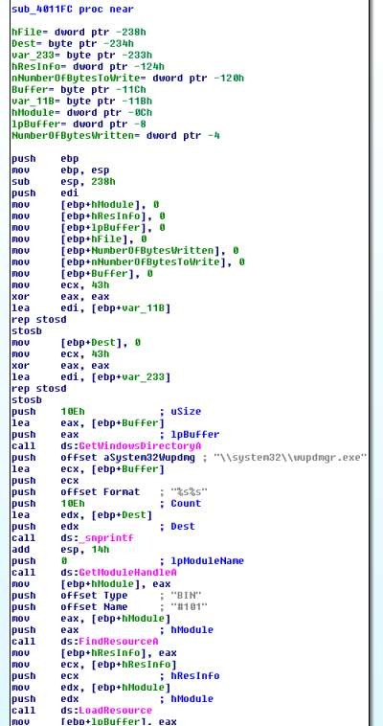

Figure7.droppingform resourcetosystem32\\wupdmgr.exe

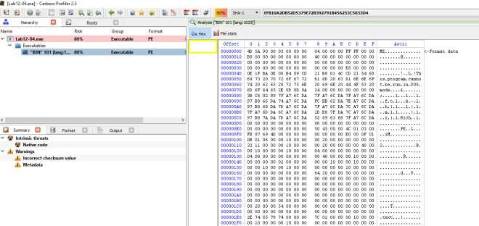

Figure8.Bin101 intheresourcesection

Whatisthepurposeof thisand thedroppedmalware?

Apparently in order for SfcTerminateWatcherThread() to work, the caller must be fromwinlogon.exe.That explains whythemalwaregoesthrough the troublein looping throughallrunning threads to locate winlogon.exe and it even attempts to get higher privileges by usingAdjustTokenPrivileges to change token privilege to seDebugPrivilige. With the higherprivilege,the malwarethen callsCreateRemoteThreadto askWinlogon to

invoke SfcTerminateWatcherThread(). With that, file protection mechanism will be disabledandthe malwarecanfreely changethesystem protected files untilthe next reboot.

The dropped malware in “C:\\windows\\system32\\wupdmgr.exe” executes the originalwupdmgr.exe (which is now in the temp folder) and it attempts to download new malwarefrom“[http://www.practicalmalwareanalysis.com/updater.exe”](http://www.practicalmalwareanalysis.com/updater.exe)andsaveit

as“C:\\windows\\system32\\wupdmgr.exe”

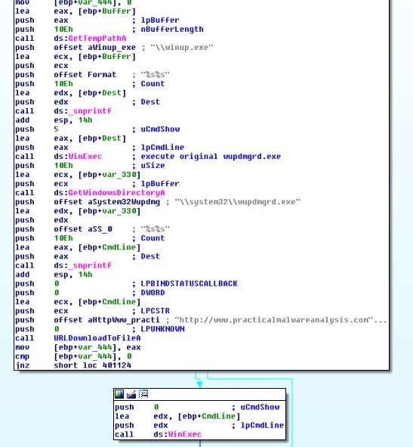

Figure9.URLDownloadToFileA

# PracticalNo. 6

## A. Analyzethemalwarefoundinthefile*Lab13-01.exe*.

### i. Comparethestringsinthemalware(from theoutputofthestrings command)withtheinformation available via dynamic analysis. Based on this comparison, which elementsmightbe encoded?

In IDA Pro, we can see the following strings which are of not much meaning. However onexecution,ifwe weretostringsthememoryusingprocessexplorer andsniffthenetwork traffic,wecan observesomenew strings suchas[http://www.practicalmalwareanalysis.com](http://www.practicalmalwareanalysis.com/).

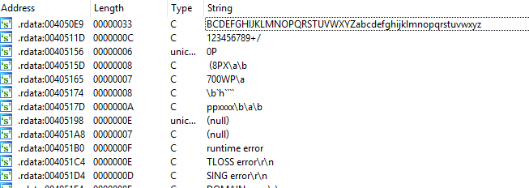

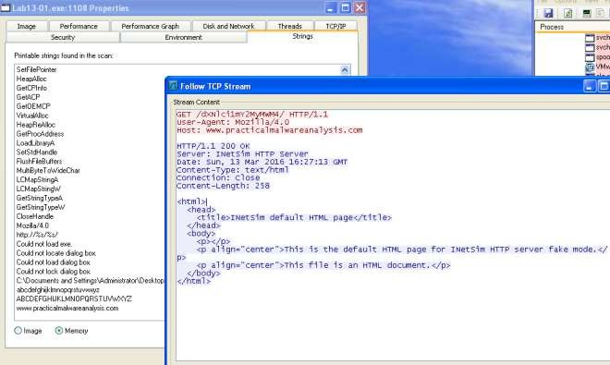Figure1.Meaninglessstring

Figure2.URLfound

### ii. Use IDA Pro to look for potential encoding by searching for the string xor. What type ofencodingdo you find?

Thesubroutine@0x00401300loadsaresourceinthebinaryandxorthevaluewith“;“.

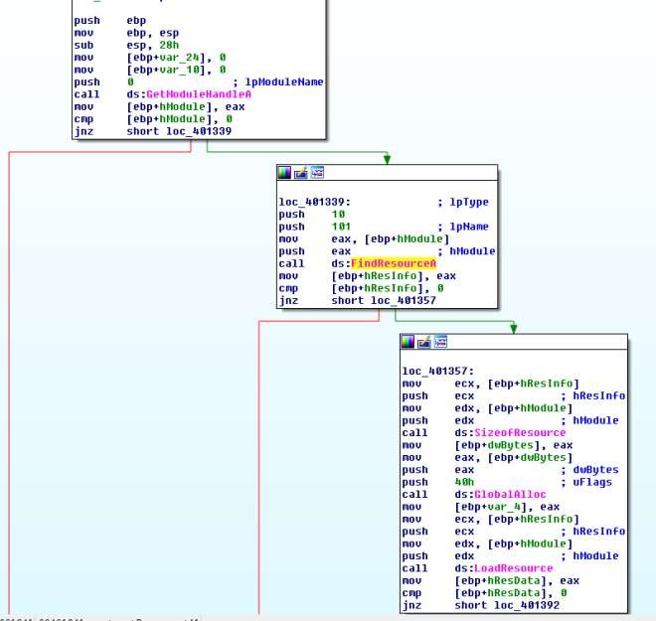

Figure3.FIndResourceA101

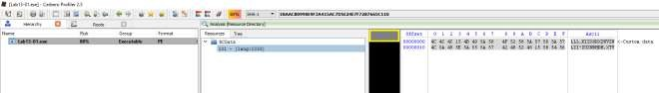

Figure4.Resource String

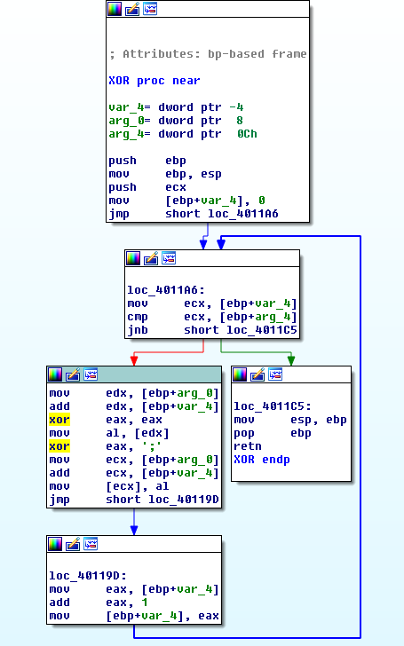

Figure5.XORwith ;

### iii. Whatisthekeyusedforencodingandwhatcontentdoes itencode?

Thekeyusedis“;“.The decodedcontentis[http://www.practicalmalwareanalysis.com](http://www.practicalmalwareanalysis.com/).

### iv. UsethestatictoolsFindCrypt2,KryptoANALyzer(KANAL),andtheIDAEntropyPlugin to identify anyotherencoding mechanisms.Whatdo youfind?

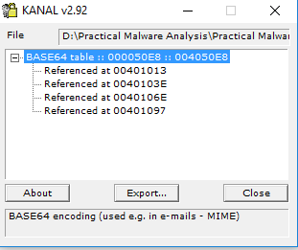

KANALpluginlocated4addressesthatuses

“ABCDEFGHIJKLMNOPQRSTUVWXYZabcdefghijklmnopqrstuvwxyz0123456789+/”

### v. Whattypeof encodingisusedforaportion ofthenetworktrafficsentbythemalware?

base64encodingis usedtoencodethe computername.

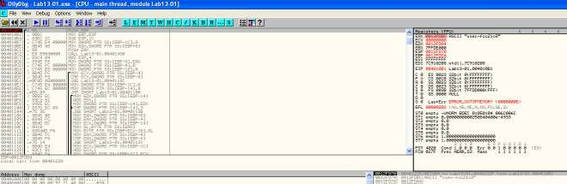

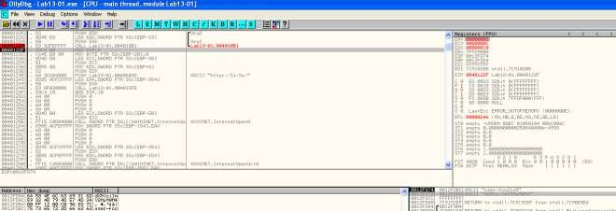Figure7.Encodingstring

Figure8.Stringencoded

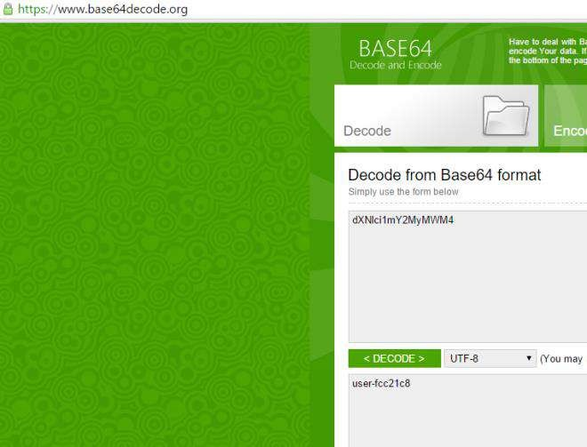

Figure9.Checkingbase64encodedstring

### vi. WhereistheBase64functioninthedisassembly?

Ataddress0x004010B1.

### vii. What is the maximum length of the Base64-encoded data that is sent? What isencoded?

Themaximum length is12 characters. Themaximum base64 lengthis 16 bytes.

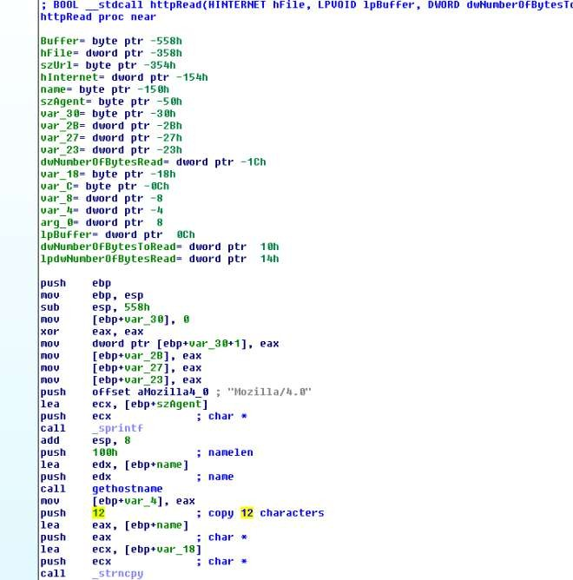Figure

10.Only12Characters

### viii. In this malware, would you ever see the padding characters (= or ==) in the Base64-encodeddata?

Accordingto[wiki.](https://en.wikipedia.org/wiki/Base64#Padding)Ifthe plaintextisnot divisibleby3,padding willpresentintheencodedstring.

### ix. Whatdoesthis malwaredo?

Itkeeps sendingthe computername (max12 bytes)

to[http://www.practicalmalwareanalysis.comevery](http://www.practicalmalwareanalysis.comevery/)30secondsuntil0x6Fisreceivedasthefirstcharacterin theresponse.

## B. Analyzethemalwarefoundinthefile*Lab13-02.exe*

### i. Usingdynamicanalysis,determinewhatthismalwarecreates.

Afilewithsize6,214KBis writtenonthe samefolderas the executableevery fewseconds.Thenamingconvention ofthe fileistemp[8xhexadecimal]. Thefilecreatedseems random.

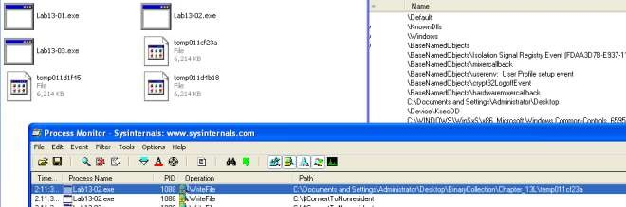

Figure 1.ProcMon

### ii. Usestatictechniquessuchasanxorsearch,FindCrypt2,KANAL,andtheIDAEntropyPlugin to look forpotential encoding. What doyou find?

Onlymanagedto findXOR instructions.Basedon thesearch result,we wouldneedto lookatthefollowing subroutine

1. 0x0040128D

2. 0x00401570

3. 0x00401739

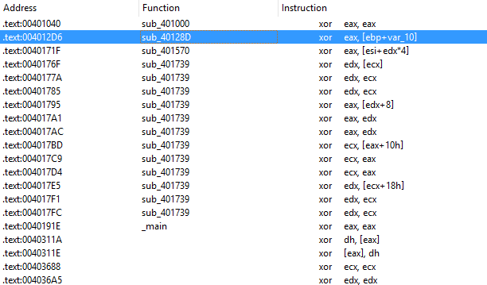

Figure2.XOR

### iii. Based on your answer to question 1, which imported function would be a good prospectforfinding the encoding functions?

WriteFile.TraceupfromWriteFileandwemightlocatethefunctionresponsibleforencodingthecontents.

### iv. Whereistheencodingfunctionin thedisassembly?

Theencodingfunctionis@0x0040181F.

v.TracingupfromWriteFile,youwillcomeacrossafunction @0x0040181F.Thefunctioncalls anothersubroutine(0x00401739)that performstheXORoperations and someshifting operations.

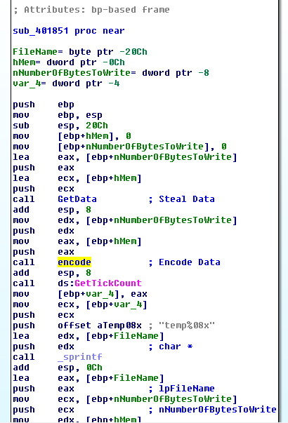

Figure3.encode

### v. Trace from the encoding function to the source of the encoded content. What is thecontent?

Basedon thesubroutine @0x00401070. Themalwareis taking a screenshotof the desktop.

[GetDesktopWindow](https://msdn.microsoft.com/en-us/library/windows/desktop/ms633504(v%3Dvs.85).aspx): Retrieves a handle to the desktop window. The desktop window covers theentirescreen. Thedesktop windowis theareaontop of which otherwindows arepainted.

[GetDC](https://msdn.microsoft.com/en-us/library/windows/desktop/dd144871(v%3Dvs.85).aspx):TheGetDCfunctionretrieves ahandletoadevicecontext(DC) for theclientareaofaspecified window or for the entire screen. You can use the returned handle in subsequent GDIfunctions to draw in the DC. The device context is an opaque data structure, whose values areusedinternally by GDI.

[CreateCompatibleDC](https://msdn.microsoft.com/en-us/library/windows/desktop/dd183489(v%3Dvs.85).aspx):TheCreateCompatibleDCfunctioncreatesamemorydevicecontext(DC)compatiblewith thespecified device.

[CreateCompatibleBitmap](https://msdn.microsoft.com/en-us/library/windows/desktop/dd183488(v%3Dvs.85).aspx): The CreateCompatibleBitmap function creates a bitmap compatiblewiththedevicethat is associated with thespecified devicecontext.

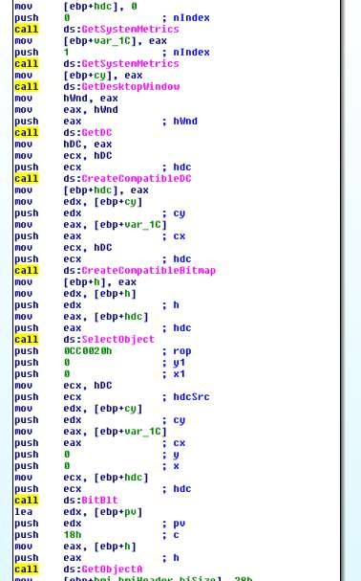[BitBlt](https://msdn.microsoft.com/en-us/library/windows/desktop/dd183370(v%3Dvs.85).aspx): The BitBlt function performs a bit-block transfer of the color data corresponding to arectangleof pixels from thespecified sourcedevicecontextinto adestination devicecontext.

Figure4.Screenshot

### vi. Canyou find thealgorithm usedforencoding?Ifnot,howcanyou decodethecontent?

Theencoder used ispretty lengthy togo through, Howeverifwelook atthecodes in0x401739,we can see lots of xor operations. If it is xor encoding we might be able to get back the originaldataif wecall this subroutineagain withthe encrypted data.

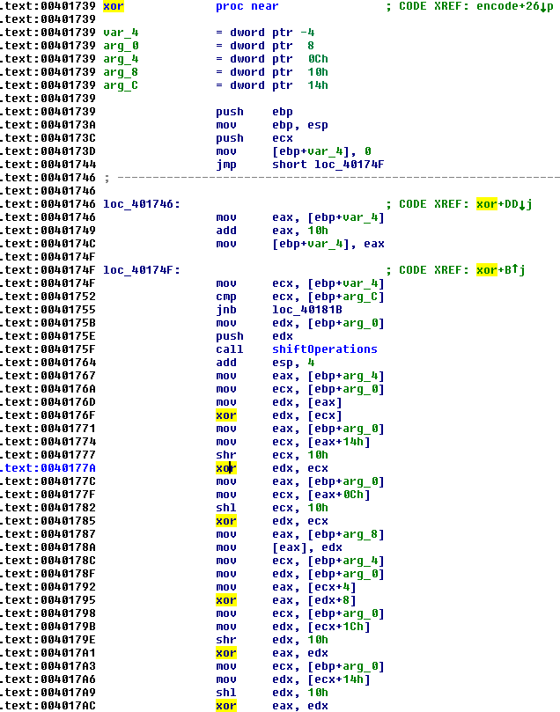

Figure5.xoroperations

### vii. Usinginstrumentation,canyourecover the originalsourceofoneoftheencodedfiles?

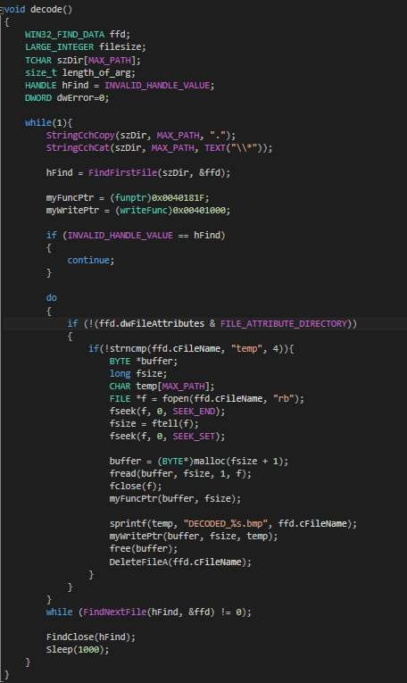My way of decoding the encoded files is to use DLL injection. To do that, i write my own DLLandcreateathreadtorun thefollowingfunctionon DLL_PROCESS_ATTACHED.Toattachthe DLL to the malware process, we first run the malware and use a tool called Remote DLLinjectorby securityxplodedto inject theDLL into the malicious process.

Figure6.DecodeFunction

The above codes simply scan the path in which the executable resides in for encoded files thatstart with “temp“. It then reads the file and pass the data to the encoding function @0x40181F.Oncethe data is decoded, wemakeuseof thefunction@0x401000 towriteout thefileto

“DECODED_[encoded file name].bmp“. Last but not least i shall delete the encoded file so asnotto clutterthe folder.

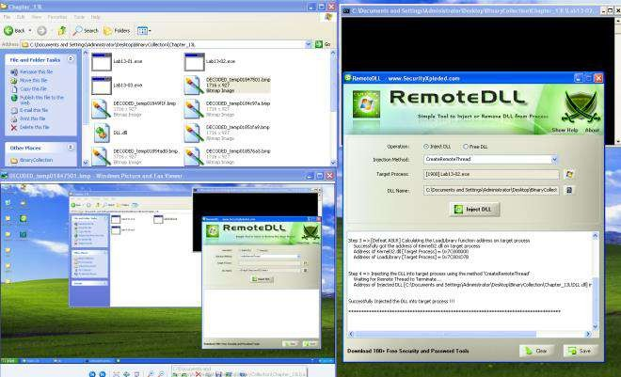

## C. Analyzethemalwarefoundinthefile*Lab13-03.exe*.

### i. Compare the output of strings with the information available via dynamic analysis. Basedonthis comparison, which elements mightbeencoded?

BasedonWiresharkandprogramresponsewe couldseethefollowingstrings.

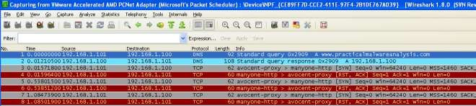

Figure1.[http://www.practicalmalwareanalysis.com](http://www.practicalmalwareanalysis.com/)

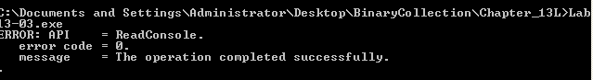

Figure2.ErrorMessage

InIDAProwecanseethedomain hostnameandsome possibledebugmessages.

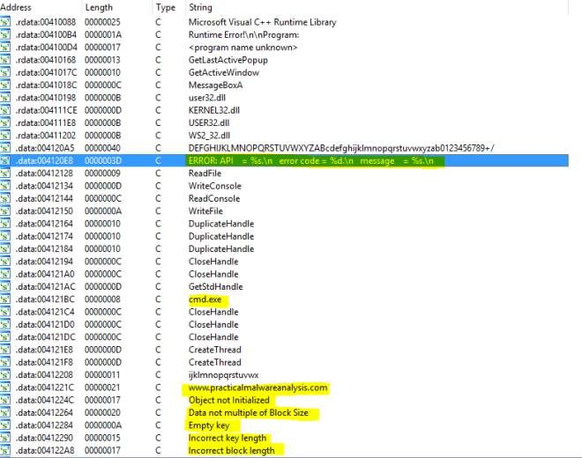

Figure3.IDAPro strings

### ii. Usestaticanalysistolookforpotentialencodingby searchingforthestringxor.Whattypeof encoding do youfind?

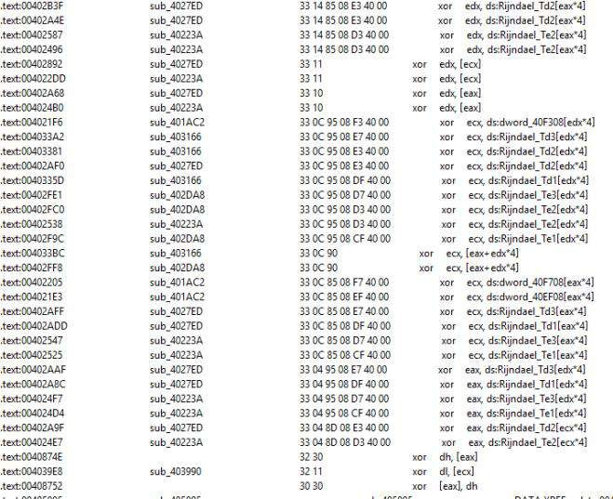There are quite a lot of xor operations to go through. But based on the figure below, it is highlypossible that AES is being used; The Advanced Encryption Standard (AES) is also known asRijndae.

Figure

4.XORoperations

### iii. Use static tools like FindCrypt2, KANAL, and the IDA Entropy Plugin to identify anyotherencoding mechanisms.How dothesefindings comparewith theXOR findings?

Mostlikely AESis beingused inthemalware.

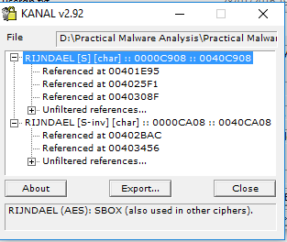

Figure5.PEIDfoundAES

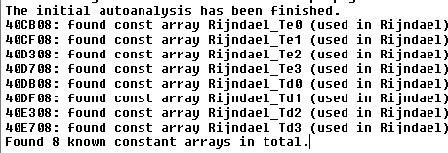

Figure6.FindCrypt2PluginFoundAES

### iv. Whichtwo encodingtechniques areusedinthismalware?

@0x4120A4wecan see a65 charactersstring. Whichseemslike acustombase64key.Thestandard base64 key should be“ABCDEFGHIJKLMNOPQRSTUVWXYZabcdefghijklmnopqrstuvwxyz0123456789+/=”whichconsists of A-Z, a-z, 0-9, +, / and=.



Figure7.CustomBase64

AcustomBase64andAESareusedinthismalware.

### v. Foreachencodingtechnique,whatisthekey?

The custom base64 string uses“CDEFGHIJKLMNOPQRSTUVWXYZABcdefghijklmnopqrstuvwxyzab0123456789+/”Totest if this key is validi used aonlinecustom base64 toolto verify.

OnlineTool:<https://www.malwaretracker.com/decoder_base64.php>

Usingtheabovetoolwith thecustom key,IencodedHELLOWORLD andpass itto theprogramvianetcat to decode.Trueenough, theencoded text wasdecoded back to theoriginal text.

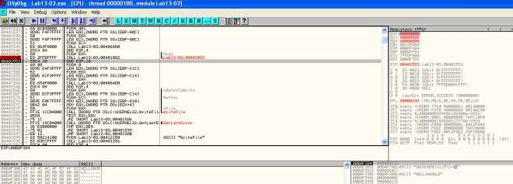

Figure8.Base64decode

Based on some debug message, this function (0x00401AC2) seems to be initializing the AESkey.

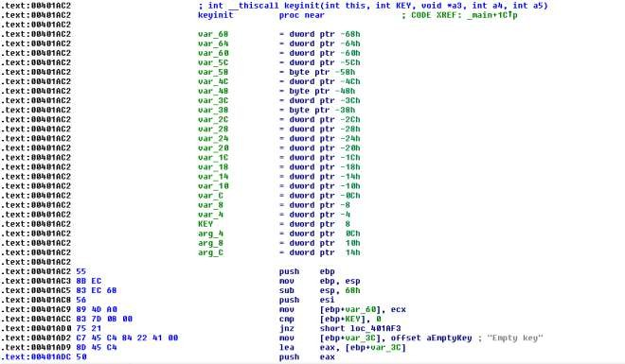

Figure9.InitKey

x-refthe functionandlocatethe2ndargument…thekeyismostlikelytobe“ijklmnopqrstuvwx“.

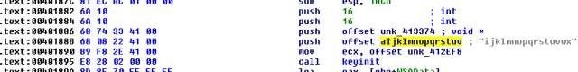

Figure 10.Key pass inas2nd argument

### vi. For the cryptographic encryption algorithm, is the key sufficient? What else must beknown?

Forcustombase64,wewouldjust needthecustombase64string.

ForAES,wewouldneedtheCipher’sencryptionmode,keyandIV.

### vii. Whatdoesthismalwaredo?

The malware connects to an [http://www.practicalmalwareanalysis.com’s](http://www.practicalmalwareanalysis.com/)8190 port andestablishesaremoteshell.Itthenreadsinputfromtheattacker.Theinputsarecustom base64encoded. Once decoded, the command is pass to cmd.exe for execution. The return results isencryptedusing AES andsendback to theattacker’s server.

### viii. Create code to decrypt some of the content produced during dynamic analysis. What isthiscontent?

Usingthekey, weuseCBCmodewith noIV todecryptthe AESencrypted packet.The contentistheresponsefrom the command sentearlier via theremoteshellfrom theattacker.

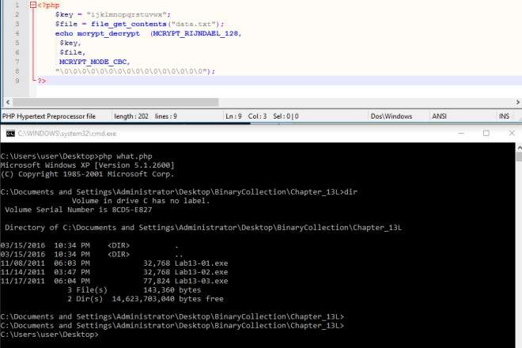

Figure11.DecryptedData

# PracticalNo. 7

## A. Analyze the malware found in file *Lab14-01.exe*. This program is not harmful toyoursystem.

### i. Whichnetworkinglibrariesdoesthemalware use,andwhataretheiradvantages?

Thenetworkinglibraryusedisurlmon’s[URLDownlaodToCacheFileA.](https://msdn.microsoft.com/en-us/library/ms775123(v%3Dvs.85).aspx)

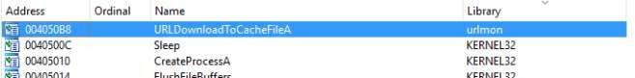

Figure1.urlmon’sURLDownlaodToCacheFileA

Theadvantageofusing this apicall is thatthe httppacketsbeing sentlooks likeatypical packet

fromthevictim’sbrowser.

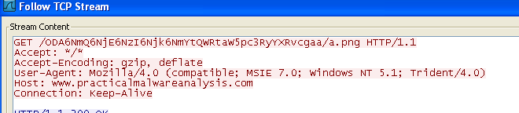

Figure2.User-Agent

### ii. Whatsourceelementsareusedtoconstruct thenetworkingbeacon,andwhatconditionswouldcausethe beacon to change?

Fromthefigurebelow,wecanobservethat the networkingbeacon isconstructed fromapartialGUID(19hto 24h)via[GetCurrentHWProfileA](https://msdn.microsoft.com/en-us/library/windows/desktop/ms724311(v%3Dvs.85).aspx)andusername via[GetUserNameA](https://msdn.microsoft.com/en-us/library/windows/desktop/ms724432(v%3Dvs.85).aspx).

BasedonMSDN,szHwProfileGuidisagloballyuniqueidentifier (GUID)stringforthecurrenthardware profile. The string returned by [GetCurrentHwProfile](https://msdn.microsoft.com/en-us/library/windows/desktop/ms724311(v%3Dvs.85).aspx)encloses the GUID in curlybraces,{}; for example:{12340001-4980-1920-6788-123456789012}.

Therefore on different machine, the GUID should be different which infers that the beacon willchange.Ontopof that,anothervariableusedistheusernamethereforedifferent usersloggingintothesame infected machine will generate adifferent beacon as well.

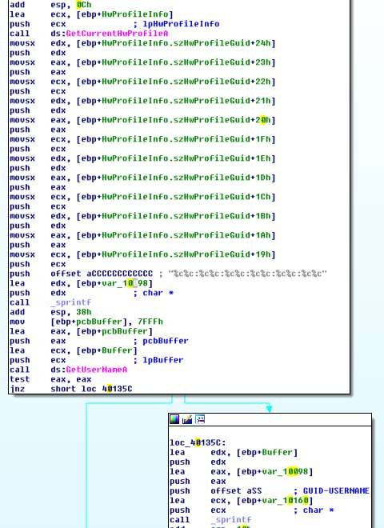

Figure3.GUID &Username

### iii. Whymighttheinformationembeddedinthenetworkingbeaconbeofinteresttotheattacker?

Sothat theattackercanhaveaunique idto keeptrack oftheinfectedmachines andusers.

### iv. DoesthemalwareusestandardBase64 encoding?If not,how isthe encodingunusual?

Yesexceptthatthepaddingusedisdifferent.

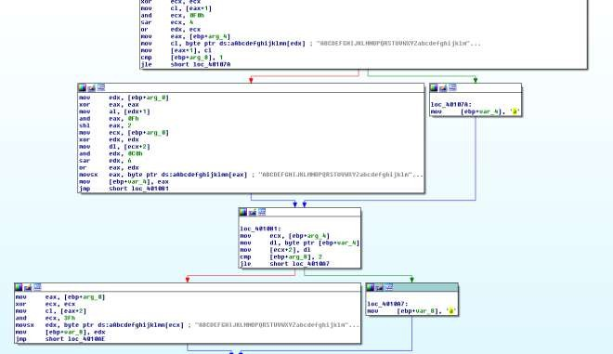

Figure4.padding‘a’ is usedinsteadof‘=’

To prove that let’s try it using ollydbg. Set breakpoint @0x004013A2 and we can step throughthe base64 algo in action. In my test experiment i used AA:AA:AA:AA:AA:AA-AAAAAAAAAAAAA to let it encode. By right the standard base64 should give me thefollowingresults.

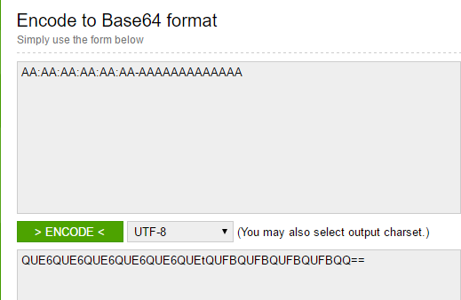

Figure5.

EncodingAA:AA:AA:AA:AA:AA-AAAAAAAAAA

However we got back QUE6QUE6QUE6QUE6QUE6QUEtQUFBQUFBQUFBQUFBQQaainstead.WhichfurtherreinforcedwhatwehaveseenearlierinIDAProwhere‘a’isusedinsteadof‘=’forpadding.

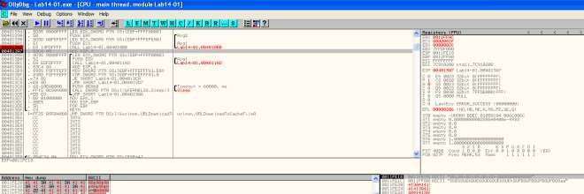

Figure6.Encodinginollydbg

### v. Whatistheoverallpurposeofthismalware?

Themalwareattemptsto downloadfilefrom the c2serverandexecutesit every60seconds.

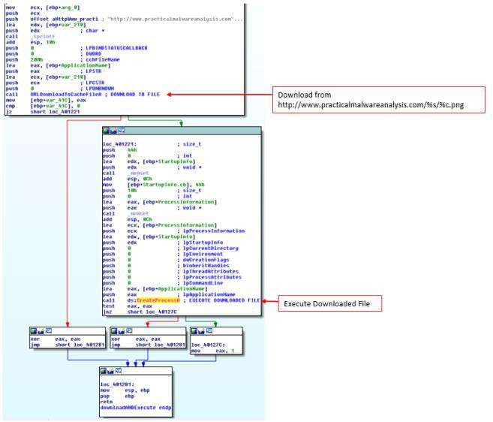

Figure7.Downloadandexecute

### vi. What elements of the malware’s communication may be effectively detected using anetworksignature?

Wecanusetofollowingelementsto detectfor thismalware

domain:[http://www.practicalmalwareanalysis.com](http://www.practicalmalwareanalysis.com/)

Getrequestendswith/[%c].png

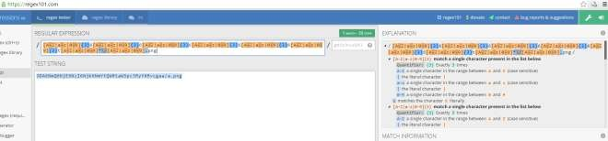3.Getrequestpatternisasfollows“/[A-Z|a-z|0-9]{3}6[A-Z|a-z|0-9]{3}6[A-Z|a-z|0-9]{3}6[A-Z|a-z|0-9]{3}6[A-Z|a-z|0-9]{3}6[A-Z|a-z|0-9]{3}t[A-Z|a-z|0-9]*\/[A-Z|a-z|0-9].png/”

Figure8.online regexptool

### vii. Whatmistakesmightanalystsmakein tryingtodevelop asignaturefor thismalware?

thinkingthattheGETrequestisa staticbase64 string

thinkingthatthefilerequestedis“a.png”

### viii. Whatsetofsignatureswoulddetect this malware(andfuturevariants)?

refertoquestionvi.